Montour Memories # 4

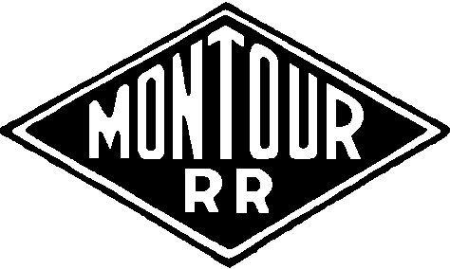

A Discussion Group

Some More Montour Stories

In previous posts we spoke of other areas of the MRR that we overlook at times, so I thought a few of the workers faces might be in order.

Summer of 1976, I have had about 15 months employment by now when we started to safety tie sections of the main between Hills and Library Jct.

Standard procedure was to spend a day or two spreading new ties through a section, then coming back to install them.
Most work was done by manual labor, MRR was lean on the mechanized equipment. We would load 30 ties on a push cart and hi-rail to the drop points. The foreman would be walking ahead with a yellow lumber crayon and "X" the tie end to be replaced. The truck would follow slowly as we walked next to the cart, one man on one side, one on the other.

As we reached the bad tie, one man would snag a new tie with his hands as the other man gave it a push and this would "torpedo" the tie along the six foot. This momentum would allow a man to carry the tie clear of the cart.

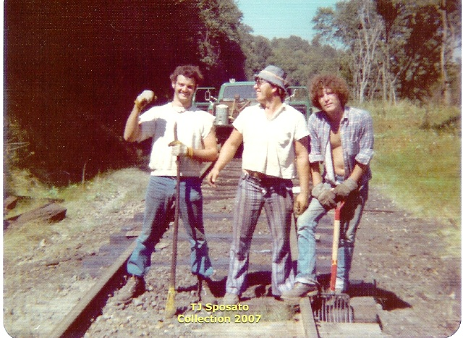

Jim Beaver John P. Schmidt Bobby Dengler
Foreman
Section Gang 2

1
This picture was taken as we installed the new ties and were tamping them with ballast & cinders against the rail bottoms.
The picture was taken east of Turkey farm crossing and west of mile post #34 in Peters Twp. The truck is the RH-2.

The man on the left was Jim Beaver, John P Schmidt, foreman, in the center and Bobby Dengler on the right. This was a portion of the Section Gang Two based out of Hills Station.

I was a proud member of this gang at the time, since this section covered the east end by my home grounds. I got the boys to line up for a couple of shots that day including some of the tie distribution action and a shot of a younger me posing with them.
Guess I need to copy those to share sometime.

Since that time, JP Schmidt was killed in a construction accident, Bobby Dengler overdosed on drugs and died, and last I heard, Jim Beaver was in jail.

Amazing how we never know what the future holds......

Tim Sposato

Injury report: 1-18-56 1:50am
George Barefoot Loco. Fireman. American.
(In his own words)

Opened trap door in deck of Engine 75 and took out hammer to give to train crew working on switch at W.E.Champion. Library crew came down running track and I moved engines out on main track against caboose. I forgot that trap door was still open and I stepped with right foot into pit. I caught myself against controller with right elbow. All my weight went against right elbow, shoving it up as my body went down, hurting right shoulder. Feels like right shoulder is dislocated.

Sent to Dr. A.J. Berlin, Coraopolis, Pa.
Disability began 1-18-56
State report made out 1-20-56

This same type of accident occurred in the 70's, usually at night. I know it must have happened quite often on the diesels over the years. I came close to stepping into it myself a time or two.

The trap floor is about 2'x4' in the cab, in front of the electrical cabinet. Wreck blocks were kept in here also for use in minor derailments.

Tim Sposato

2
As mentioned in earlier posts, we cover the last 20 years of the MRR a lot. Prior history and stories are not as frequent.
In hopes of encouraging more of these older stories, I will recall some stories as told to me by the employees that had lived them.

Time era 1940's:

The MRR had two terminals, Montour Jct. and Mifflin Jct. Locomotives were assigned to these points along with the maintenance and inspector personnel. Crews would report and the trains would be sent on the runs.

The RR had two locals that ran 5 to 6 days a week from each location. Departure times were close together allowing each train to work the customers as they headed for one another. They would eventually meet at Cowden or Peacock sidings and exchange cars that needed to continue to a customer or interchange. Sometimes these locals would also pick up coal to fill out the tonnage that in turn would allow the mines to continue loading.
Each local would then return to their starting terminal.

On one occasion, Jim Lane (my grand father-in-law) was an engineer on the Mifflin Local. They had already made the connection with the MRR Jct local, and were returning east. They had received a boxcar of lumber to be set off at McMurray from the other local.

Now as Jim said, they had been working steady 16 hr days due to the tremendous business and everyone was routinely tired. This caught up to him and other crew members this trip. This particular day was to be a shorter than normal one, so everyone was thinking about getting back to Mifflin and tying up.
The last stop before Salida was McMurray.

It was just after dark as they approached McMurray, the boxcar was just ahead of the hack and normal procedure was for the rear end crew to close the angle cocks and cut the hack off as they rounded the curve. The rear brakeman would drop off and signal the head end once the boxcar cleared the switch.
Hand signals and lanterns were the only means of communication at this time.

Well the caboose was cut, the signal given but the train, minus the caboose, continued east. The head crew forgot the stop, and no one looked back as they headed for Salida. The rear crew called the DS from the phone box, to report the incident, but there are no signals or manned points until Salida.

Well, the head-end pulled into Salida, and the crewed waited for the Conductor to walk up to call for permission to enter the P&WV. With great concern they suddenly realized the error and reported to the MRR DS.
Their orders were changed and the train set off in Salida siding, and they ran light back to retrieve the forgotten rear-end.

Jim laughed loudly as he recalled this event and the punishment of 25 "brownies" to his record and 30 days off. He did admit he wasn't laughing then.

Tim Sposato

3
Easy Pickin’s

Back in the 40's or even 50's did the Montour have any stops that dropped off coal to be used in people’s houses for coal furnaces? I can remember, just barely, our big old furnace being torn out some time in the early 60's.
Our house had a 'coal cellar' and still had coal in it when the house was sold in the 90's. Was there a particular stop where coal was stockpiled and folks or small trucking companies came in and shipped to neighborhoods?
Where I used to work, an old mining engineer told of days in the depression when his parents would send him out walking the tracks to retrieve coal that had fallen off railcars and used it to heat their home.
Ken Caine

I believe that coal for home heating was delivered to coal distributors/coal yards, who then retailed it to residential customers.
However, walking the tracks to pick up coal and fill buckets to carry home to add to the coal bin was a common practice. I'm sure there were exceptions (there always are), but I believe this was the usual practice.
Of course the railroads delivered coal to large industrial customers and still do, the best example being power plants.

Bill Bigler

I have heard stories of local residents climbing on parked hoppers and throwing coal down to their cohorts on the ground. This was a common happening in Cecil when the power would cut off from the train to go to Muse or Westland leaving loaded cars on the main. It was easy pickings for locals to fuel their furnaces.
Dennis Sims

Dennis & Bill are correct about the removal of coal from trains, standing or moving.
I recall riding the trains as the labored up grade through Hendersonville and looking back from the engines or forward from the caboose and seeing men tossing large chunks from the hoppers as we were passing the old mine location and gob piles.
The Montour crews said this always happened around winter time and no one would say or do anything about it.

4
Cars set off at Cowden & Peacock would get picked from by the locals for their heating purposes. I
remember the smell of coal smoke from these small communities all the time during cold weather
along the MRR.

I also remember seeing the locals walking the tracks with burlap bags picking the chunks that fell from the rocking motion of the hoppers, mostly between #4 mine up to Henderson.

I did bring a lot of coal home myself for use in our family downstairs fireplace that I got from the right of way or derailment sites.

I will relate another Jim Lane story in a few days about a coal removal event that got him in hot water once again on the MRR.

Tim Sposato

I have three entries.
There was an elevated siding below the Montour RR dispatcher's office in Coraopolis. Champion Coal trucks and others loaded from beneath the hoppers and proceeded to make deliveries in the Coraopolis area.

The second point; I was informed recently by the daughter of the man from Groveton who made coal deliveries that he gave credit throughout the Great Depression. The grateful recipients made good on all tabs except for one. She didn't share the identity of the stiffer.

And third; the loaded coal hoppers typically waited near the bridge built in 1935 for a new track to a point near Groveton Station. After a fresh snowfall it was easy to trace the coal dust to a home that received free coal. The Groveton yard was fenced about early 1936 after a young boy had his leg lacerated while climbing through a string of cars. That didn't seem to stop coal picking as long as there were stoves to be kept lit.
Jimmy S.

Nice info Jimmy, Now that you mentioned the elevated coal track it makes a lot of sense on how the coal was distributed locally. The elevated track design still remained in place for several commodities including coal at the Keifer location and Slater supply in Bethel Park until the RR was removed in the early 80's.

I would imagine these looked similar to the one at MRR Jct you have mentioned.

Tim Sposato

5
Tim,

As we all know, the condition of the track and ties were in very bad shape in most places near the end of operations on the Montour. This was definitely true of the turn just outside of the Jeffrey Town tunnel near Enlow. In the 70's, I personally saw numerous derailments there where the hoppers were lying on their sides and coal was everywhere. I remember seeing entire families out there filling just about anything they could with coal to take home for home heating.
Jack Chamberlain

Jack,

You are correct, derailments were extremely common on portions of the RR. Jefferytown saw its share for sure. I remember the largest derailment occurred in 1974 just west of the tunnel as the track entered the curve into the cut. There were several cars sideways in the cut, starting at the cement slab bridge over the creek. When I walked up the morning after, the fog gave the scene an eerie appearance. I managed a couple of so-so pictures and returned
later to see the wrecking crew dragging hoppers out and laying them along the RofW. Maybe these are the ones you recall seeing.

A few new P&LE hoppers turned over just east of the Tunnel in the curve next to the road in the late 70's early 80's. Up until the Trail developed that section, there was entire draft gear and coupler still lying between the grade and the creek. My last trip there did not locate this item, I trust they had picked it up for scrap. There are still broken and twisted rail sections on the outside of that curve along with splintered ties from the wreck.

Tim Sposato

Home heating with coal wasn't just part of W. PA history. My mother-in-law lived in Wilkes-Barre near Scranton in NE PA in the Anthracite coal region and heated with coal until the flood of 1972 took out her coal furnace. As a little girl she would daily walk over to the railroad yard with her friends with buckets to gather coal. She's 95 and still tells stories of knowing just where the cars banged (coupled) together and knocked coal off. They got chased often by the RR cop, but she says he was old and fat and no match for a bunch of kids. They just made fun of him!

Bill Bigler

6
Here is a photo of Jim Lane taken at Boggs yard on the main. They had just pulled clean coal off the siding at Champion and were air-testing the train for the trip to Montour Jct.

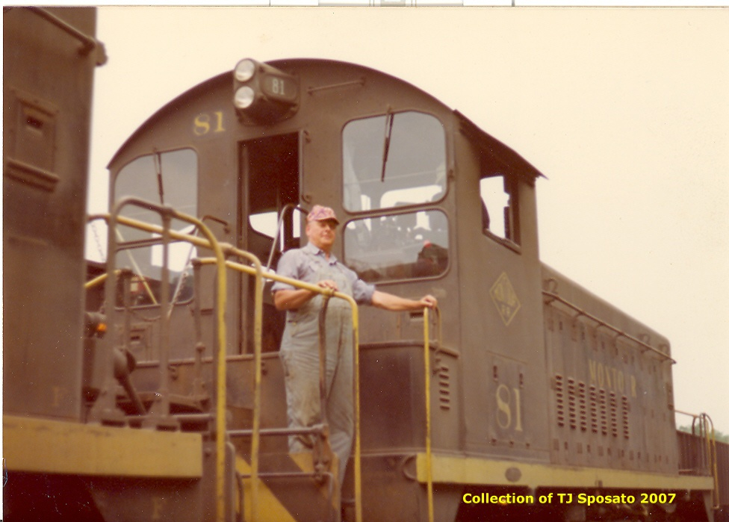

Jim Lane 1974

The recent posts of free use of Montour hauled coal, allows me to relate another human interest story about Jim Lane.

Jim was working as a fireman in late 1930's on a run, late one winter evening out of Montour Jct, he thought it might have been locomotive #33.

As they headed east they passed through Greer Tunnel, over the PRR in the through truss bridge and around the left hand curve. Here they exploded a track torpedo used for signaling an obstruction ahead. They slowed down and caught sight of a flagman giving them a stop signal with a red lantern. After stopping the flagman said his train ahead of them was having air trouble with a pick up off the PRR Transfer at Hills, but expected they would be moving East shortly.

The flagman climbed aboard as the engineer (George Barefoot) eased down to stop behind the flagman's caboose.

At this point they had stopped on a short straight stretch east of Greers crossing above what later became the water purification plant for #4 mine along Chartiers Creek. This was also next to an old frame/ log dwelling belonging to an old widow woman.
Her husband was a miner all his life, but had past away.

I can only believe the miner used to walk either the Montour, or the PRR that crossed the creek at this same point, to work every day, depending if he worked the tipple or entered the mine at the supply yard along the PRR.

7
Well, Jim, living in Hills station and knowing all his neighbors, decided to toss some coal out from the tender into her front yard. He said he had tossed coal as he passed by on moving trains before, usually a shovel full or two if he was quick enough. After he supplied her yard he climbed down into the cab and was confronted by the trainmaster. Seems the TM had been lurking around the train stopped in front of them and walked back for a visit. He asked Jim what he had been doing on the tender and Jim replied he was shoving coal closer to the bunker doors and trimming the loose coal so as not to have it fall from the top of the tender. Well the trainmaster knew the real story and wondered why he saw coal landing in the widow's yard. No reply from Jim would have changed the verdict.

The TM reported Jim and disciplinary actions where given in terms of more "brownies" to his record, but the coal remained for the widow.
Guess the TM may have had a soft spot himself.

I easily imagine the scene of the #33 sitting there, shrouded in steam on a cold evening with its headlight illuminating a wooden caboose, and the silhouette of Jim against the night sky making sure the old widow woman would be warm for another night.

As you walk east today from Greers Crossing when the foliage is dead you will be able to see the remnants of the old dwelling foundation of the widow's home on the right side of the grade.

I have stood there, looking around, listening, recalling this story...........

Tim Sposato

8
Back On Track

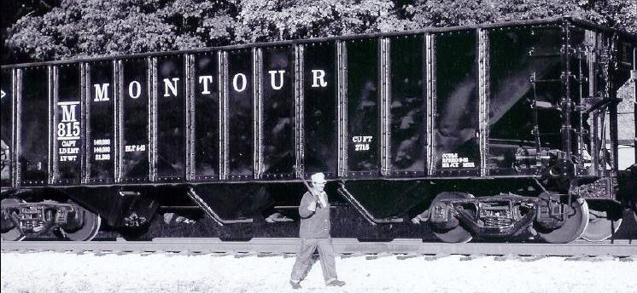

As some of you may have known, we have been doing vintage photo freights here at the Ohio Central for a number of years.
About 5 years ago I had an ex PRR 70 ton hopper repainted as a MRR #800 series hopper.

This series was built in 1943 during the big WW2 coal boom and numbered 800-899 and were very similar in design to this PRR car. The main difference between the two are the type of trucks.

As the photo shows the paint was fresh and glistened nicely in the afternoon sun as we were finishing an air test in preparation of returning the train to Coshocton at the end of a long weekend.

The photographer recently surprised me with this shot of yours truly, as I walked the air test with a brake club on my shoulder. As you can see by my attire, we strive to lend the entire scene that authentic look of railroading in the 40's/50's time frame.

To my knowledge, this is the only hopper painted with the MRR scheme in existence today.

Tim Sposato

9
I signed up on the MRR posts just last month and have been enjoying the reading.

I'm not all that knowledgeable of the area of the Montour, so I take a little time now and then to look at the maps to see where everyone's posts are referring to.

I grew up in Sharon, Pa. and as a little guy I watched the trains from Erie, Erie-Lackawanna, New York Central, and Pennsylvania come thru town. Eventually it became Penn-Central, Conrail, and now Norfolk & Southern. I have no rail experiences at all, except hearing switching taking place on the Pennsy rails near our house, or the conductor's signal to the engineer that the Erie-Lackawanna passenger train was loaded and ready to go to Youngstown, Ohio for the next stop on the other side of town. My buddies were amazed that I knew when the train was ready to leave, and I never told them that I figured it out and how I knew. I was just "Get ready!" and we'd turn our bicycles around and give chase to the next street crossing and wave everyone good-bye!

I was employed in the auto industry with Delphi Automotive, a spin-off of General Motors that's currently in bankruptcy court. Thank God I was able to retire, but GM has not picked me up yet on their pension rolls, so I have no idea what's in store for the future!

What got me to the Montour was my interests in history and I'm kind of a railfan in a way. A small group of us former co-workers have bought bicycles and we looked up the Montour Trail and rode from Milepost 0 to the McDonald trestle which was not open for trail riding yet. That must have been in 2003 maybe? Missed a ride in 2004, but in 2005 I took them from Hendersonville to and over the McDonald trestle, then Rt. 980 into McDonald and picked up the Panhandle to Walkers Mill Rd. Tuff ride back, slightly uphill and into the wind on the Panhandle!

With winter, I take the time to look at the history of these rail to trails. Would love some time to make an attempt at modeling the Sharon area railroads. My knowledge of model railroading is still kids stuff to me, but would like to try and do that in N scale sometime.

I'll try and make the drive down for the meeting! Sounds interesting!

Paul W

It was Thanksgiving 1950. My family had its first automobile and just moved to a suburb east of Cleveland. We drove down to Coraopolis to spend the weekend with my grandparents. My grandfather Eggbeer (we kids called him "Pop") asked me at Thanksgiving dinner whether I'd like to spend the next day seeing the Montour RR where he now worked.

Next morning we were off. He showed me his office, the right hand one of the two yellow houses on State St. (Route 51) in Coraopolis overlooking the yards.

After a brief look at his office we walked farther down State St. to the steps that led down into the yard. We watched for awhile from the bottom of the steps. I was 10 years old in 1950, and the Montour was all steam. We then crossed the yard and went into the shop buildings. They were working on one of the steam engines inside. We came back out, watched them shove cars over the scales, then Pop said "let's go for a ride!" He looked up at the engineer and fireman, pointed to the two of us, and they motioned us to come on up. I sat on the seat box behind the fireman. We moved some cars around, then coupled onto a string of loads and took

10
it over to the P&LE where we dropped the loads and picked up a string of empties and took them back to the yard. After riding around a little longer, we thanked the engine crew, climbed down, and went back up the steps and headed home. I think I talked nonstop until I went to bed.

A 10 year old boy had been introduced to the Montour, the beginning of a relationship that continues today.

Bill Bigler

Can anyone explain the layout of tracks at #4 mine? Or better yet, a diagram or photo???

I know the empty yard was on one side and the loaded on the other. How many tracks were there?
According to the track chart, these tracks seem to be about 1/2 mile long.
How many actually loaded under the tipple?

On the track chart, it looks like 3 tracks [besides the main], plus a small 4th siding - was this under the tipple?
It looks like it on the photo - 2 tracks with cars on them + 2 empty tracks. Looks like 3 tracks approach from behind the camera - unless one of them is the cross-over that appears on the chart. It goes down to 2 and then splits into 4.

On the 1939 aerial pictures, you can't quite get good enough resolution to check it out for sure.
Were different types / sizes of coal loaded on the different tracks, or was it all one type?

Were the cars rolled by gravity thru the tipple, or were they pushed by a locomotive?

Bryan S

#4 with four load out tracks...
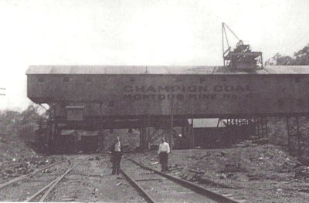

11
#4 was a very long lived seam of coal. At the date of the picture, (I place it in the late 1920's) coal was loaded by size. Lump, egg, pea, slack, or run of the mine....
Towards the end of the Montour in the 1970's coal was loaded out as run of the mine and processed at Champion.

The mine and the tracks changed with time. I wonder who the two gentleman are that had the time and money to make the picture, maybe the Superintendent and the ???

When the yards at #4 where built, they where laid on a down hill grade so cars could be rolled though the tipple. There was a cable hoist added to help pull cars along in loading.

-Donald McCarty

12

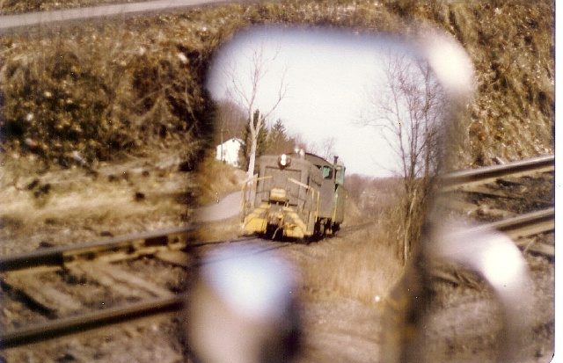

One winter day in 1979, I had to report to the Superintendent at Montour Jct, prior to my shift at Champion yard office.
As luck would have it a Champion yard crew was on duty and preparing to leave as a "caboose hop" just when I had finished the meeting.

Seeing that I had plenty of time before my 2:00pm shift, I quickly decided to follow the crew to Champion.

I stopped at numerous locations for pictures or just to listen to the single note airhorn sounding for the crossings.
A favorite spot over the years was to sit at McLaughlin crossing, and allow the train to get along side of the truck so I could pace it eastbound for about a quarter mile.

This particular day was no different, but as the engine rounded the curve as I watched the side mirror, the sudden notion of shooting a picture came to mind.

The #83 was on its last whistle blast, the crossing directly behind my 77 GMC Jimmy, I fired this shot and dropped the camera onto the seat and started rolling as the engine caught up to me. The clanking rail joints sounding with the rumble of the EMD in the lower throttle notch was music to the ears.

The usual good nature banter started as engineer Jack Harvard and I hollered back in forth during the 15 mph chase to North Star Jct.

After this short run, the track is on a higher grade as the road to Champion from here is on the opposite side of the valley until MP 13 as it enters the Boggs cut.
I arrived at the YO just as the Crew pulled in.
Then it was another typical day at the Coal Washer.

13
Note also the short piece of 90# rail, a repair of an early break at one time. These short pieces were a common sight on the 90# rail through out the system. One can also see the general track appearance in regard to the ties and ballast condition.

I always enjoy looking at this shot, the only one I ever did using the mirror, but these unique shots make them more special.

Tim Sposato

That's a great shot Tim,
Very artistic, I like how the tracks in the background almost line up perfectly with the tracks in the mirror.
Troy
__._,_.___

These came from a Carnegie, Pa. old news site.

September 1, 1933
James ALLOWAY, 65, of Clinton was seriously injured when his car collided with a coal train at the crossing in Clinton block.

August 28, 1913

The Montour Railroad Co. has purchased the Joseph COWDEN heirs farm of 240 acres near Bishop for $250 an acre, or $60,000.

Tim Sposato

14
A Dedication to the Trainmen

Earlier today as I put the finishing touches on the 3 carousels of 35mm slides for this Saturday’s Get Together, along with corresponding with Moderator Bob, clearing up some issues from weeks ago, I couldn't help not reflecting on several Specific Trainman of the Montour RR who were so wonderful in fulfilling the ambitions of a camera toting teenaged boy.

As our March 24th Get Together draws near, for me it will be a time to share with all of you images of what drew me so close to a broken down coal hauling railroad here in southwestern Pennsylvania.
In the images you will see Saturday, there will be no organization.
Scenes will jump from one end of the railroad to another.
Coverage of specific areas might dominate other areas.
In these images, you will see the good ... and the bad...
In the images you will see Saturday, you will see dedication.
The dedication of a young man, to record both on film and cassette tape, a record of a railroad that no longer exists.

As I wound back the clock the past few days, reviewing 3 carousels of 35mm images, there were scenes of Montour Conductor Mike Desko standing in the door way of his caboose, with Flagman Dan Leonard standing on the platform steps as their light engine consist was being shoved back to Champion after moving coal to the "P"- Company at McDonald.
Dan Leonard was my hero.
Hardly anywhere I showed up...
No matter the time of day...
No questions asked, Dan seeing my presence as his caboose neared, dropped down out of the cupola, and out onto the caboose platform waving me aboard if I wanted.

One such event, nearing dusk early 1975.
One of the last crews to Mifflin Junction was approaching Salida.
I was down at the West Switch camera in hand, praying the light would hold so I could document of this crew at this location.
After a lengthy wait, finally the crew was East of Horning Road crossing.
As the 3 SW-9s with a short train passed over the N&W, Engineman Herbie Wirth recognized the teenager with the camera, and eased his short train to a near stop there at the West Switch so the photographer could climb aboard as Dan Leonard stood there on the caboose platform waving me aboard.

Then more times than I can recall, riding with Desko and Leonard on the Library Branch moving coal out of Montour #10.
Usually two cuts of coal were made out of #10, and with caboose leading the way up the branch with the loads, Dan simply handed me his company radio, with instructions, if the kids put spikes and stuff on the rail, stop us so we don't derail.
Then, after the crossover near #10 tipple was destroyed and getting around the caboose required shoving up Research Track at #10, often I was given the caboose hand brake with firm instructions, don't stop us short...
At Montour #4, the ritual was put the empties away, take lunch, then gather up your westbound train after dropping the caboose by down in the loaded yard.

15
As time passed, the "teenager" with the camera was in charge of dropping the caboose by gravity, as the engines gave the caboose a gentle kick into Kamps Cut with the engines clearing up in the loaded yard and the caboose came back down the main to clear...

Once in the loaded yard with the engines coupled to a designated track, the "teenager" laced up air hoses, made the air test, knocked off hand brakes and often put the first cut of coal out against the caboose.

In later years, after Dan bid off the road and onto the Champion Job, I often rode out the "Hollow" on the Champion Jobs.
Dan’s wife Paulette worked in the Bank Building in Imperial and...after the usual ice cream stop in Imperial, with me at the throttle, our locomotive consist roared out of town with Paulette standing in the doorway of her employer waving at roaring EMD SW-9's amongst clanging bell and blaring air horn headed on up the line to Champion.
I'll never understand how one teenaged camera toting historian fell into the hands of two wonderful Trainmen on the Montour RR as were Dan Leonard and Mike Desko.

Conductor Mike Desko, when working Montour #4, would obtain his green bills for his westward train from the #4 shipper.
As his crew ate their dinner, Conductor Mike Desko would jot down on cardboard, for his two train man, the last car numbers he needed from each track in the loaded yard so as not to have more cars than his engines could haul.
He would also have written down, the number of cars and how many "big" cars (100 tonners) his train would have including the number of shuttles. This information would be given to the train dispatcher when calling for a train order to head west.
Often, Mike Desko would prepare a third copy of his cardboard report for the teenaged historian.
This would then be attached to the extra copy of the train orders the crews often made for the Historian.
Train Orders and any other miscellaneous memorabilia would be set aside for the Historian when he made his next visit.

As time passed, numerous Trainmen offered the same opportunities.
Dave Sherwood, Dave Lockerbie, Roy Parkinson, Charley Jones, J. Marvin Conley, Chip Wright.

In later years, Trainman Roy Parkinson was quite outgoing and was responsible for many opportunities in running the SW-9's.
I could often count on Roy to drive me back to my car any time I wanted to ride into Montour Junction.
And then there was the one time Roy left me and Friend Dave D. stranded at Montour #4.
Roy was conductor one afternoon as myself and Dave D. were over at Rook on the P&WV hoping for some Western Maryland power to photograph.
Roy was leaving Champion headed for Montour #10 with a meet at Cowden.
After a quick conference with Dave D., my 1974 Nova was headed for Cowden.
Roy gave Dave and I the o.k. to ride that night.
After the meet at Cowden, over to Montour #4 and onto Montour #10 we went.
After making 2 cuts out of Montour #10, Roy’s crew had enough time to make Montour #4 where they outlawed.
If I remember correctly, it was Friday night and there were no crews available to relieve Roy.

16
The coal from Montour #10 was left on the main track at Thompsonville and the engines brought down to Montour #4 and tied down.
Now what to do...
Roy and his crew were in the taxi and gone.
Montour #4 tipple was empty...
And Dave and I were stranded.
A telephone call to my sister at home to drive over to Montour #4 at 11 PM was over-ridden by my "loving" father’s "WALK" response.
Dave had to be at work in the AM...so we began the 7 mile walk back to Cowden in the wee hours on the night.
I think it was somewhere around 2:30 AM when Dave & I made it back to the car...

Then a time, probably 1974 a westbound was departing Mifflin with instructions to meet the fuel and sand truck at Brightwood. I arrived there about the same time to learn Jim Lane was Engineer.
Jim, in seeing my tape recorder, beckoned me over to his locomotive consist...
Asking me if I wanted a good recording of his locomotives...
With a gigantic grin, not knowing what he was talking about...I nodded happily...
Jim returned to his locomotive cab...
And in seconds...his 3 unit consist of SW-9's were roaring to life...
Throttle position #2..then #3...then #4...then #5...the entire way to throttle position #8 those 3 SW-9s roared...
I was completely dumbfounded...that afternoon.
(Tim - remember Arden and the "F's a few years ago with the cab door wide open)

During the past few days...
Sitting here at home in the quiet silence...
With the slide projector illuminating images of 30 wonderful years ago...
The memories flood back...
Dan Leonard...
Mike Desko...
Roy Parkinson...
Dave Lockerbie...
Charley Jones...
J. Marvin Conley...
Chip Wright...
You guys welcomed a teenaged camera toting person into your work enviroment with little or no fanfare.
Of course there were many Engineman over the years who did great deeds, but for the time being, this dedication belongs to the Trainman’s side of the Montour Railroad Company...

Dan, Mike, Roy, Dave, Marvin, Chip...THANK - You.

Gene P Schaeffer

17
Your post of the past, Gene, really refreshed my memory of those better days on the MRR. I sure miss all those times of swaying back an forth as those rail joints clanked beneath the engine and those ex UP cabooses, boy they would rock a baby to sleep on those High-Speed trucks they had.

I recall each caboose had its own personal touches by the regular crew men. Some engineers weren't permitted in certain conductor’s hacks, I remember that well also.

I learned to drink coffee, black, with cream, without cream, sugar, no sugar, you name it, I can drink it because of those crew men and how they stocked the caboose. Just climb in the hack and help your self. Frank Girimonti always had the best coffee. When they arrived in Champion I always climbed aboard and got some, he claimed his wife knew the best kind to buy and she would buy the Best!

There was always coffee available, even in the summer when they had their coleman stoves, so the coal stoves could remain unfired.

Here’s a companion picture of Gene’s that he made at Scott Siding, with Dave Sherwood, this was an early shot in 1973 as the Coal Run was ready to place the first loaded cut on the main against the hack. Dave is throwing the Loaded Yard Switch prior to shoving back. Note the "Repco" radio in his hand on this nice summer day. You can see a PRR hopper sitting on the Transfer to the PRR, the phone shanty and wayside poles still standing. The bridge and Kamps Cut is behind me.

Between the caboose and the hopper on the hillside is where the steel water tank once stood for the steam engines, the standpipe for this was to the right of the hack along the main.

Gosh those days were wonderful.

Tim Sposato

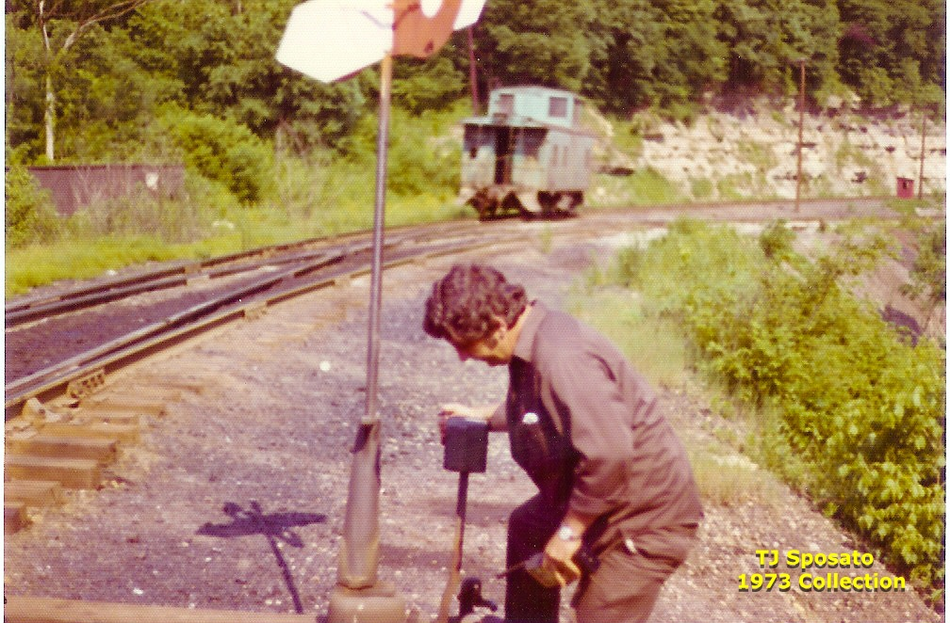

18
Tim;
Lovely photo of Dave S.
I think his hair is a different color these days.
Girimonti's coffee...
Interesting...
You know where I'm going with this so I'll stop now...
GPS

p.s.; I like the reflection of the switch target on the ground.

I neglected last night to complete my tribute.

Here at Montour #4...after the train was together and beginning its 2 hour westward journey...
As the flag swung aboard the caboose and farewells were given...
I would often stand here...for 10 or 15 or 20 minutes....and listen.
You could hear those SW-9's climbing the hill out of Montour #4.
For a few moments, the sound stopped as the engines passed through Grers tunnel....
But you could stand here at the West Switch...
Listening to the on-going loading of hoppers up at #4 tipple...
And still hear those SW-9's working up through Henderson...
Knowing on the second floor of the train dispatcher’s office...
Another train crew is either being called...or now on duty...
To come back to Montour #4 and do it again...
When Montour #4 was working good...
Three - four unit road crews were needed every 24 hours over here...
Lots of coal moved out of this ol'e mine...
Luckily Tim & I were a small part of it....

Gene P Schaeffer

19
More on the Montour

MTR Hi-Line pictures:
OK boys they are all up! Enjoy...follow the link.
http://www.thepwvhiline.com/MontourInThe1950sand60s/index.html

Most physical features of the railroad seemed to have names attached
to them.
Peacock Cut & Kamps Cut - Geary Curve - each of the junctions,
branches, transfer tracks & tunnels - sidings, switches, etc.
Everything had names to help identify what & where they were.
Other than the viaducts [McDonald & Library] - did bridges get names?
I can't remember seeing any.
The through-truss bridge by Greers Tunnel - over Chartiers Creek on the other end of Greers - over Montour Run near B&T [Parkway West] - over Rt 50 at Venice - over Valleybrook Road west of #4 - there were some fairly big bridges that don't seem to have names.
I am not thinking of the numerous road crossings and small stream bridges - there were too many of those.
Just wondering - or is this "one of those railroad things"?
Bryan Seip

- Glass's Bridge
- Venice Bridge
were often used as reference names.

GPS

Forgot Shaw Mine Bridge...

I don't know if the Montour did it, but most railroads identified their bridges by Milepost. For example, a bridge that was three-tenths of mile beyond Milepost 30 would be identified as Bridge 30.3. Down here on our railroad the bridges were numbered consecutively starting where the "Old Line" connected to the L&N main line in Etowah, TN. A few notable bridges were also given names, but the bridge numbers were how they were identified.

Bob Ciminel
20

Since Bryan is on the subject of bridges, a little side trip about a certain bridge, not a Montour RR Bridge, but a bridge over the Montour RR.
I don't have the details at hand, but the Parkway Bridge over the Montour near Wicks Furniture raised quite a stir years ago when it was constructed.
I had read when the steel work for the bridge arrived by rail,
The highway construction company hired Briggs & Turvis to erect the steel work.
Hence, B&T cranes left the confines of their yard, and out onto the high iron of the Montour RR Company where the cranes positioned themselves to lift steel.
I heard some of the unionized labor on the Montour RR didn't approve of this little operation and time slips began flying...

Gene P Schaeffer

Gene,
Did B&T have the Montour dispatcher's permission to foul the track?
By timeslips flying, I assume you mean that the union wanted the Montour to pay for an engineer, conductor, and brakeman?

Bob Ciminel

Train Dispatcher permission would have been a must, unless the train dispatcher put the main track Out of Service between Scott and Cliff Mine or something.
I don't remember how protection was obtained, and it could of been accomplished several ways.
I'll try to find the info on that work.
Yes, Union contracts and an outsider working on the Montour, some of those guys just waited for the opportunity to time slip.
But from our perspective, it would have been neat seeing 2 or 3 B&T cranes out there, booms up...lifting steel for the highway overpass...

Gene P Schaeffer

21
In doing some research on unrelated material, I happened upon these articles. I have read about the Henderson tragedy, but not by the McDonald Record. Thought I might share this.

Tim Sposato

From the McDonald Pa Record

Harry PIRATT, Colored, died at the hospital in, Pittsburgh at one o'clock Tuesday morning,
February 7, 1928, from injuries received on Saturday, January 26 when he was injured by a fall of slate in Montour No. 9 mine of the Pittsburgh Coal Co.
His back was broken. He resided in the Southside, McDonald with his wife and one child.
Services conducted by the pastor of the First Baptist Church were held Tuesday evening in the___Funeral Home.

Hendersonville Mine Disaster Mar. 15 , 1917 McDonald PA Record
Fourteen Die in Mine Disaster

Fourteen miners were killed in two explosions at the Hendersonville mine of the Henderson Coal Company, south of Venice, early Tuesday morning.
Company officials have announced the names of the dead miners and stated that all others have been accounted for.
Steve JATKOWIC, Hendersonville, single
John ROZAM, Hendersonville, married; leaves wife and three children
Metro YUKONE, Hendersonville, married; leaves wife and one child
George MOLISH, Hendersonville, married; leaves wife and four children
Harry LACOCK (?LANOCK?), Hendersonville, married; leaves wife and two children
Daniel GOSSETT, Cecil, single
Joseph GOSSETT, Cecil, married
Hector GOSSETT, Cecil, single
Joseph MISCHELL, Hendersonville, married; leaves wife and one child
George SAMALLA, Hendersonville, single
John PADEN, Hendersonville, married; leaves wife and two children
John MILLER, Hendersonville, married; leaves wife and three children
Michael PHILLIPS, Hendersonville, married; leaves wife and four children
William OSKOSKI, Hendersonville, married; leaves wife and one child
The bodies were taken to MCNARY's mortuary at Canonsburg, where an inquest was held Wednesday by Deputy Coroner James MCNARY.
Gas that had collected in face No. 1 was generally admitted to have caused the explosion. Whether it was ignited by a defective safety lamp, crossed electric wires, or a spark from a cutting machine,

22
could not be told. Mine inspectors, officials of the company and workmen would make no positive
statement. Twenty-seven men were in the mine at the time of the explosion.
When operations will be resumed at the mine is indefinite. Burial of the victims will start today (Friday). Services over the three GOSSETT brothers will be held at Cecil with interment at Venice. John ROZAM will be buried at Carnegie, and the others will likely be interred at Canonsburg.

23
Morris Mine

Does someone have a photo of Morris Mine they can send me? Anything anyone can tell me about Morris Mine? Thanks.

Bill Bigler

There are some photos here
http://montourrr.com/Plogger/montour_railroad/morris_mine
Bob Ciminel provided them
Ken Caine

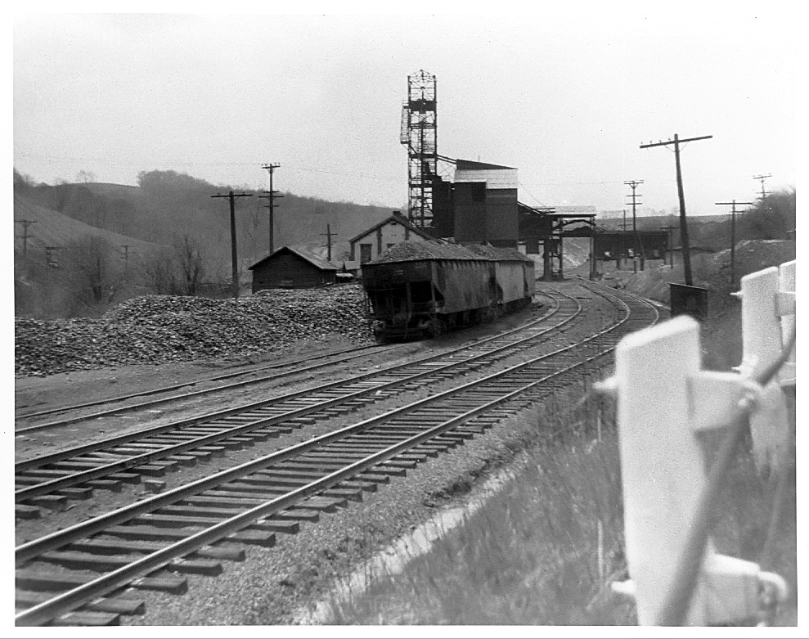

Morris Mine 1956

24
Thanks. Those pictures of Morris Mine were exactly what I was looking for. The former site of Morris Mine was one of the coal mine locations we found on Friday that I hadn't found and identified before.

Bill Bigler

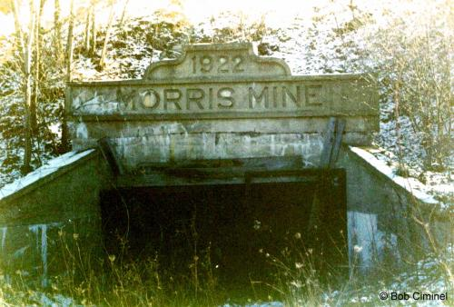

- Morris Mine was built by the Morris Mining Company in 1922. The company also built the community of Gilmore, named after one of the company's officers, to house the miners. There were 22 single-family homes in Gilmore. Locals often referred to Morris Mine as the Gilmore Mine.
Comment by Bob Ciminel- posted on 3.10.2006
- The coal seam was about 100 feet below the surface. The slope was used to move men and equipment in and out of mine and the shaft was used to bring the mine cars to the surface for dumping in the tipple. Montour No. 4 Mine had a similar arrangement; however, the slope contained a stairway for the miners. As I recall, there were no tracks in the slope at Morris Mine, so the miners probably walked up and down it.
Comment by Bob Ciminel- posted on 5.11.2006

25
So what is the status of that mine? Bulldozed over? Any remains of it? Does anyone have any current photos?
ROB

Here's what Morris Mine looks like today.
The road running across the picture is Rt 50 west of Venice. The mine is just west of the intersection with Southview Road.

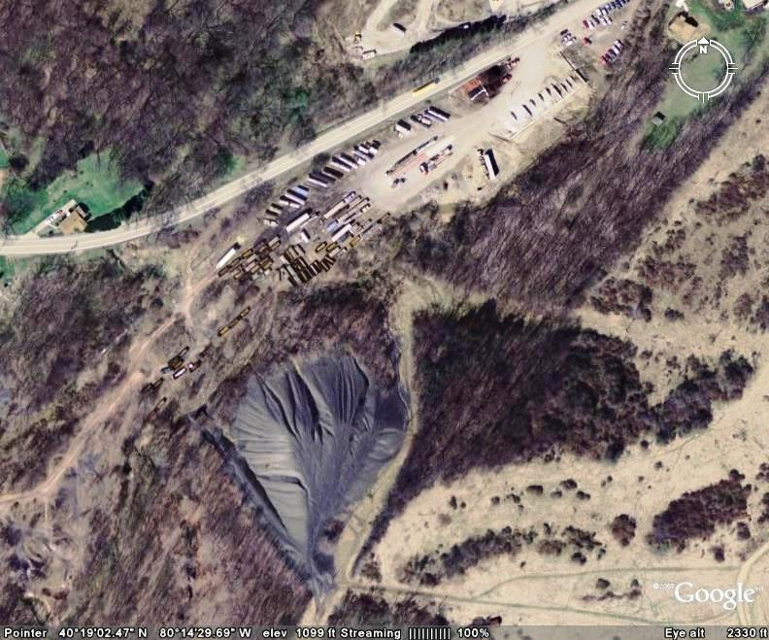

Thanks for the photo.
Is the Mine opening like in the old photos still intact?
What rail line is / was it near ?
Thanks
ROB

26
Great pictures. Can anyone give me an idea of the location? Mile post #'s won't be much help.
Maybe nearest junction or town?
Bud Brock

It is West of Venice. South of Southview. Town was called Gilmore. Check out the Files on the website. There's one I loaded several years ago called Towns Along the Montour. Talks about the mine and town.

Here's a partial mine map of Morris Mine.
Bob Ciminel

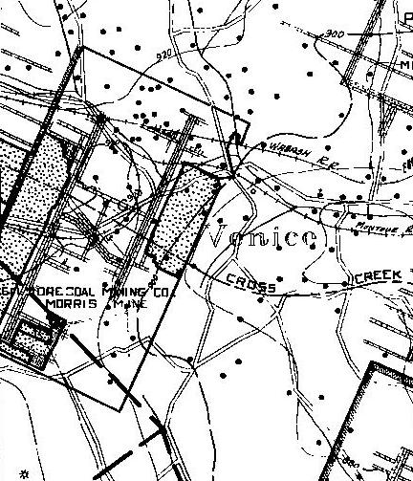

The road running across the middle of the map is Rt 50. Rt 980 runs top to bottom.
The Wabash RR tracks are the current Wheeling & Lake Erie tracks.
The Montour tracks listed are the main line – the Westland Branch starts above the mine in the left center of the map, with Southview Road running along the Montour tracks at that point.

27
Morris Mine Memorabilia...
Good subject theme for this Saturdays tromp around Morris.

After parking the car at the former driveway entrance, the first artifact I discovered was the AAR crossing tag still nailed to a post for the gate leading down the driveway.
The AAR tag was Montours ID for the crossing for the mine.

I found a narrow passage for crossing the creek then climbed the slate pile to the very top. Lots of coal in that slate pile.
At the top of the slate pile, I made a number of photographs that I will share later next week when time permits.
On top of the slate pile, I next visited a seemingly abandoned oil rig that was perhaps 50 yards away. I recorded the innards of he oil rig using the built in flash on this new digital camera.

After dropping back down the slate pile, I searched for the former slope entrance for Morris Mine.
The concrete bridge piers for the narrow gauge railroad for crossing the creek were located and...lo and behold... there on the hillside was the top of the concrete arch for the slope entrance for Morris.

If I remember correctly, it was November 1982 when Morris Tipple was dynamited.
That stubborn ole tipple refused to come down requiring 3 seperate sets of charges to drop her.
Even then, the tipple kinda kneeled to one side, gently leaning over, in defiance to the attempts in bringing her down.
I guess it was then the slope shaft in the side of the hill just over the creek was buried.

I guess 25 years of weathering has eroded the hillside and the concrete arch has re-appeared along with being able to see into the slope for a few short feet.
There were 2 very good condition rails sticking out of the ground near the slope entrance. At a guess, I'd say they are 50 pound rail???

Not only did I re-discover the re-birth of the slope shaft entrance, but I found I'm assuming 2 sheave wheels from the top of the tipple.
The sheave wheels were at the very top of the tipple, and had gigantic steel cables wrapped around them for hoisting the elevator out of the pit.
The spokes appear to have been torched off, but both wheels are in otherwise good condition. Both sheave wheels appear to be about 10 feet in diameter.

And lastly, at least 6 mine cars were found partially buried.
Steel frames and wood bodies. The wheels appear to have been removed, but talking about a neat find, seeing these mine cars with their rotted out wood sides was a wonderful discovery.

I guess today’s find could be labeled more Morris Memorbalia as labeled by Moderator Bob last week.
When I have time next week, I'll share today’s photos...

Gene P Schaeffer

28

