Montour Memories # 5

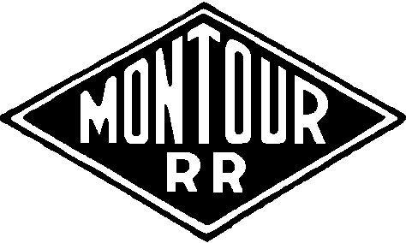

A Discussion Group

More on Morris

While we're on the Morris Mine subject:

Back in December 2005, I posted a story about the deer steak cookout we had under Morris Mine tipple (message #1021).
I also had mentioned I would locate the picture of that day.

Well....
I finally was able to locate that slide and with the new slide scanner can mate that story with this picture. Take a minute and re-read the story, this took place around Christmas.

The main line is behind the section truck, the truck is on the grade for #1 loading track.
The grills are set up on #2 track.

I recall we had been gauging rail towards Westland Mine on the curve to the left of this shot.

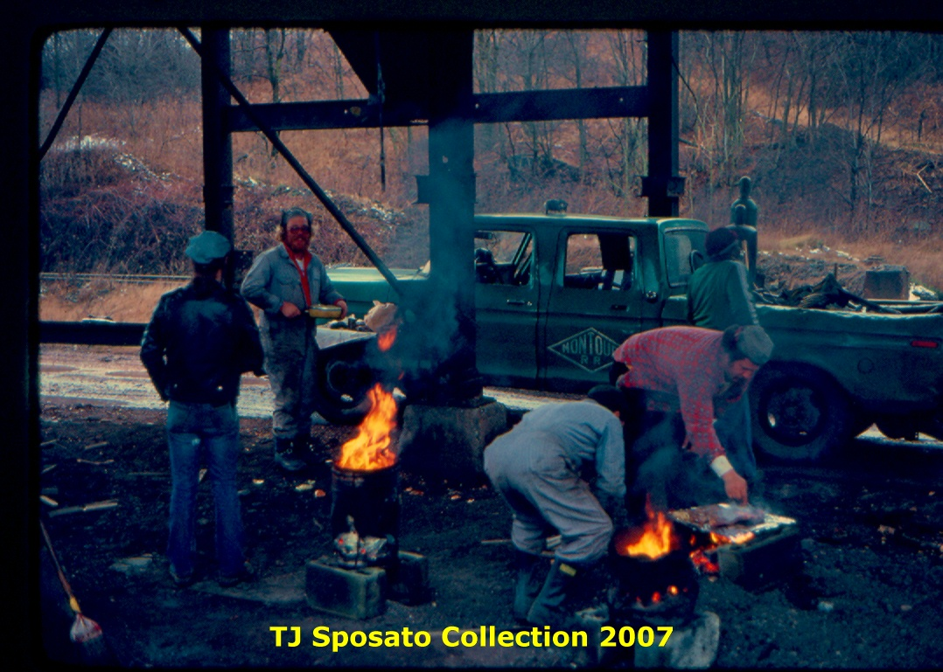

L to R; "Hippie" JP Schmidt Patsy Gileot Pete Williams Nate Watson

Putting in another tough day on the 'Mighty M'.

Tim Sposato

1
Tim’s Story RE: Morris Mine

Some more to add to the Morris Mine story.
While working with the #2 Section gang it was decided to have a BBQ and roast around the Holidays one year.
We planned that it being a Friday (payday) and we were gauging some rail on the Westland Branch that week, since the weather had turned colder with snow flurries, under Morris Tipple would be a great place to cook up some deer meat that a few of us had bagged earlier in the season near Library Jct.

Since this was a well planned event the gang all brought a covered dish or beverage of some kind and of course the Track Super was also invited.
This meant we needed to start cooking as soon as we reported for work that day! Empty spike kegs were used as the BBQ's and warmers, we used mine coal that was lying all over to get the base started and continued with the abundance of wood along the R of W.

Naturally, while we cooked, we explored the remaining mine structures.
We made our way down the sloped shaft opening about 75ft before we came to the water level, the mine rails that were left continued into the depths.
We then visited the old air shaft just west of the tipple. This was an enclosed structure, as you entered the door way, the walkway ran the length of the building on one side. There was a metal railing on the other side of the walk to prevent falling into the vertical shaft opening.
About a 25ft drop before hitting the water.
We decided to test the quality of the fusee's the MRR purchased by lighting them, dropping them into the water and watched as the red glow faded away into the shaft. Most of them did remain lit as they sank.

After dinner and the reception of the paychecks, we wished the Super a Merry Christmas as he departed for his home.
At this time rule "G" came into play as we finished out our tour of duty.
About then, the late Foreman, John Schmidt and myself explored the tipple and really studied the elevator shaft under it.
This elevator had mine rails still affixed to the platform, the lifting cable still wound its way through the pulleys and wheel and spool.
John commented that the elevator was resting on two pieces of rail that were laid over two of the corners of the shaft opening, "If you and I" John said, "were to take two spike mauls and hit these two rails at the same time it just might drop into the shaft"
I found two mauls and returned as we all gathered for the great event.
At the command we struck the blows and all hell broke loose.

The elevator plunged, the cables started swinging, snapping as the sheave wheel rotated with increasing speed, at this time fragments of the tipple started to drop as we all ran for cover.
In all honesty I though that the way the tipple shook and groaned that it was coming down. Over my shoulder I saw in the coal dust and debris, a column of water shoot straight up out of the shaft as the elevator hit the water.
For a time after, the cable continued to unwind into the shaft and then just coil up in the girders.
You can believe the laughter this brought for quite sometime until John realized we had created a real hazard for others walking near the open shaft. He decided to visit the farmer up

2
the road were we got some snow fence and some steel posts so we could fence off the opening before we left.

As you know Gene , 'you can never have taken enough pictures', I only took a few of us grilling the steaks that day, maybe one looking into the sloped shaft. I suppose I need to locate these this winter and share them with you all.

By the way the steaks were fantastic, not to mention the trimmings that day.

Tim Sposato

Tim;

Gotta admit, Foreman J.P. Schmidt was probably lots easier to work for than was Foreman R. Maga.
R. Maga would have never allowed "cookouts"...
R. Maga was from the old school.
Working with Marshall Sacco was also rewarding.
Marshall was R. Maga's right hand man.
Our 8 hour days were spent raising track, replacing ties, gauging...cookouts, hirail trips and the likes were unheard of...
Driving to Montour Junction for tools... Not R. Maga, have the Track Inspector bring out new equipment.
If you goofed off, you got docked...
If you were late coming to work, you got docked...
If you left early, you got docked...
If you were late returning after lunch...you guessed it...
Guess that’s why Section #1 had fewer derailments...than Section #2...<LOL>

Gene P Schaeffer

If I'm not working some train somewhere, I would love to see Morris Mine again.
Tim, remember the flooded ventilation shaft that we used to drop lighted fusees in, Spiraling down till the glow faded out of sight.

Thanks for the photos that add the human element to the memories.
I was on the the Montour Trail with my son Ryan yesterday.
Stopping beside the trail next to the higher point of ballast where I knew the Jewell switch used to be, I stood back and tried to remember that twin headlight pronounced in the early morning fog some 30 or so years ago; throwing the iron against the main to back and grab 21 loads to add to the 60 or more waiting on the main. It was strange to remember.
Looking at things as they were (present day) made it hard to visualize what I have actually seen.
Sort of going to Gettysburg and seeing a nice National Park rather than an actual battlefield where men cried and died. Faces put the human touch to those memories. Thanks!

Kurt Anderson
3
All In the Family

Hey Tim

I was talking again to Bill Varley - he is the site manager for T.A.R. Storage - at Montour #4 site.

He says Jim Lane was a distant relative - he thinks his mother's cousin??
His Grandfather was Frank Kamp - and he remembers Jim calling his Grandad "Uncle Frank"
He is checking with some of his cousins - trying to find out when Jim Lane died and where he is buried. He thinks possibly at Queen of Heaven on Rt 19 in McMurray - which would be just over the hill from #4.
I thought perhaps you or your wife would know this information.

I met Bill when I was looking for permission to get onto the TAR property at #4 - when Carter, Bill B & I were doing our "tour".
He was kind enough to let us in and we were able to roam the property.
As we were talking, he made the connection with the Montour & Jim Lane.
I gave him a copy of your recent stories about Jim.
He has also joined our discussion group, as we have given him some interest in the Montour, through his relatives.
He said his Great-Grandfather was perhaps Stationmaster at Hills Station - and ran the General Store/Post Office at Hills. It sounds like it could even be the same house you described to me as your wife's childhood home. Right next to the PRR [P&OC] tracks & underpass.
Bill says there is a picture of his Great-grandfather [Kamp] standing on the porch with his wife and a couple of their kids, probably taken in 1910 era. It is in a 150 year anniversary booklet of Lawrence/Hills Station that he is trying to locate. [He thinks one of his cousin's kids has it.]

Bill grew up in Carnegie - the family connection comes from his mother's side, so the names might not match up - but he is probably a distant relative of your wife ???

Bryan Seip

I think I have some additional files from J. F. Lane when he was employed on the Montour.
I'll have to dig.
Tim might have additional info on the 78 incident at Brightwood Spur when Jim went down the embankment.
J.F. Lane was Father to D.J. Lane.
R.D. Lane was father to R.J. Lane.
All employed on the Montour.
Gene Schaeffer

4
The general store was center of social life at one time.
When I was dating the wife, remnants still remained.
The building was combination store & post office.
This was the lower floor, the merchants dwellings were upstairs, kitchen facilities in the rear.

The right side of the lower floor was used as a storage area and laundry room when I first saw it. The two front entrance ways were still in use, dividing this floor in two large rooms.
There were marks on the wooden flooring where the counter once sat, the wall showed the marks of the shelving also. The shelves under the front windows also remained.

There used to be several iron hitching rings on the concrete retaining wall along the road, I remember about four left in the1970's, last time I looked, I recall at least one still was present.
I guess it was a tight fit to hitch the horse & wagon along the road next to that small underpass, but the auto traffic at that time was pretty sparse.

Frank Kamp was a well known figure in Hills Station, he is related to the Lane side of the family as you mentioned.
Jim and his wife Mary are in Queen of Heaven, just a short walk from my family’s plots. We visit the cemetery quite regularly when we all get back to Bethel Park, both family sites are tended to each time, we will be freshening up both locations this coming Easter weekend.

Jim passed away in 1984 and etched on his headstone is a PRR K-4, he always talked about that being his favorite class of passenger engine.
He recalled looking for them every time he was crossing McDonald Viaduct or working the interchange.

He also remembered seeing a few running on the Washington Secondary through Hills Station.
One time as he crossed over Greers bridge on a Montour mike, a K-4 headed to Washington was getting ready to pass under him.
Pretty Awesome to imagine!

I have a print of his headstone here, I'll try to post it soon.

Tim Sposato

5
Right of Way

Back on February 27th, I posted a photo of the Montour RR overpass at Brightwood in downtown Bethel Park.
Today I uncovered my filed away Montour RR Bridge Data Book for the Mifflin Extension dated 1913-1914.
The bridge data book contains the detail of each bridge crossing between North Star and the P&WV overpass at Longview/Salida which includes Broughton Road overpass at Alleco and Brush Run Road overpass east of Library Junction.
What is neat about the data book, specific details are recorded for each bridge.
For instance, the photo of the Montour RR Bridge at Brightwood was known back then as Summit Park and carried Station number 255.
The base of the rail on the bridge was at Elevation 1224.81 - Level.
Masonry work started January 17 ,1914.
The steel was erected during May 1914.
Brightwood Road had a clearance of 20 feet and West Library Road had a clearance of 14 feet.
Pittsburgh Railways had a clearance of 19 feet from the top of their rail to the underneath clearance of the steel deck.
The East Deck Girder section was 57 feet, 10 & 1/2 inches.
The middle deck girder section over Pittsburgh Railways was 53 feet.
The West Deck Girder Section was also 57 feet, 10 & 1/2 inches.
There is a notation with a line that this bridge was designed for a second track to be constructed on the North Side of the bridge.
With the bridge being constructed on a 40 degree angle as illustrated in the photo, even though each deck girder section was 57+ feet in length, there was roughly 30 feet of clearance for both roadways and streetcar line underneath.
The deck girder width is indicated as 6 feet 6 inches.

Gene P Schaeffer

ps; if your interested, I can post the details about the missing bridges at Montour #4 and the missing through deck girder bridge at the sanitation plant.

Subject: [Montour-Trail] Rt 88 Railroad trestle in Library..
I walked this section today from the Peters trail to Rt. 88.
I crossed Rt. 88 and went behind the Rite-Aid.
I saw a creek with railroad tracks on the other side.
Question: Is there a path to follow from this point to continue the
trail?
Are there plans to extend the trail clearly from this point ?

T Brown

6
RE: Library
The railroad tracks along the creek are actually the Port Authority trolley line from Library going north.
You also no doubt noticed a trestle beside the Rite Aid running across the valley and crossing over the creek (Piney Fork) and the trolley tracks.
This is the Library Trestle and there are plans to eventually extend the trail from its current terminus at the Bethel Park - South Park border to the trestle, rehabilitate the trestle and extend the trail to Pleasant Street in South Park. Including the trestle that's about 0.45 mile of trail. A portion of that 0.45 mile section is currently useable, especially by pedestrians, but does not have a finished trail surface.

The Montour Trail does not have right-of-way beyond Pleasant Street to Stewart Street, a distance of about 1.1 miles, so trail users must ride on road from Pleasant Street to Brownsville Road to the Stewart Street trailhead (currently unimproved, but passable by bicycle).

The original Montour Railroad right-of-way through this corridor is owned by CONSOL Energy and a local self storage facility.

David Oyler

7
Hi Gang-
First I'd like to thank everyone for the great time at the 2007 meeting.
It was very nice to meet so many new friends and put faces with names.
Last night while I was trying to clean out the in box of emails, I went back on one that lead to the Pennpilot site. WOW, what a site.
Starting at #10, I saw the old lines around the mine. Having just walked this area while being back, I was impressed with the detail of the photos.
Panning around and looking for other sites in the area I found three mines thought to be lost in time.
All of them were properties of the Pittsburgh Terminal Coal Co.
#6 in Curry (now Broughton), #3 Molienner, both serviced by the P&WV.
And #8 in Coverdale, This is only the second photo of this mine I've ever seen... This site is really worth spending some time on.
Donald McCarty

Mac - I second your thoughts about the PennPilot site. It is neat to look back and see what was in existence before we got here. And, the clarity of those photos is excellent, as long as you download in the high resolution mode.

Bryan Seip

8
Attached photo of the AAR Crossing Tag, former driveway entrance for Morris Mine.

As a side note, last year when peddling the right of way, a similar tag still existed at the
West End of Peacock.

Gene P Schaeffer

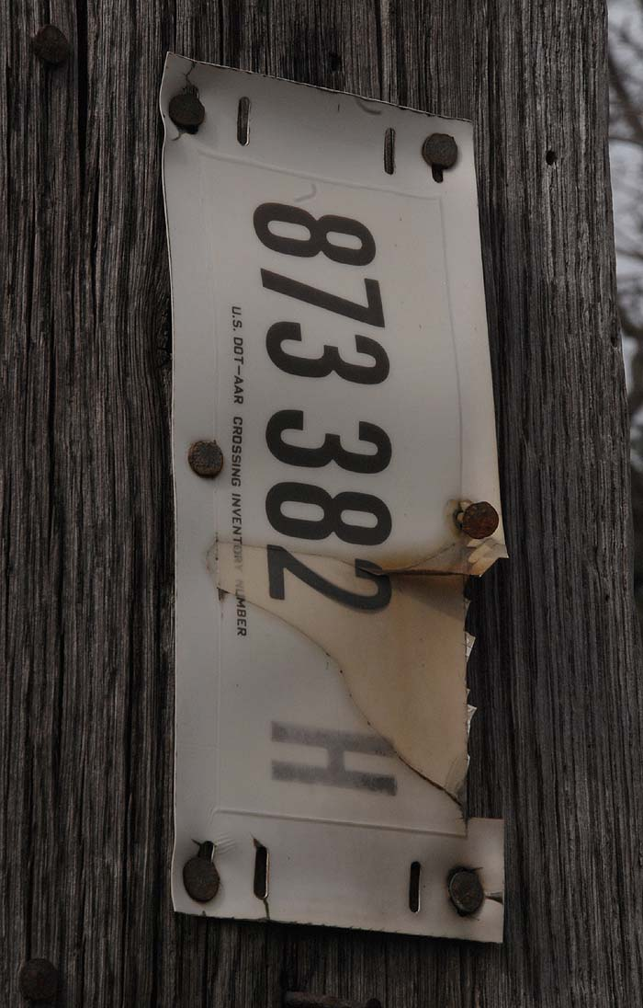

Here’s a link to follow up the AAR ID picture that Gene posted.
As I suspected they still carry the MRR crossing info even though they show no train activity.
At least they updated about 5 years ago, wonder if they maintain the info in the thoughts that it may be re-installed someday??
This particular number came right up in the search.

The same thing happens here in Ohio on our railroad.
Crossings that no longer exist are shown as active and we even have active ones that aren't on the AAR list and never have been. We are active in getting all our
crossings up to date with the Gov. agencies at this time.

Amazing how many crossings are on just one RR when you take a closer look.

Tim Sposato

http://safetydata.fra.dot.gov/officeofsafety/NewCrossing/Default.asp

9

There is an interesting item on ePay today from the Montour. They are called boxcar seal locks. Were these used to prevent theft of boxcar contents? How do they work? I've posted the link below.
Ken Caine
http://tinyurl.com/2hwxq7

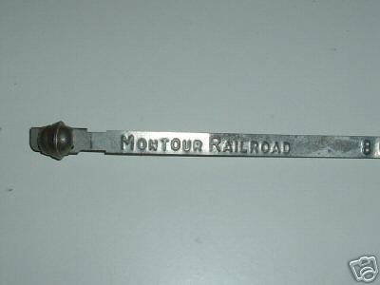

If you look closely, to the very right of the photo is numeral 8.
Car seals were early devices used in securing doors for cars carrying freight.
These seals once secured could not be opened or unlocked.
Upon destination they were simply cut off.
The numbers on the seals were added to the waybill so upon destination, the agent or special agent...or consignee could determine if the door(s) were opened during transit.
These seals were not great devices in securing doorways.
The metal used was thin and not terribly sturdy.
Usually each car had 2 seals with 2 different numbers.
Luckily I was able to preserve a handful of these seals... brand new ones at that...
as life on the Montour RR came to an end.

Gene P Schaeffer

10

Briggs & Turivas

Does anyone know what became of Briggs & Turivas?
I understand that they moved from Moon Twp to Dennison, Ohio - Tim's neck of the woods, sort of -

I have a 15 year old phone number that gives me a "checking on circuit trouble" message, and Google comes up empty as far as anything current.

Is B & T still around?
Does anyone have any contact info?
After Gene's posting about the bridge work they did on the Parkway West, I was trying to get in touch with them, to see if they had any photos of that event - or others that related to the Montour RR.

I remember passing their facility on the way to/from the airport in the 70's. I would always look to see what was going on in that yard. At the time, I thought the facility belonged to the railroad - I didn't know it was a separate business.
[in my younger and "not-so-wiser" days.....]

Was their move a result of the MRR closing down, eliminating service to their facility?
Or, did they move earlier - thus taking another piece of business away from the MRR?
How much movement/business did B&T generate for the MRR when they were operating?

Thanks

Bryan Seip

The B&T at Lotus shut down before the MRR closed, seems they had an on going employee issue at this location and the one in Dennison, Ohio.
The decision to close the Pa. facility was made on account of this issue and the decline of rail equipment business in the late 1970's.

The Dennison site was on the former PRR division point that was down graded after the end of steam.
The work was sent to Conway or Columbus and by the late sixties it was sold off to B&T.
Most of the buildings were already gone or in bad repair, a portion of the roundhouse remained and this was the primary indoor shop for B&T.
Some time in the early 70's, a strike saw much damage to the facilities including the torching of the roundhouse.
B&T managed to survive through this by downsizing and consolidation to Ohio.

They did make out well with the Pa site sale, the developers saw to that.
Most equipment was scrapped on site, the only major piece shipped to Dennison was the red-white-blue, bicentennial crane.
11
This crane was the mainstay until MRR X-1 was purchased in the early 80's and both worked the yard until 1988.
At that time we started the Ohio Central and I had the opportunity to see them both in action, but by the end of that year the Bicentennial crane broke down for good.
She was scrapped and X-1 loaded her remains in gondolas.

The engine was removed to replace the aging X-1 engine which ran another couple of years until B&T shut down.
They had an inventory sale and we purchased mucho freight car parts.
The complex was then sold to a local fabricator company who tried to repair railcars for about 8 years, but once again, the business was gone with the new AAR & FRA regulations on older equipment repairs.

They in turn moved their business to another location and prospered. The remaining railcars were scrapped on site including about 75 P&LE hoppers that had been purchased by the defunct Sharon Steel Corp.

When they had the equipment sale, we once again purchased large amounts of freight car parts and the X-1.

The property was purchased by the city and is developing into an industrial park complex.

The last office of B&T was located in downtown Dennison and has long closed up.
Most records (older) were destroyed during the labor problems and the remaining ones have
disappeared.
I know the last general manager pretty well and he cannot even account for them.
I still have been looking, hoping to locate something of interest.

Tim Sposato

An added notation concerning the Bicentennial Crane.
3 Montour crews were required to deliver the B&T crane to the interchange at McDonald.
Was it the crane kept derailing on McDonald Transfer and had to be returned to Lotus each time for repair before the 3rd and final attempt was successful?
Was side bearing clearance the problem?

Today while talking with a long retired Montour RR Trainman, I brought up B&T's Bicentennial Crane and the problems the Montour had in moving the crane to McDonald.
I was told the crane developed a Hotbox enroute to McDonald.

Perhaps Tim's memory can detail what exactly occurred in moving that red-white and blue machine to McDonald!

Gene P Schaeffer

12
I do recall the trouble with the B&T crane, The hotbox was one issue, the second was defective brakes. It was moved back to B&T with the brakes cut out and they in turn put a fresh set of valves back on.
The hotbox came first if memory serves correctly. By the third try it was able to make the trip west over the Panhandle to Dennison.
I added two albums to the photo section for the X-1 crane.
One album is for photos of her as she looks today, the second one is of shots of her on the MRR. I plan to add more pictures at a later date.
Meanwhile feel free to add some of your own pictures to the albums.
Tim Sposato

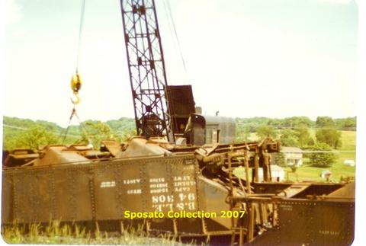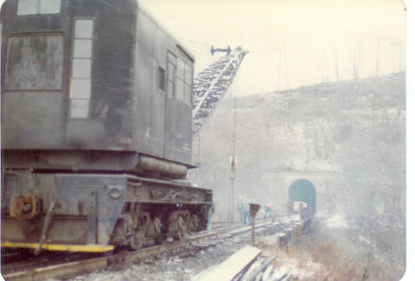

X-1 crane in 1970’s X-1 in action 1974

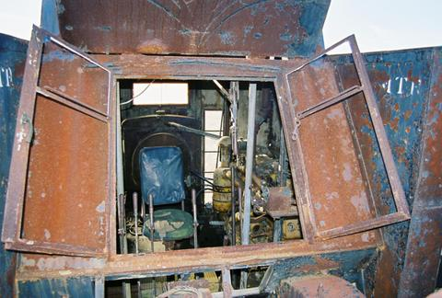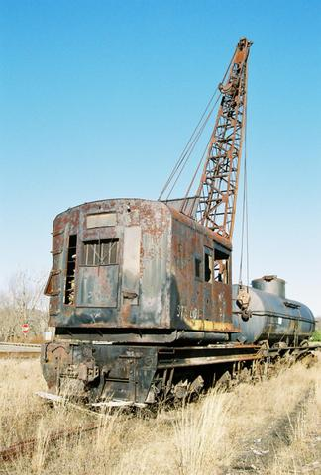

X-1 Cab view 2007 X-1 in 2007
Tim,
No outriggers? How'd they lift anything with the boom angle less than 90 degrees?
I didn't see any counterweights either. Did they clamp the darn thing to the track, or what?

Bob Ciminel

B&T was home to several locomotive tenders and wooden troop cars in the early 1970's also. They were scattered about the other rail equipment along with several wooden MRR cabooses. I do recall the cabooses were torched about 1974.
I saw the twisted steel remains of two of them about that time. I swear I have some pictures of the above equipment, but just haven't located them yet.
Where’s that secretary I keep wishing for !!!!

Tim Sposato

B&T at Lotus was one of those neat places I kick myself for only visiting a few times.
Lots of neat equipment...
Centercab Whitcomb engines, URR and NP cabooses,hoppers, tank cars and former WM gondolas.
You all may remember my photos of a former WM gondola that was cut in half and was being converted into 2 mill gons.
Old hoppers also going into mill service.
If memory serves me, Wheeling-Pittsburgh Steel was customer for the hoppers and gons.

I guess the employees cut old box cars in half and made personal garages out of them.
Remember the balloon track adjacent to the Parkway with all the old tank cars.

Not only do I have some neat color images of the above equipment, I have some old 8mm color movies of B&T.

And lastly, some day I will have printed some of the black & white images I have of B&T taken in the 1960's.
Several different views from several different angles of the facility.

Gene P Schaeffer

65ton Whitcombs?
I don't suppose any of these pictures are (or can make it) online?
Derrick Brashear
closet Whitcomb lover

14
I second the request for a shot of the Whitcomb. I remember seeing one of these engines years ago riding with my folks on the parkway.
For years I could only remember it was seen from a highway overpass. Your mention confirms it was the B&T site.
To further check my memory, it was a very dark colored sloped hood engine.
Thanks,
Brian Budeit

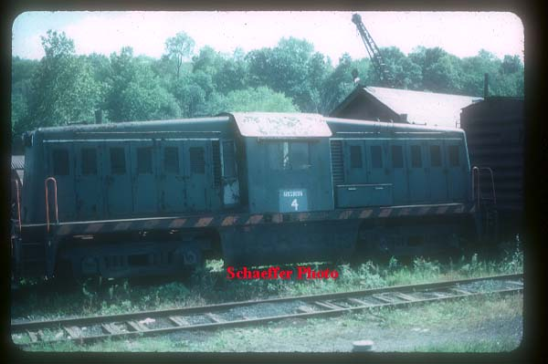

Attached is the centercab at B&T...October 1975.
What can you tell us about her?

Gene P Schaeffer

Man, that is one ugly locomotive! No wonder it went to B&T.

Bob Ciminel

15
Bah!
Allegheny&South Side, Union, P&OV and others had them. One that worked in the USS nail? factory in Benwood WV survives outside the plant there, in the shadow of the abandoned Bellaire toll bridge.
Another was seen at Deitch (now Azcon) in 1976 because it had bicentennial paint there.
I'd love to know the heritage, I haven't figured out where the AYSS 100 went.

Derrick Brashear

I'm thinking MonCon - J&L Steels Railroad. Probably was delivered to the P&LE if correct.
P&LE transported it to Montour Junction. The Montour delivered it to B&T..
Just a guess though.

Gene P Schaeffer

I haven't found any evidence of a MonConn Whitcomb (65 ton; the narrow gauge in plant may have had some but Jack Polaritz's picture is ostensibly a Porter)

Derrick Brashear

My point is: If they replaced a steam locomotive with this "which way is forward?" contraption, somebody should've been taken out and shot! BTW, the Cheswick and Harmar RR had one of these - not the identical model, but twin-engined - to haul coal from Harwick Mine to Duquesne Light's Colfax power plant in Cheswick. It was so slow that even a fifth-grader like me could hop it. Here's a picture of it.

Bob Ciminel

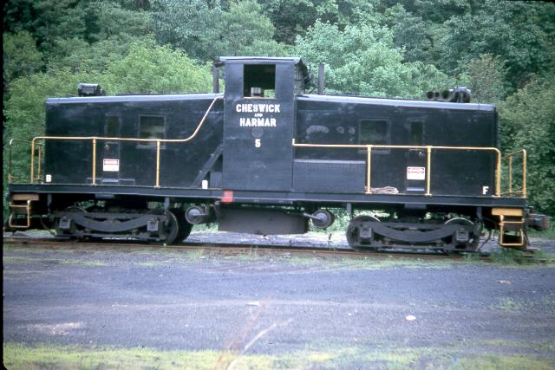

16
Not even the same builder. It was a Westinghouse. The Short lines of PA 2 book color series from Morning Sun covered it.

Derrick Brashear

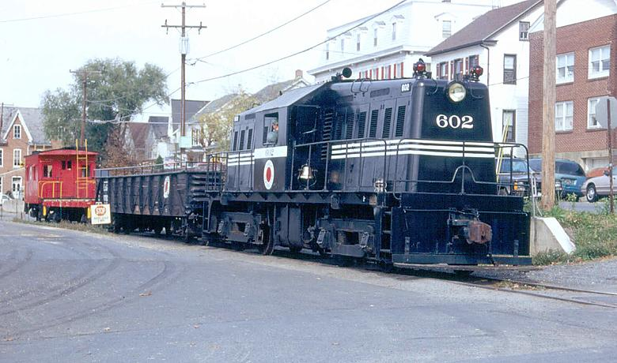

Here is another similar looking Whitcomb to the B&T loco

Wanamaker, Kempton & Southern 70DE26 70T [LNE livery] #602, nee USA 8467, [65DE19a rblt 1947], ex Gulf Oil 7, blt 1944 cn60473
Photo by Randall C. Kotuby

For those Whitcomb fans - [closet & otherwise]
If you don't already have it, here is a link to a bunch of Whitcomb pics.

http://www.northeast.railfan.net/diesel134.html

There are 18 60-Ton Whitcombs and 1 70-Ton that look like the B&T loco Gene gave us.
None include B&T as a former owner - hard to tell where that one went.

I guess beauty is in the eye of the beholder.

Bryan Seip

17
Gene,
Thanks for digging out the Whitcomb shot. Just as gloomy as I remember it.
The odd look of the Whitcomb can be attributed to its being an Army design, or at least built to army specs.
Equipment intended for use overseas was and is built for the very restrictive clearances encountered in Europe and the middle east. Thats why the Whitcomb has the low cab with the almost pagoda roof contour in it.
Most army equipment, from Pershing class 2-8-0's to the ww 2 versions, to six axle Alco diesel units; they all have that hunkered down look; totally utilitarian, no thought to how it looks.
Bob,
Great shot of the C&H Westinghouse unit. This is a real "model t" of locomotives, being one of four built around 1935.
The C&H used two of the four, although not at the same time.
Shame this early engine wasn't preserved.
The Pa Trolley Museum has a box cab cousin from 1930, I think its the oldest operating diesel in US, but I'm no expert on diesels, nor want to be.
Thanks for the slightly off topic stuff,
Brian Budeit

Just to chime in here....

As a trolley museum volunteer I can verify that yes, the diesel referred to was built in 1930. It's number B-73, and spent its career at the Armco steel plant in Butler. We occasionally use it to shift our standard-gauge collection around, as well as to push/pull our Monongahela Railway cabosse when we offer caboose rides.

Since it produces the same 600-volt direct current that we use to run the streetcars, it can come in handy as a back-up power source. We hook it up to the overhead, pull the traction motor cut-outs, and there you go....

Overall, a really neat machine.

Chris Walker

18
Thanks Chris,

Also the B-73 has dual operator controls, using a unique chain system under the floor to work the controls from either side of the cab.

When looking at this engine you can see the steam engine technology in its construction, very nice example of true first generation diesel.

Bob Jordan takes very good care of this loco and loves to show it off to anyone that wants the grand tour.
I highly recommend that you all should try to visit it and the Museum, don't forget the MRR motorcar shanty is there.

Tim Sposato

Back to B&T –
Gene - does your collection of 60's B&T photos include any of the bridge raising at their site? I know that was in the '50's.
I was planning to go over to the Carnegie Library & see if I could find something from the old newspapers, but if you already have something.......
Since you did not mention pictures in your other posting about the bridge, I take it that you probably do not have any of that event.

Does anyone know when that bridge was erected? That section of the Penn-Lincoln Parkway was opened in 1954 - I am assuming the bridge was '53 or '54.

Bryan Seip

No, nothing in the collection of the erection of the Parkway, however there is fantastic coverage of the right of way from Beaver Grade Road to B&T, with one scene of a Euclid that tore up the main track complete with F.C.R. in the scene.
Starting at Beaver Grade, photos of the overpass being built, and a real interesting item, the Passenger Shelter at Beaver Grade.
Then there is right of way scenes up to and including the Scott Farm.
Some fantastic images of the Scott Farm & Barn showing the crossing...with scenes looking both ways.
Then, peaked hoppers in Scott Siding...and another scene of flat cars in Scotts...
Scenes looking down from the Parkway from above Wickes...
Then of course images of B&T.
Some real gems I'll tell you.

Gene P Schaeffer

19
There are shots in a book at the Carnegie from the PA Dept of Highways with building shots.
I'll have to see if it's still in the PA Department open stacks.
No clue if any B&T visible.

Derrick Brashear

Thanks, Gene

I will look forward to any of those images when you get a chance.

I will continue in the quest to get any pictures of the bridge construction - especially if I can find the B&T cranes on the MRR. Not sure how soon I can get to Carnegie Library, [it's playoff time] but will pursue it.

Still looking for a better time frame, if anyone knows. I am guessing 1953 or '54??

Bryan Seip

20

