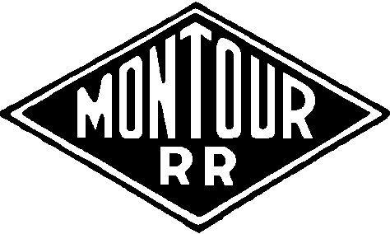

A Discussion Group

Table of Contents

I have grouped the stories under these general topics.

3 History of the Montour Railroad
7 Safety First
10 Champion Coal Preparation Plant
26 Living in Muse
30 Operations
55 Tunnels
58 Montour #4
70 Library Junction
76 Montour #10
87 Personal Stories
96 If Mom Ever Knew…..
112 A Tip of the Cap
115 More Stories

Try using your page down / page up keys to navigate through this document.
All the stories included here came from the group postings. All I did was re-sort them into a different order.
I was not trying to write a book – although it looks like that is the way it turned out.
Enjoy!

Bryan Seip 3/5/07
History

Montour Railroad

Reporting marks | MTR
Locale | Coraopolis, Pennsylvania to Imperial, Pennsylvania and West Mifflin, Pennsylvania
Dates of operation | 1877 – 1984
Track gauge | 4 ft 8½ in (1435 mm) (standard gauge)
Headquarters | Coraopolis, Pennsylvania
Montour Railroad (AAR reporting mark MTR) is a former short line railroad company operating passenger and freight service on standard gauge track in southwestern Pennsylvania. At its height in the 1930s, the railroad served 27 mines transporting nearly seven million tons of coal annually in Allegheny and Washington Counties.
The Montour Railroad Company was chartered in 1877 as a wholly owed subsidiary of the Imperial Coal Company. The first segment constructed extended from the Pittsburgh and Lake Erie Railroad line at Montour Junction, near Coraopolis, Pennsylvania to the Imperial Coal Company mines at Imperial, Pennsylvania. In 1901, the Pittsburgh Coal Company assumed control of the railroad. A major expansion, known as the Montour Extension, was undertaken in 1912 to reach new coal mines and factories. By 1917, the town of West Mifflin, Pennsylvania on the Monongahela River was reached. The Montour Railroad became an important feeder line and eventually all five major truck carriers in the southwestern Pennsylvania market were linked to the Montour Railroad. In 1946 the Pittsburgh Coal Company sold the Montour Railroad to the Pennsylvania Railroad and the Pittsburgh and Lake Erie Railroad (a subsidiary of the New York Central Railroad), who operated it jointly. The P&LE acquired sole control of the Montour Railroad in 1975.
The railroad's engine houses and shops were located at Montour Junction, near the Ohio River at Coraopolis, Pennsylvania. The Montour Railroad had passenger service in its early years from 15 stations along its route, but passenger service was abandoned by the mid 1920s. By the 1950s, most of the coal mines the Montour serviced had been worked out and the Montour began a slow decline. The Montour Railroad was down to just 23 miles of track between Montour Junction and Gilmore Junction when operations ceased in 1984 with the closing of the Westland Coal mine, the Montour’s last remaining major customer. In the 1990's large portions of the rights of way were acquired by the Montour Trail Council in a "rails to trails" program.

Keep in mind that one of the reasons the Pittsburgh Coal Company built the Montour Extension and, in particular, the Westland Branch was to avoid having to pay the confiscatory freight rates the PRR was charging the coal company. Once the extension was built, they opened the Hills shaft in 1914 and began shipping on the Montour. The Westland Branch captured the coal traffic that had been going out on the PRR Chartiers Branch from the Midland Mine.

Bob Ciminel

This is an excerpt from "History of Allegheny County," by Thomas Cushing, published by A. Warner & Co., of Chicago in 1889.
"The village of Imperial was laid out by the Imperial Coal Company. Prior to that, this site was the farm of Robert Wilson. The population is largely composed of miners and their families, and numbers about six hundred. Most of the houses are owned by the company. The town is superior in some respects to ordinary mining villages.
The company now operates three mines - two on Montour's run, in North Fayette Township, and one at Bower Hill, on the Pan Handle road. The two first named are operated by wire-rope haulage. The daily output of the three mines is one thousand tons. The company operates coke-works on the line of the Montour railroad, near Montour junction. There are 102 ovens here, and a coke-crusher, for preparing domestic coke, has recently been added.
The Montour railroad, though a distinct organization, is under the control of this company. Four hundred men are employed in the mines of the company, at the coke-ovens and on the railroad. The officers of the company are U. A. Andrews, president of the Imperial Coal company; William McCreery, of the railroad, and F. L. Shellenberger, superintendent of both."

In 2005, Gene Schaeffer writes: Today, enroute home from a day of railroading in the State of Ohio, I followed the Montour from the Washington/Allegheny County line at Champion, east through McDonald, Primrose, Peacock, Southview, Gilmore Junction, Cowden, past Montour #4 then up through Thompsonville and on home.
Exiting Route 22 at the McDonald/980 exit, I saw new concrete overpass pillars just west of the 980 exit. These pillars are part of the Airport connector expressway.
At McDonald Viaduct, a new waste water treatment plant has been built occupying the field adjacent to Montour's former McDonald Transfer trackage at Noblestown Road crossing.
At Peacock, the vegetation is so dense you can no longer see the right of way from the road.
At Venice, the open wound from the missing Venice Bridge at the Rt 50/980 junction is nothing more than a scar to me.
In Cecil, at the Muse-Bishop Road, the concrete tunnel has been removed and replaced by an overhead bridge.
I remember a time in 1976 when a coal train derailment had 2 open top hoppers over the side of the hill.
At Montour #4, a townhouse type structure has been built where the tipple once stood.
Then up at Rocky Ridge, east of Library Junction, new homes are being built in the valley that once had a wonderful panorama of the main track from McMurray Road.
Acre by acre, the property surrounding the Montour right of way is being developed and the picturesque environment of farms of long ago is dwindling, erasing the Montour that I once knew.
Safety First

May 5, 1949.....7:45am
Terminal Foreman Snead.
While walking westward from the boiler room to terminal foreman's office, hostler started to move engine 27 off shop track, just as I was passing cylinder, left side, steam from cylinder cocks blew loose sand and cinders into my face, embedding several particles in right eye.
No time lost. Went to Dr.J.Edgar Kent, Coverdale Pa.
Release sent to GCH 5-5-49.
Which is why we wear safety glasses with side shields today.

I tell our new brakemen/conductors that every rule in the rulebook is there because someone was killed or injured by doing just the thing the rule says not to do. The latest change on our railroad was a prohibition against rolling cars to spot them. We had a track worker lose his right arm when he fell in front of a ballast hopper he was repositioning.
Tim Sposato

Parker Plastics and the derailment...early 1990's...
I was at the Gas Company Crossing when the coal train crept off the Mifflin Branch.
After the 5 locomotives passed, I drove down 88 to Castle Shannon to watch him cross the bridge.
After waiting at Castle Shannon for about 15 minutes, fire sirens were heard in Bethel Park.
But no coal train...

So I drove back up 88 to see fire trucks ... and the stopped coal train.
I think there was 125 loads of coal in that train...

And turning up Valley Drive, there in the Parker Plastics parking lot was an upside down coal hopper.
Bethel Park Firemen were all over the place...
I still don't know exactly what all those firemen were going to do at the coal train derailment...
And they had the nerve to question me...about being there...

There were 3 firemen sitting on the destroyed roadbed right next to an upset coal hopper.
As one of the fireman grilled me about being there...
In my typical fashion I stood my ground as I told him he needs to worry about his own people...
With his dumbfounded stare...
I showed him that where his people are sitting, is right next to a derailed car truck that is standing on end...
And I asked him to show me what is holding that one set of railroad wheels in place...
Yes, the set of wheels that is dislodged from the truck frame...
Yes, the same set that has no wedges or brake rigging in place that might hold it in place...
Yes, the same set of wheels that seemingly at any second could simply drop to the ground and crush his resting firemen who were directly underneath...
Quickly, 3 firemen scattered...
And I continued taking photos...

Then I became a witness for the engineer who was accused of speeding.
The engineer asked me to vouch to management when he came across the crossing, as to what speed he was doing...

Management didn't believe a 3 foot section of ball of rail broke and allowed coal hoppers to begin derailing...
The Sperry Car tested this same rail about a week before...
After the tapes were pulled from the SD-45's...speed was around 7 MPH, I believe...
And a broken ball of rail was found guilty...
And Sperry Rail service was called on the carpet, from what I was told, as to how this rail escaped detection...

Ahhh, this is railroading at its finest...

Gene Schaeffer

Champion Coal Preparation Plant

In 1964, CONSOL coal celebrated its 100th anniversary and published a brochure on the modernization it undertook at Champion. Gene Schaeffer was kind enough to send me one of those brochures, which I will someday scan and post in the files section. In the meantime, here's what CONSOL had to say about the "new" Champion Prep Plant.
Enjoy,
Bob Ciminel
"LOCATION
Situated a short distance Southwest of Pittsburgh, Pennsylvania, the modern Champion Preparation Plant is strategically located in the heart of Consolidation Coal Company properties. Established coal reserves in the area total over 130 million tons including the
combined tonnage of 56 million tons of Montour #4 and Montour #10.
Available, also, are other substantial coal properties which have not yet been designated as reserves. Consolidation Coal Company existing and future properties are Champion customers' assurance of a continuous supply of fuel far into the future.
Three different methods of transportation are readily available to ship the 13,000-ton daily capacity from this modern facility. The Ohio, Monongahela and Allegheny rivers offer economical and convenient barge service to destinations near and far. The area is
served by six railroads with trunk line interconnections that can reach virtually any rail-served point in the country. The railroad companies are: Montour, Baltimore & Ohio, Pennsylvania, Bessemer & Lake Erie, Pittsburgh & West Virginia and Pittsburgh & Lake Erie.
Primary highways and the Pennsylvania Turnpike are easily accessible from Champion Plant to provide truck delivery to customers not accommodated by river or rail transportation."

"DAILY CAPACITY: 13,000 TONS
Strategically located in the famous Pittsburgh Seam, Consolidation Coal Company's Champion Preparation Plant has long been famous for its high quality products. Since the plant was originally built in 1928, rigid quality control measures always have assured chemical and physical analyses to suit the many and varied types of burning equipment.
As demands increased and burning equipment changed through the years, Champion Plant was enlarged and renovated several times to keep abreast of these developments.
Once more, progress in coal burning equipment and transportation methods have necessitated change. And, again, Champion has modernized to meet the challenge. Recently, Champion Preparation facilities were completely renovated and equipped with the most modern coal processing machinery available. Champion Coal customers now receive the finest prepared coal available at the rate of 13,000 tons a day."
"WASHING, SIZING, DRYING, ANALYZING
Champion coal undergoes exacting care. From the time it rolls from the rotary dumpers until it reaches its ultimate destination, the very latest crushing, washing, sizing, drying and analyzing equipment meticulously process high quality coal for a variety of uses. The plant employs "prescription" loading to assure customers of exactly the right specifications and dimensions to meet their needs. Available are the following coal sizes: 8", 4", 1.25", 1/2" and 5/16". Special services such as freeze-proofing and oil-treating are offered customers requiring them."
"IN-PLANT TRANSPORTATION
A network of conveyors quickly and efficiently shuttle coals of different specifications from one processing sequence to another and eventually to loading facilities. Standby equipment is ready to go into operation immediately in the event of a failure to assure a continuous flow to truck, train, barge or storage. This efficient in-plant transportation system is necessary to insure the annual production of 3,000,000 tons on which Champion's hundreds of customers depend."

Usually twice a week during the late 1970's the Montour loaded 2 sets of CONSOL hoppers at Champion Preparation Plant.
One of the sets was the 4000 series CONSOL gondolas carrying GSCX reporting marks.
The 2nd set was the 11000 series GSCX hoppers.
These two car sets typically ran at about 75 cars but not always all GSCX cars. Usually there were 5 or 10 or so CONRAIL system hoppers in these "unit" trains, which were 100 ton cars to fill out the needed tonnage.
These unit trains came empty off CONRAIL at McDonald and went straight to the preparation plant for loading.
Usually the 2nd Champion would get 3 SW-9's and would take the loads back to McDonald just as soon as half the train was loaded.
At one time the Montour was given an AEPX empty hopper train to load, which was all 100 tons hoppers with rotary couplers and loaded just as the GSCX train.
These unit trains were given priority at Champion Preparation Plant in loading.
The Montour from time to time loaded unit trains for BOW in New Hampshire also.

Gene P Schaeffer

Montour #10 and maybe half of the coal loaded at Montour #4 was "met" (metallurgical) coal.
When coal arrived Champion from Montour #10 and Montour #4, a phone call to the plant was made, identifying car numbers for the met coal. The coal company kept track of met coal and the cars in which it was loaded. The coal company made more $$$$$ on met coal shipments.
Also for a while, around 1981, Westland was loading met coal. Unfortunately, that didn't last, as its quality was not where it needed to be and isolating met coal coming out of Westland was quickly forgotten.

Gene Schaeffer

Back in the early '50's Champion had a rotary dumper. They would dump the hoppers, then let them coast down the grade into the yard. I remember my grandfather showing me the rotary dumper, then we rode a couple of hopper cars down into the yard.

Bill Bigler

Coal was unloaded one car at a time. Each car was uncoupled, then turned upside down.
In the winter, sometimes coal would be frozen in the cars. Unless it was slow at Champion, frozen coal was moved to sidings and stored until spring. If it was slow, 5 or 10 cars of frozen coal would be spotted on the 10 car dump track allowing the heaters to thaw the coal. Usually this process burned off paint and burned up air hoses.

Gene P Schaeffer

The rotary dumper was a great invention as compared to unloading through hopper pockets. Cars empty quicker and 100% of the load will be discharged in good weather conditions. Champion use track heaters to get the car body to radiate heat quickly and then it would immediately be dropped into the dumper for the roll-over.

The heating caused damage that Gene mentioned and also, at times, the car droppers would spot the trucks on the heaters. This would cause the friction bearing boxes on the older shuttle cars to ignite. Now, if the journal boxes survived the heaters, they would then be emptied of the journal oil as the car turned upside down.

Although I always enjoyed the dumping process anytime of the year, winter would prove to be the hardest. Even though the mines would spray calcium with the coal during loading, the coverage was not always thorough and coal would freeze. As the car dumped, very large chunks of frozen coal would fall in the pit and just roll around on the belts. The dumper crew would turn on the high pressure water gun that was mounted by the pit and slice through those chunks.

I got to "cut coal" a few times using the gun. It was amazing to see how that thin steam of water was capable of doing the job. The pump created a pressure, if I recall correctly, of about 7500 psi. The stream was about ¾ inch diameter. They did demonstrate it cutting a 2 x 6 in half for me one time. The gun would only aim downward for safety.

Just below the dumper was a wooden caboose body mounted on a railroad tie foundation. This was a retired Montour hack that was now used at the car repair shop/office. The car knocker would inspect all the cars coming off the dumper hill for those burnt hoses, add oil to the journals, repack journals with fresh journal pads, look for off-center cars from hard couplings and any other defect. He would repair or tag the car to be sent to the MRR Jct car shops for heavier repairs. Champion Yard would produce several shop cars per day. It could be a tough place on equipment.

Run-aways, would always be a time of excitement. The droppers would actuate a siren if one occurred. Numerous times while working the yard office I would hear the siren. A quick jump up to the window to see what was coming down the hill. I would holler to the yard crew, if they were in the crew room and we all would stand out front to watch the car or cars hit the runaway track. If the track was empty the dirt embankment would muffle the impact. I enjoyed if there was a car already in the bank from a previous incident. The hollow booming metal sound of those hoppers coming together are unique to their own, not to mention them trying to climb the bank into the driveway.

Boy the potential for disaster was ever present in that configuration!!

Tim Sposato

I've attached a photo of the rotary dumper used at Champion. The photo was taken in 1945-46 by P&LE.
Bob Ciminel

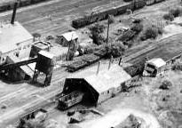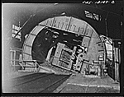

On the very right is the shanty for the rotary dump employees, an electric heater, a bench...and lots of reading material...dirt floor.
The cable and winch were used to pull cuts of coal into the dumper, if the car dropper stopped short.
Once the car was emptied, it was kicked out of the dump and away from the camera by another loaded car coming in for dumping.
The preparation plant itself would be on the right.
Champion Yard Office would be in front of you, about 25 or so car lengths away.
The Old & New Tracks would be behind the camera.
On top of the hopper was a clamp type device, that was lowered by cable when each car was turned over for dumping. It held the car stationary while upside down.

On the very left of the hopper, the hopper laid itself up against a wall made of wood.
I can't tell you how many times I stood here and watched hoppers being dumped.
Between the winch and the shanty, there was a walkway that took you overtop of the dump where all of the coal went. I often stood on the walkway watching hopper after hopper being emptied and seeing the coal being fed into the Preparation Plant underneath.
I remember how lucky the coal company was when a car dropper was bringing in the Old Track for dumping one snowy winter’s night. The Old Track held 16 cars. Those 70 ton hoppers got away from the car dropper.
All 16 loads passed through the rotary dump at maybe 5 or 10 MPH, coupling into 4 empty hoppers on the opposite side of the rotary dump...
Then everything came down the empty hill...out of control, and into the Run-A-Way they went.
The 4 empty hoppers jackknifed all over the place. A few of the loads derailed.
The coal company was lucky that the rotary dump was in position for the loads to pass through.
What a mess it would have made if the dumper was turned over when the loads ran-a-way.

Gene Schaeffer
The coal freezing inside the hoppers is still a problem today. However, there are some tricks they use. An anti-freeze solution is added to the coal when it's loaded at the mine. Another way of dealing with this is to heat the outside of the car with torches. Today's aluminum hoppers can't take the torch method and other equipment is used to heat up the side to, but not exceeding 250 degrees. I think using dynamite would be fun to watch.

Kurt Anderson

If you thing frozen coal was a problem, pity the poor sand house worker.
When I was there, the top of the sand storage was open and the sand would freeze solid.
It was then necessary to use a pick to break it up.
Foot note--we would fill burlap sacks with this sand and carry it in our car trunks. Good for ballast and if stuck under the wheels.
Does any one else remember doing this?

Carter Roth

We didn't mention, in the dumping process, down inside the cavity of the rotary dump were large (perhaps 12 inch) steel poles that covered the cavity to the conveyor and were spaced so large clumps of coal would be broken before reaching the conveyor. If those clumps didn't break up at that point, Tim mentioned the follow up process to break down the larger clumps of coal.

On occasion, knuckle pins, knuckles, brake shoes, anything not secured to the car that could come out, would fall off and would end up inside the dump.
If these large steel items weren't caught in time, damage inside the plant would occur resulting in down time for repairs.

The empty hill Tim and I have been talking about was a "live" track.
Technically, the empty hill was not a track a car inspector was permitted to make repairs on, unless he shut down the rotary dump. The Montour Car Knocker was only supposed to make visual inspections of cars coming out of the dump.
The dumping process occurred every few minutes.
Empty cars were constantly coming out of the dump and unless there was a real problem...perhaps a car off center...or brake rigging down...
The car inspector was not permitted to be in or under railroad cars while on the empty hill.

The empty hill also had retarders. I never seen the old one used nor after rebuilding of the empty hill and shove up, a new car retarder was installed on the empty hill, but for what ever reason, it also was never used.
Car retarders would of prevented/saved the coal company time and money in the event railroad cars coming out of the dump didn't have operative hand brakes. If the brakes didn't work, the car or cars would/could run away and into the empty hill they went often resulting in damage.

In bad weather, both rain and snow, empty cars would slide on wet or snowy rail. The empty hill was steep and if several hand brakes weren't applied, away they would go into the run-a-way. Car droppers often sanded the empty hill rail by hand when the weather was wet or snowy.

As Tim and I mentioned, run-a-ways were an ever present danger at Champion. The entire operation was built on grade so coal company car droppers could spot cars by gravity using hand brakes. In addition to the empty hill, I remember one Monday morning, working daylight Yardmaster.

The shove-up track had about 25 or 30 coal for dumping on it. The 1st Champion crew had a single P&LE SW-1500 which was often left at the west corner of the Yard Office when the crew was caught up, as the crew took a break.
The shove up had 1 dirt driveway crossing, and 1 walkway crossing that needed kept open at all times. On this particular morning, the stop off coal on the shove up track stretched down near the run-a-way track which was only a few car lengths from the Montour RR Yard Office.

The Champion Job had just pulled the empty hill, and one of the brakeman had removed the d-rail from the shove up as they were going to shove it up for dumping in about half hour after pulling the empty hill.

The Champion job had switched the empty hill, and took a short break, leaving the P&LE engine in its typical spot near the west corner of the Yard Office.
A few minutes had gone by when I heard a gigantic bang. Thinking it was an empty hill run-a-way, and not being able to see the dump from the office because the shove up was blocking the view, I started to walk to the office window to look and see if I could observe what the bang was all about.

At that very moment, I heard that familiar sound of flanges of loaded hoppers biting rail head. The Champion Job wasn't shoving coal to the hill as that sound is so familiar from the office when coal loads start through the curve, over the empty hill switch, and on up the shove up.

At that very moment, in complete disbelief, the stop off coal on the shove-up came rolling down the shove-up all by themselves accompanied by that ever familiar sound of flanges biting rail head as the run-a-way cars started past the Yard Office, Westbound.

The 1st Champion Job Engineer on this date was a P&LE Man, Jim Davis.
Jim came running out of the Trainman’s side of the Yard Office trying to get on his SW-1500 before the run-a-way loads struck the engine.
The loads weren't running fast, but they were on the move...and they were moving on their own.
Jim mounted the SW-1500 and inside a second I could hear the independent releasing and the throttle advanced just as the loads struck the SW-1500.

I don't remember exactly how many loads came off the shove-up that morning on their own, but it’s safe to say there was at least 20 cars loads of coal that struck that P&LE SW-1500 with a vengence.

After the run-a-way stopped, inspection of the SW-1500 revealed its drawbar on the cab end was driven through and out of its pocket underneath the locomotive frame.
Yes, that SW-1500 was now Out of Service.
I don't remember if the brakeman removing the d-rail was acceptable at that point, because if he would have left it applied, chances are several of those loads would of d-railed and probably tore out the shove-up/empty hill switch, and perhaps laid a few of those loads over on their side right there at the Yard Office !

Over the years, there were all types of run-a-ways at Champion. At the east end of Champion in 1976 a train of B&LE hoppers ran-a-way at the East End destroying about 6 of them. In 1979 another train of coal left on the Runner, ran-a-way early one Monday morning as the First Coal Run was going down the main along side of it and reported it moving.

In the empty yard one rainy night, on #2 track, I was helping the 3rd Champion do their work. They spotted about 5 empties on the empty yard lead, and I dropped them down to the d-rail for them and the car dropper.
#2 was out of empties and the shipper kept telephoning, he needed empty hoppers on #2...
And they needed to be clean. So after finding 5 clean "o.k." hoppers for #2 coming off the empty hill, I had the 3rd Champion switch these 5 in.
Funny, with 2 working hand brakes and 5 empty 70 ton hoppers, on very wet rail, those 2 working hand brakes could NOT slow those other 3, and away I went with all 5, right over #2 empty yard track d-rail. The stop was so soft, smooth and gentle. BUT, the east truck was now completely off the rail.

The 3rd Champion Conductor was great. After working the loaded yard, we went down into #2, and that errant d-railed truck, with just a couple wood blocks came back up on the rail with little fanfare.
Since it was a Yard Master error, no accident report was completed and no 2 hour arbitrary was turned in by the crew.

Back to the Champion Car Inspector, cars with defects would be shopped as Tim mentioned.
Many were tagged Montour Shop, but as time progressed, many P&LE cars were tagged Return and were sent to McKees Rocks for repairs. There were now 2 different types of shop tags being used at Champion, Montour Home Shop tags and P&LE Return tags. I'm guessing this also applied to foreign cars coming off the Union, PRR and B&O prior to 1976 if the defects were severe enough to require heavy repairs, they were sent home for repairs.

Gene Schaeffer

Conversation here recently was on Champion and some of the associated dangers that existed there.
Champion was built so coal company car droppers could, via gravity, spot cars for either unloading or loading.
The shove up to the Old & New tracks were on grade so when Montour crews spotted stop off coal, car droppers could bleed off the air brakes, then using hand brakes bring loads in on the dump track for un-loading.
The same went for the empty and loaded yards.
Montour crews would spot empties and car droppers would drop them under the tipple where a steel cable would be attached and using winches, cars could be regulated for loading via a coal company employee located
under the plant, where he could observe loading.

Montour had 2 long tracks at Champion that were used each and every day.
The Runner which held about 55 70-ton hoppers and the Siding that held about 57 hoppers.

The Runner in the last years of operation at Champion was in better shape than the Siding, so it would be used for loads. Clean coal coming from the plant, or stop off coal coming from the mine. Most often though, only on weekends would the Runner be used for stop off coal set offs.

Thus on a Saturday morning in September 1979, a westbound crew was instructed to set their train off on the Runner. I think that train was a 3 unit, 33 car train of coal.

Two mornings later, as the 1st Coal Run was passing through Champion, the crew reported to the Train Dispatcher the Runner was moving...and if there was a crew ahead of them...which being the first coal run, they were the only crew out and unless it was a very early Champion Yard crew, there were actually no other crews out.

Anyhow, this first road crew approached the East End Champion very cautiously.
Since the train of coal on the Runner was moving, it was expected the d-rail at the East End would d-rail the errant cars...as it did.

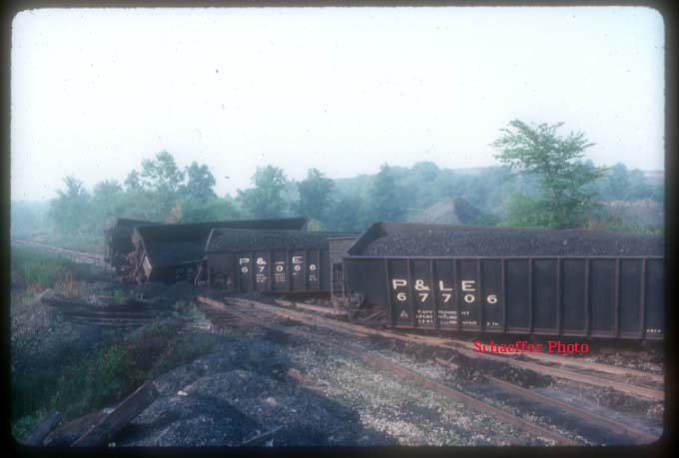

In this attached scene, P&LE 70 ton hoppers are jackknifed at the East End Champion after running away off the Runner. The First Coal Run was then instructed to shove back, to the West End Champion, and after the arrival of Superintendent J.E.S., they would head in the Runner and pull the rear of the train back.
I was lucky to arrive at Champion as all of this was being done. Daylight had arrived prior to the move and I have photos of the First Coal Run pulling the rear of the train back, then rerailing one of the derailed loads with Superintendent J.E.S. orchestrating....

Another moment in the daily life of the Montour Railroad Company

Gene P Schaeffer

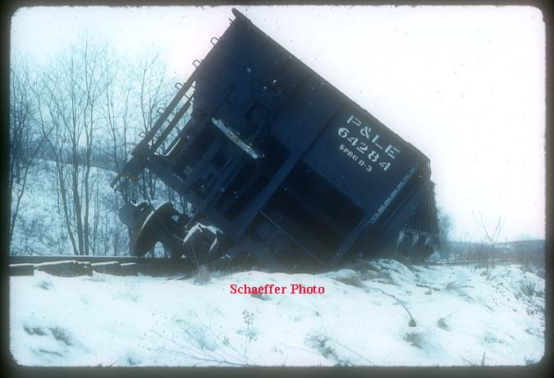

A unique perspective of an accident at the East End McAdams.
Stop off coal set off at McAdams early 1979, with one load over the derail.
I think this car sat like this for several weeks.
GENE P SCHEAFFER

Living in Muse
J Soma relates what it was like to be in a miner’s family at the village of Muse, where the mine was serviced by the Montour Railroad.
I was four years old when my family moved to the coal mining village of Muse, Pennsylvania during the depth of the depression of the 30's. My father was fortunate in getting a job with the H.C. Frick Coal Co. since there were many people unemployed at that time.
Only miners who had a job in the mine could live in Muse, because it was built for the miners only. The whole village was owned by the coal company, streets, red dog roads, company store, service station, everything, including their own private cops who had much more power than private security has today.
The village of Muse was situated on three hills with a baseball field in the middle of the valley, bordered by two orange creeks. These creeks flowed through the village killing everything they came in contact with. Nothing lived in that flowing mixture of sulfur and iron oxide. Most of the streams in western Pennsylvania were in the same condition. A large white house used by the mine superintendent, overlooked the ball field. You knew it was the boss's. The common miners’ houses were painted various shades of gray. A small shed, called a coal shanty was in the rear of the lot on the alley. It stored coal for cooking and heating. Outsiders commonly mistook them for out houses. Actually the village had one of the most modern sewage disposal plants in the whole area.
There were 150 gray duplex houses in the village for the working miners. Each side of the duplex contained four rooms. Only half of the basement was dug out. Most people dug the rest out by hand. There wasn't any furnace for central heating, since gas was not supplied to the homes. Coal hetrolas and coal cooking stoves were used to heat the house. No hot water. With a modern sewage disposal plant, they never installed bath tubs. Think about that. A commode was in the basement. Electricity was installed in the homes with one light bulb in the middle of the ceiling. There weren't any receptacles in the house. A 30 amp fuses were the only fuse in the fuse box. To operate an appliance, we would take the bulb out and installed a plug adapter. Most miners installed their own receptacles. The kitchen had a sink with a cold water spigot. A coal cooking stove was in the kitchen. Some time when things got a little tough and the electric wasn't paid, you would get your electric shut off. It happened to some of the miners.
Two large mine tipples stood out on top of the hills. One tipple was situated near the bath house so the miners could change into work clothes and go down the "cage", which the elevators were called, and get to the bottom of the mine to go to work. A string of empty coal cars, called a mantrip, were waiting on the bottom of the mine to take them to the working face further into the mine.
The second tipple was used to load coal into coal cars outside the mine. Railroad tracks were laid to this mine tipple. A coal burning steam engine pulled coal cars to and from the tipple. Waste products such as slate poor coal and other waste products were dumped all around the mine creating what was called a slate dump. It burned, smoked, smoldered and stunk up the town. It was also a hazard to the public, the granddaddy of all pollution. There were no pollution laws in those days.
Once a twelve year old boy died from the fumes after lying down on the dump trying to keep warm one winter and not knowing the dangers.
The large red building in the center of the town was the "company store". It was the only store in town. Prices were very high. You were under the impression that if you didn't buy there you might not be working there. They sold everything such as mine tools picks, shovels, large crowbars. augers, brass checks for blasting powder, hard hats, furniture, clothing, jewelry, guns, etc. They also gas and tires in the service station. They greased your car too.
There was one problem though. Nobody made any money in those days. Everything was sold on credit. It was deducted from your pay at the mine. A lot of paydays you got nothing. More was spent than made. In fact, most miners in those days were in the minus column after working for the coal company for a while. The company managed to do this by working you only one, two, or three times a week, keeping you broke. It didn't take long to go in the hole.
There was a curfew whistle that blew at 9:00 pm, and all the kid had to be off the streets. The company coal and iron police (company cops) would patrol the streets and if they were caught on the street, the kids dad would be called into the super's office. You can bet when he came home somebody would have a hard time sitting down.
Five o'clock was an important time in the life of the miner. That was when the whistle would blow if there was work tomorrow. No whistle, no work. Needless to say, they liked to hear the whistle. There weren't any drugstores, movies, swimming pools or restaurants, but some considered themselves lucky anyway. We had six bars, speakeasies, and etc. just across the village line. On pay day that that part of town looked like the wild west. Occasional gun fire could be heard.
As kids we walked to Canonsburg (three mile away) to go to the movies or swimming pool, if we could get a dime somewhere. Money was hard to get. There were five two room school buildings on the hill where the present school now stands. I helped to open it up in 1937. These building had a coal furnace in each room. The upper grade boys did the coal shoveling. It was kind of hard for the teachers in the lower grades. There were about forty students in each class. Some classes had two grades. Paddling? Sure. Some teachers were more generous then others. You remember the most generous ones the longest. Ink wells were built into the desk. You were issued replaceable pen points. It was really tough to write with that pen. No cafeteria. The rest rooms were out side. Nobody wasted any time there in the winter. We played street hockey with tin cans and sticks, soft ball with a home made rag ball, out door basketball, or just plain roaming the fields, picking apples, berries, choke cherries and nanny goat turds. Most everyone had to do chores. I spent a lot of time in the garden, weeding and planting. Firewood had to be gathered. Coal had to be picked on the slate dump put in burlap sacks, loaded in the wheelbarrow and pushed about a quarter of a mile home. It was real tough for a kid in the hot summer. We had to make sure we didn't run out of coal. That was called the good ole days.
J Soma

Operations

Some questions have been asked about operations on the Montour Railroad.

Servicing the mines was really a simple responsibility.
Every 8 hours, at the end of each shift, each "shipper" from each mine would telephone in the past 8 hours loading to the train dispatcher. A little homemade tablet divided up for Montour 4...Westland and #10 was maintained with each shift/mine's loadings along with an accurate "empty" hopper count.
The train dispatcher maintained this and was responsible in having crews called far enough in advance to move empties to the mine and remove the loads. I usually used a 6 hour window meaning it took a road job 6 hours from the time they went on duty at Montour Junction to the time they arrived at the mine...which usually was slightly overkill, but gave you the insurance from keeping the mine from either blocking up with loads or running out of empties.
The train dispatcher had to order empties from either the B&LE via the Union at Mifflin Junction (practice ended in 1975)... Chessie via Snowden...the P.R.R. via Hills Transfer or the P&LE.
Montours SW-9's were rated at about 1,100 tons per locomotive... reduced when raining or heavy snow.... and the typical locomotive consist was 4 SW-9's.
Brookside Lumber could be switched from the east or west...
But preferably eastbound crews was the proper method so crews could shove each move...westbound crews out of Mifflin or Salida had to "drop" loads into the spur which was dangerous for the locomotives had to speed up and runaway from the loads so they could line the switch into the spur... then back east and shove/spot the loads with the locomotives.

I've noticed the switch machines in all the postings were the manual type, were there any electric machines? On freezing cold days, I would think it's nearly impossible to free up the spring mechanism inside.
The company I used to work for made switch machines that had snow/ice melters inside to thaw up the mechanism under such circumstances..
Bill C.

No, the MTR had no electrically operated switches, all manual type. These were always cleaned and salted as soon as the snow was falling. In the fall months the section gangs would "crib out' between the ties on all the switches the length of the switch points.

The idea would that the snow would fall into the "crib" and not build up in the points. This did help some, but the switches still would require a brooming and salt, around the machine and points. We would also sweep out the frog and guard rails.

The ice problem was dealt with using the oxy/act torch for a quick meltdown.

I recall a few older kerosene heaters lying in the tool shanties, but never saw them in use.

Tim Sposato

The car shop was a great place, the department as you would have remembered was quite large at that time.
I only saw the scaled down version of the 70's.

Do you recall approximate number men of the different departments at the Jct when you were there? I understand the big layoffs occurred in the 50's, as the steam locos retired and the mines slowed up.

Were the shops still operating 3 shifts in 1957?

Thanks for your recollections
Tim Sposato

Tim S. Thank you for the kind reply. I'm not the writer that Gene is but sometimes I give it a try. In response to your questions, When I started work as a warehouse man there was myself, Clarence Thompson, [the boss] and Charles " CHICK" Lanagan and later a fellow by the name of John Chopp. Also I believe the purchasing agent was Bill Dugan. Gene knows Bill. There is a picture of Chick chapter 6 Genes book.

There was a fair amount of work in the shops but pretty sure only one shift. Our locker room was in the long bldg [page 48] as I remember not over crowded less than fifty.
By the time 1957 came around John Chopp was gone Chick was messenger boy and I was it for warehouse labor. Plus I was laid off from time to time. At this time I could have bumped to weightmaster but the thought of long cold nights alone with a string of coal cars did not sound like fun and at this time I thought the Montour was done for. Had I known it was to go on I would have stayed.

As a passing thought, the warehouse was located next to the two story bldg were Gene worked. To get material to the shops we had a push cart on rails that we shoved thru the machine shop, out the back door, then around the back in a big loop to the car shops. We delivered stuff like rivets, brake shoes, bolts, air brake parts, etc.
In the winter we had to break a trail thru the snow. With two men it was tough but with just me it was *&%$#. There is a picture of our cart in "THE BOOK" taken Jan third 1981. Just looking at that shot gives me chills, but this was what we worked in all day.

We had to put our lunches it the dispatcher’s bldg or they would freeze solid.

Today in Florida it will be in the 70's.
If anyone can tell why I'm moving back please do.

Stay warm.

Carter Roth

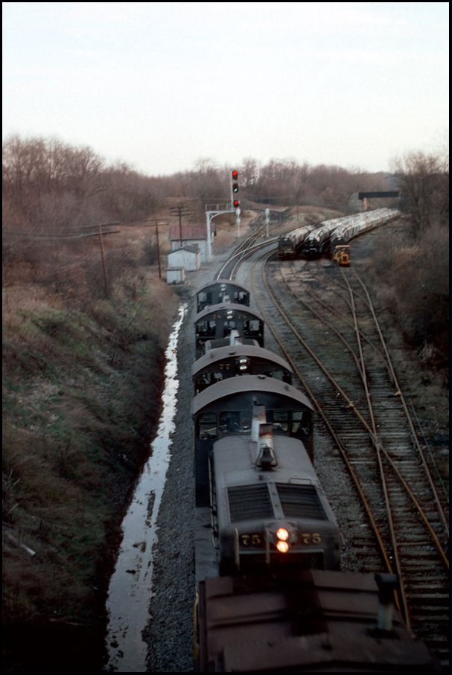
Ok, I see it all the time.
2, 3, and 4 engines all linked up together to pull extra large loads.
How is this done?
I realize that today these units are linked electronically to operate in sync with each other.
Was it done the same way in many of the Montour shots?
Was there only one operator for all of the linked units?
Thanks,
M

The MU cable has 27 pins that allow all connected engines to run as one. In fact, five engines MU'd together are considered one locomotive. There are switches inside each engine that allow individual engines to be shutdown to save fuel or because of mechanical problems. I'm not that familiar with the newer engines, our railroad can't afford them. Somewhere, I have a list of what each of the 27 pins does. When I locate it, I'll post it.
Tim Sposato

Bryan asked:
My "Railroad 101" question for today. Did the Montour have a policy for how they positioned their locos when MU'ed?
Did they run long hood forward or cab forward? Elephant style or back-to-back? [or front-to-front]
Most of the pictures I have seen seem to indicate a back-to-back, long hood forward consist, but was that a given rule?

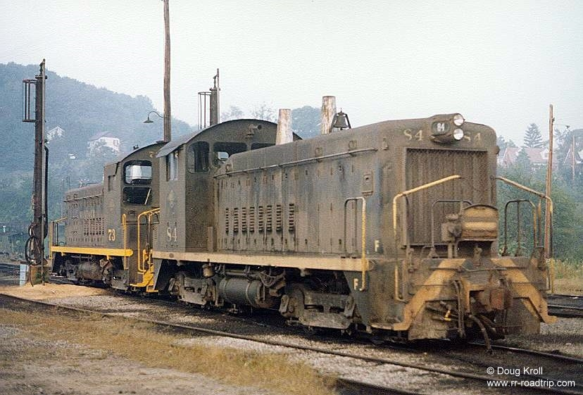

The general rule was "long hood" forward when 2 or more engines were in the consist, but it would change if the engines used were all facing the same direction, this rarely occurred, but did occur.
Trains from MRR Jct. were stopped at North Star and wyed to get them in the correct direction.

North Star was used a lot to rotate the engines direction on a regular basis to help even out the wheel wear. Most time this would consist of a train stopping and wyeing the engines consist and tieing back on the train. The engineer would then "trade ends" and set the once trailing unit into the leader. The shop foreman would make a note of the unit numbers and date turned and arrange another turning at a later date, thus allowing equal wheel & flange wear.

Library Jct was another location that this reason for turning happened.
I recall numerous #10 coal trains being shoved clear of the east wye switch on the main and the engines running through the west wye before tieing back on.

Tim Sposato
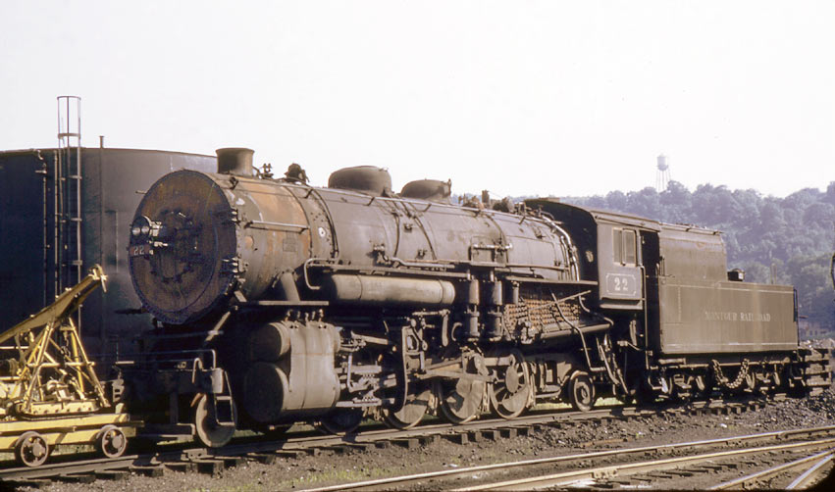
How do you double head two steam engines and have them both work for you effectively?
Does the second engine run slightly slower than the first?
Ifit wasn't slower then the second would be pushing the lead engine and then pulling the remaining cars behind. You don't see many double headed steam photos as you do diesels lash ups.
Most of the steam shots show just one engine.
Anyone know how this was set up running?
Ken Caine

Attached is an enlargement from one of the 1939 aerial photos. This shows a coal train about a mile east of Montour No. 4 probably heading to Mifflin Junction. It has a helper engine pushing at the rear of the train. The coal is probably coming from Champion, but could also be run-of-mine coal from No. 4 or one of the mines west of there.
Tim Sposato

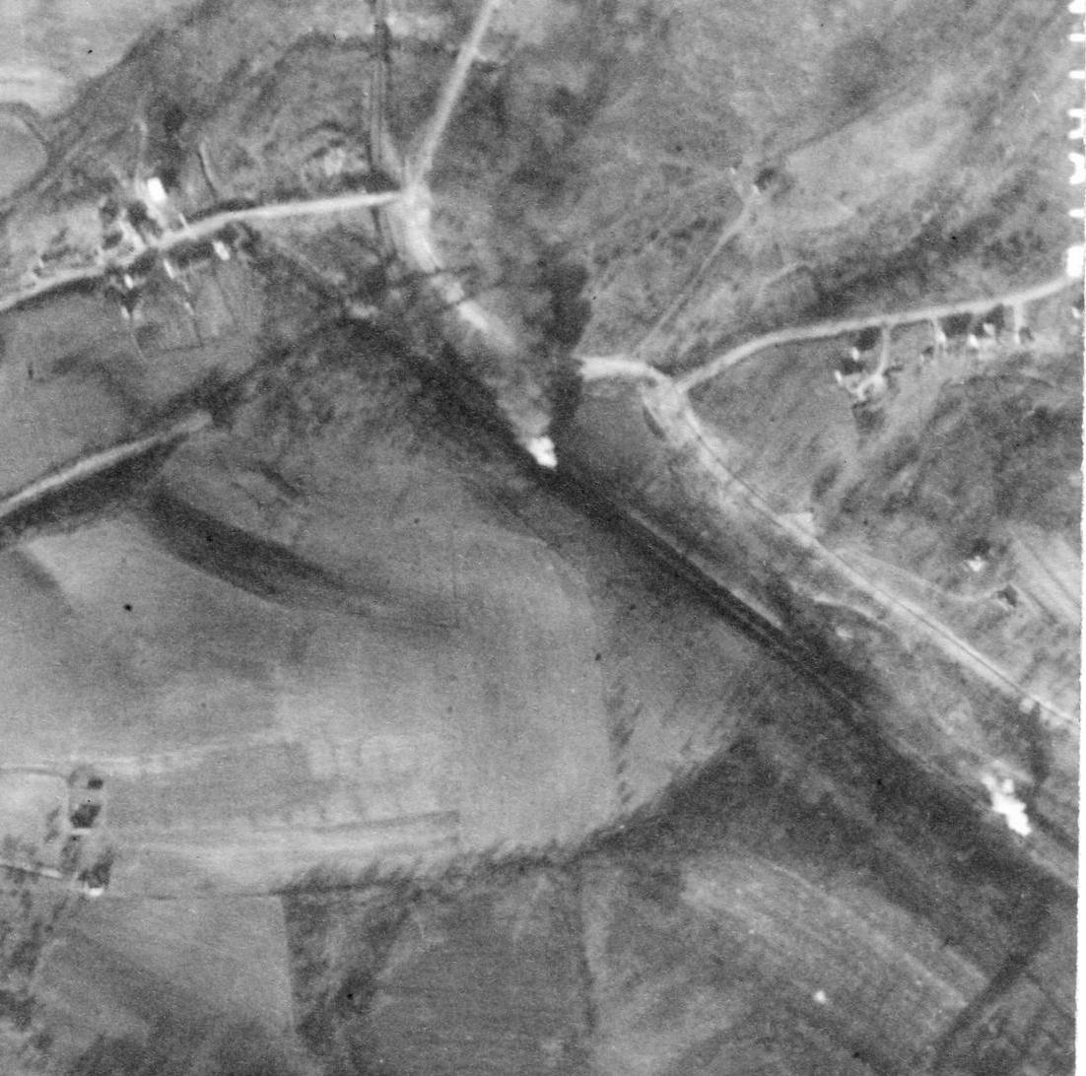
Ken,
The art of double steam is a harder one to explain, the trick is, the engineers must know what’s going on. They take in account of the type of engine, tonnage, and track geography. They both have to work as if two engines are one, constantly feeling by the "seat of their pants" what is taking place.

Starting the consist and decending on grades require a steady hand and veteran knowledge to avoid trouble.

Hand signals from cab to cab was the norm back then and even today I will "job brief" the second engineer of what hand signals will be used. We do have radios in the engines, but because of the additional noise of steam they can be harder to use, not to mention having a free hand to operate the radio. Quicker to hand signal out the window!

Steam locos are run by their sound and the feeling of the load.
You're watching the speed, stack sounds, rod sounds, not to mention what is ahead on the tracks, always watching steam consumption against water and coal usage.

I had run countless double headers, even a few triple headers over the years, and each would be run differently than the others. The basics remain the same, but your thinking cap must be on!

Even trickier is rear end helpers, especially on a lot of curves.
Once again the engineers’ knowledge come into play.

Tim Sposato

I had many visits with the older steam men, to pick their thoughts regarding Montour operations and mechanical issues.
One was that a helper would assist the 1st Library Run, then would also assist the 3rd Coal Run out of Hills on its westbound trip back to Montour Jct.
The Extra Helper would also do other jobs as needed and there was an occasional helper shove eastbound from Library Jct. to Jewell, depending on sizable coal orders to Conneaut Oh.

An interesting note shows that 5 different steam engines were used by all the crews at Montour Jct and 3 different steam engines used out of Mifflin Jct.

Diesel units #73-76 are used on the 1st & 2nd Champion and the two Extra Champion crews deadheaded out to relieve them. Also the diesels # 74-75 are used on the 1st Coal Run turning at Westland and the Extra Coal Run also turned at Westland.
At this time only these four diesels were on the property.

Hope this adds a little more to the average daily operations in 1952.

It’s fortunate that some of these papers and files and the recollections of employees exist to help see the past.
I for one would have enjoyed sitting at the passing siding at Jewell to watch the meeting of an east and a west bound at dusk.
Hopefully the eastbound would have had that helper on the rear!

Tim Sposato

Bill Bigler's query on the Montour's practice with steam helpers is an interesting one that penetrates deeply into my heart and soul. Coal trains coming up the grade from Hills, through McMurray, seemed to practically always have forty loads, with a Mike on the head end and another one shoving at the rear.
One would often see these helpers drifting back down light, tender first. It was not unheard of to see them shoving tender first.
On the other side of Hills, on the climb up through Hendersonville to National Tunnel, I could be wrong, but it seems like the drags there were more often double headed than run with rear end helpers.
As for the Library Branch, I never witnessed those operations. Surely, though, it would have taken two engines to get anything up out of there on that 2% plus.

As one looks at the sawtooth profile of the Montour and the steepness of the grades, it is evident they must have used helpers all over the railroad in every conceivable operating pattern in steam days.
What a railroad! It was sad, in my case, that it had to take a back seat to the P&WV.

Bill

To add to the discussion of double headed steam.
A gentleman named James May moved to a house on Brookwood Rd in
McMurray in the early 1950's, and in those days his home’s location gave a view of the Montour's grade up through Rocky Ridge towards Bethel.
Jim well remembered the glowing fireboxes on the engines, and told me this detail: When the weather was bad in the winter, it was common for the first engine to uncouple from the train and run light up the hill and back, then coupling on and the whole train proceeding.
He was not sure of the reason, my thoughts were to sand the rails and maybe knock off some snow and ice on the rail. When I suggested this, Jim seemed to think it correct, mentioning yes, they spread salt, sand , something like that.
While there may be a few missing details to add, Mr May would not make this up, knowing him 20+ years, if he described it, it happened in some form.
To this day I regret not paying more attention to the Montour. I considered it my hometown railroad, and figured those SW's would be around for a long while.
#4's flooding brought that idea to a crashing halt.
Brian Budeit

He's right, and we still do it today. The railroad I work on down here in Georgia will often uncouple from the consist and run up the hill sanding the rails.
Then we'll back down to the train, couple up, and start pulling.
We have to do it in the summer too when the weed sprayer doesn't periodically kill the kudzu vine growing along the tracks. We've stalled halfway up the hill and slid all the way back, even with the train brakes fully applied.
Once she stopped on the level, We'd set handbrakes, cut off the engine, and then go back up the hill sanding and grinding the kudzu off the rails. Makes for a long day when you have to do that two or three times in a 40-mile trip.

Bob Ciminel

Brian, you are correct. As high schoolers, we rode many trips in the early 70's from Jewell into Mifflin and several times, mainly during the wet winter months, the engines running light would sand the rail up to and just across from Al's Cafe.
We would make our presence be known by lighting our lanterns and the crew would allow us to jump on board for the trip back to get the train. So this practice dates back many years before we were even thought of !

This added more to our ride, which of course, we thoroughly enjoyed.

Tim Sposato

The mine entries were in the hillside at an elevation about 1100 feet above sea level. That's where the coal seam outcropped. They were all drift mines, so they went into the hillside at the same elevation as the coal seam. They would have used chutes to transport the coal down to the tipples. The tipples would have been at track level. The map on the homepage shows where the main entrances were located, although the mines were probably closed and sealed by the time the maps were drawn. You can compare the roads on the map with the older roads in the area before all the development began. Those would have been: Cliff Mine Road, which paralleled the Montour tracks, and Enlow
Road and Mahoney Road, which went up the hill to Steubenville Pike.
The mines should have been south of Cliff Mine between Enlow and Mahoney.
That's my best guess. I used to live up the hill from B & T too, but that was back in 1975-76 when the Montour was still running. I moved away in 1976, so I didn't get to see the Montour closure and abandonment, which is probably a good thing.

Bob Ciminel

Briggs & Turvis was located adjacent to Pittsburgh’s notorious Parkway "West" at the Montour Run Exit...(Wickes)
B&T as it was commonly referred, scrapped railroad equipment...freight cars, cabooses, and also rebuilt some of this scrap equipment into industrial freight cars.
I have 2 photos of a former Western Maryland gondola cut in half then being rebuilt into 2 mill gons that I believe went to Wheeling-Pittsburgh Steel.
B&T also acquired former locomotives and cabooses then resold them back onto the market with the Montour RR purchasing cabooses and steam locomotives.
I have a photo of an old Border Milk Car, a NP caboose (wood) and I think a B&LE caboose.
A unique note about B&T...
When the Parkway was being built, the bridge over the Montour was brought in by rail via the Montour.
B&T cranes were used to lift the steel into position which brought time slips from Montour Trainmen as B&T cranes came out onto the Main Track of the Montour to do this work.

Gene Schaeffer

If memory serves me correctly, this 90 pound rail was dated 1927.
I remember a time during the winter of 76 into 77, rail on the Westland Branch was worn out and seemingly breaking under each train.
New 115 pound jointed rail was on order and due later in 1977.
That rail was so bad, we spent a couple of weeks turning rail on all of the curves.
Believe this or not, the ball of rail on the high side was so worn out, it was worn down into the web of the rail.
With that in mind, imagine only a 1 inch ball of rail...on the high side of curves to boot. So the section hands removed both the high side and low side reversing their positions, so the low side was now the high side.
Again...if memory serves me...the idea was slick...but the rail was so worn out...it kept breaking under each train.
And don't forget, the late 1960's I would estimate was the time frame when the P.R.R. "yellow balls" 100 ton hoppers started showing up...
Load them with green coal and you had 100 tons of weight per car riding on that old worn out rail...the 50 & 55 tonners were being retired, because they were worn out...so, along with the yellow balls, 70 tonners were also becoming the norm.

F.Y.I...in 1981, shortly after a main track derailment just west of Mile Post 16, when a westbound "stop-off" train of coal derailed about 7 loads, the Superintendent decided to send 3 cars of "stop-off" coal to McKees Rocks for weighing...
70 ton and 100 ton P&LE hoppers were used, and low and behold, the 70 ton hoppers when loaded with "stop-off" coal, weighed in around 90 tons...with the 100 ton hopper weighing in at 110 tons.
Now, not only was the Montour transporting a additional 10 to 20 tons of coal "free", but that added weight was believed to be part of the cause of some of the derailments (overloaded rail cars) so CONSOL coal was notified not to fully load rail cars...

Gene Schaeffer

There was a story in the Pittsburgh Press newspaper back about 1970 about Montour #10 and its closing...and now its revitalization.

Also, perhaps a factor in this was the rate in which the coal company paid the Montour for moving green coal from the mines to Champion. I remember at one time, perhaps the early 1970's, a car load of green coal (stop off) cost the coal company about $46.00 from mine to Champion.

Do the math. The coal company shipped 1 car load of coal to Champion for $46.00.
In time of course, this rate changed. About 1981 this flat rate was $117.00 per car load.
I remember "someone" in the Offices at Montour Junction showing me copies of both the "stop off" coal billing and P&LE's billing for use of the SW-1500's. They were identical.
$117.00 per car of green (stop-off) coal and $117.00 per day per SW-1500...

If you write down everything it took the Montour to service the mines, from an accountant’s point of view, the railroad seemingly got the short end of the deal. Maintaining locomotives...maintenance people from shop and car yard employees...to office employees...to maintenance of way employees...to train service employees...taxes...structure maintenance...road bed maintenance...fuel costs...on and on its goes...so the money made on "stop off" coal had a long way to go.

Now the exact revenue the Montour made on clean coal is another issue.
I understood some decent revenue came from clean coal, but remember, a minimum of 3 railroads had to share that revenue...originating on the Montour...the middle man...and delivery railroad.
Maybe someone else in the know can shed light on revenue here?

Gene Schaeffer
Back in the 50’s, about ’57, I seem to remember the loss of life. As best I can tell there was a derailment and a brakeman was under a car.
Does anyone remember this?
I heard about it the next day and when I looked at a string of loaded hoppers I got the chills.

Carter Roth

Dated February 14, 1957.
Manilia envelope in Superintendents Office.
Stuffed full of 8x10 black & white glossies.
Location, Montour #4.
Reason - Accident loaded yard, Montour #4.
Loss of life - car dropper?
Montour 16042 was photogrpahed extensively on back track - Montour Junction.
I suspect this hopper was part of that incident.

Gene Schaeffer

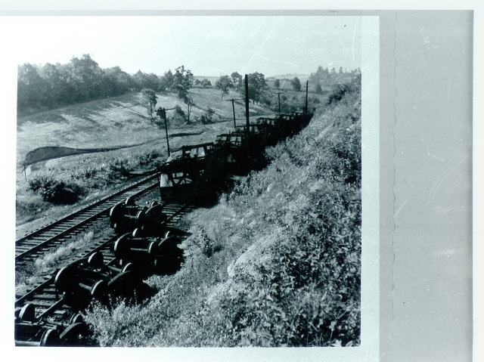

Carter/Gene,
Another incident that caused a fatality in the late 50's was a derailment involving loaded hoppers at the East End of Russell Siding.
I understand a brakeman was killed it that also.
This may have had something to do with a runaway, not sure what the details are.

This photo is after the clean-up, hoppers (some are MRR) are upside down on Russell siding. I have a few other views, this one shows all the hoppers involved (6).
SR 980 is to the right as the photographer faces East.

Tim Sposato

Tim, this sounds more like the story I remember. The story was it was a derailment and the brakeman was crushed under one of the cars. Not a pleasant thought.
For sure, he worked for the Montour.

Carter Roth

I preserved 2 glass number boards out of the headlight of Engine 74...
Measured the logo dimensions, and all numbers on the SW9's, both large and small...
In 1978(?), I often washed numbers and logos of the SW9's...
And even washed the entire cab side of the 76, removing sand and coal dust, which ended up causing quite a stir in the Roundhouse, as the Union was preparing to time slip the company, as someone was doing their work, completely against Union agreements...
Boy...after washing the entire cab of r-w-b 76, those bicentennial colors were vibrant again !
And I often joked with R. (Zing) Maga about a wash program for the fleet of SW9's...
I was also preparing to preserve an air horn and locomotive bell...
As the SW9's were leaving the property, someone else walked off with a bell or something, about the same time...
And boy, talking about a bee's nest of trouble that created...
I overheard C. A. Ross threatening an employee about the above...
So, the bolts I had removed from such appliances were stashed and the preservation program abandoned.

Gene Schaeffer

Way back, when I worked in the shops, we would stack the filters from the SW9's like cord wood and then take them to car shop [outside] during the winter.
The filters were burned in 55gal drums along the work area.
This caused a layer of thick smoke like they used to do in the Florida groves. This would help to block the cold upper air.
There was nothing like being there. The smell, smoke, rivet furnaces, the sounds, rivet guns, cutting torches, the workers dressed in layers of clothes that were as black as the smoke. The only colors there were black and grey with the red glow from the furnaces and cutting torches.
It was an unreal place to see. I only wish there was a way to be able to take you back to that time. A time only fit for hard men.
The time...1957. I know, I was there.
Carter Roth

When I worked for Corning, we would get batch materials that would occasionally freeze in the cars if there was too much moisture.
As I remember, we put magnetic vibrators on the sides of the cars. They made quite a racket, but often did the job.
Were vibrators ever used on frozen coal on the Montour? I have visions of the whole carload of coal releasing as one or two solid chunks slamming down into the collector below the rotary dumper. Anything like this ever happen?

Bill Bigler

Kurt Anderson wrote:
The coal freezing inside the hoppers is still a problem today. However, there are some tricks they use. An anti-freeze solution is added to the coal when it's loaded at the mine. Another way of dealing with this is to heat the outside of the car with torches. Today's aluminum hoppers can't take the torch method and other equipment is used to heat up the side to, but not exceeding 250 degrees. I think using dynamite would be fun to watch.
Yeah, but dynamite is hell on the rolling stock :-)

The big news here yesterday was the debut of a hybrid coal hopper jointly developed by Norfolk Southern and the FreightCar America shop in Roanoke.
Because of the problem Kurt mentioned about heating aluminum cars, the new car is part stainless steel and part aluminum. The steel lower part of the car can be heated to thaw frozen coal, but there is still enough aluminum to lessen the tare weight of the car, so it still has a higher load capacity than an all-steel hopper.
NS will receive 1,200 of the new cars.
Other methods I have seen to free frozen coal include fire and mechanical means.
Until it was decommissioned a few years ago, a nearby team track was the unloading point for coal for the Virginia Tech power plant.
Before it was environmentally unfriendly, a tire or two tucked under the hoppers and ignited helped provide the needed heat to thaw the doors and coal before the car was moved over the unloading tipple.
There was also a crawler crane on site, which would lower a mechanical shaker to the top of the car to vibrate the coal loose. An Appalachian Power plant had the same shaker set-up, although it was mounted on a more permanent framework above the unloading tipple.
At the coal docks in Norfolk, the Norfolk & Western had/has thawing sheds ahead of the rotary dumper. Cold cars would be rolled into the shed and heated with large infrared heaters that lined the building. The heat was intensive enough that it didn't take long before the coal was loose enough to be dumped from the car.
Bruce Harper in Blacksburg, Virginia (but a native of the 'Burgh)
Tunnels

There were four tunnels built on the Montour Railroad. The one at Peacock was daylighted, due to the unstable soil that it went through. The other three still exist. The Jefferytown tunnel is now known as Enlow tunnel on the Montour Trail, and lights have been added to the interior. National tunnel has long had a problem with water seeping through the ceiling. In the winter months, this causes large icicles to form and ice buildup on the floor of the tunnel makes passage through the tunnel a hazardous trip. Grers tunnel is closed for now [2007], but will be rehabbed in the near future, as the Montour Trail Council continues to add segments to the trail.

The group was asked about the ice buildup in the tunnels, and how the railroad kept operating throughout the winter season.

Gene Schaeffer related how several times, windows on the SW-9’s were broken by icicles hanging or falling from the ceiling of the tunnels.

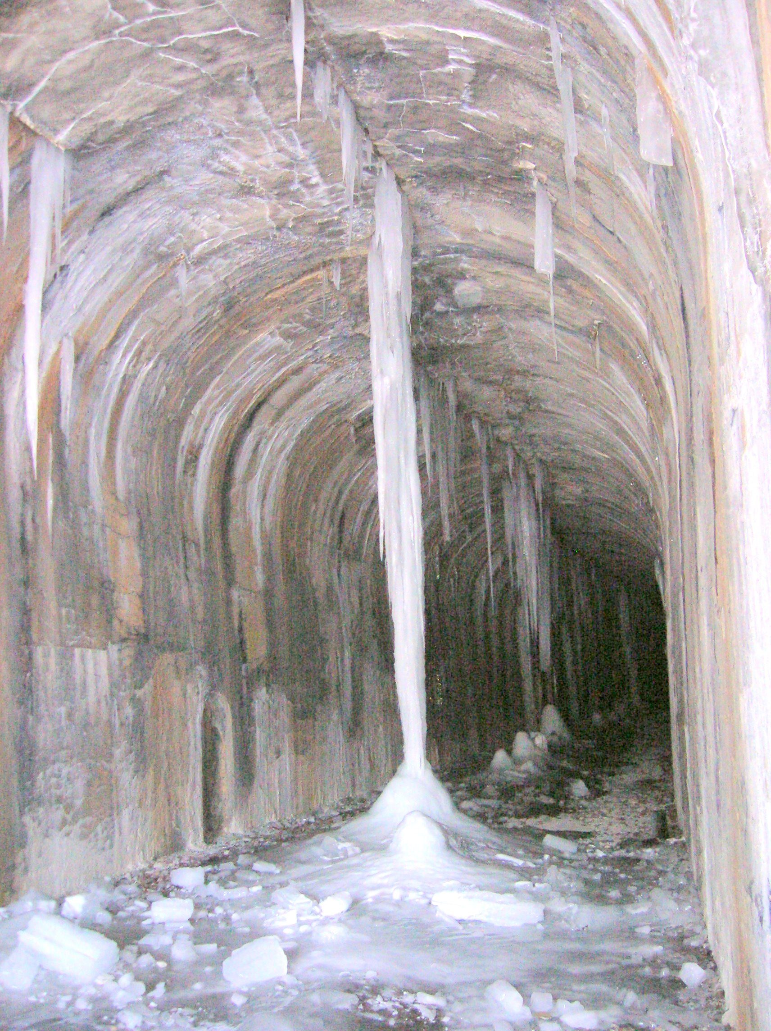

National Tunnel – February 2007

Tim Sposato writes:
The passing of trains did help keep the build up to a minimum. The continuous cold spell would also help slow the seepage down.
After a long weekend, the first train out would approach the tunnel looking out for icicles, unless the section gang was notified to check it prior.

The National tunnel seemed the wettest, lots more chipping in of ice. Greers was not so bad, smaller build ups. Jefferytown was the dry one.

And for Bill Bigler, the tunnels bring back some memories:

The trip back to Coraopolis was fun with those coal loads. Especially the tunnels - they were either on slight upgrades, or in the case of National, the grade topped out in the tunnel, but since the train was still strung out on the grade, the engineer couldn't shut off through the tunnel to minimize smoke and fumes. You sure found out how long you could hold your breath before you started breathing through the water soaked bandana!
The diesels never excited me like the steamers did. During the transition, I'd always ask for rides out the line in steam engines if any were going out. However, what I'd give to get those diesels back today!

Montour #4 Mine

Montour #4 had the supply yard and shafts for access to the mine.
Machine shops, offices, locker/showers, timber yard, etc were located next to the PRR.
This is where the stables were located for mules.
There was a spur into the yard from the PRR for inbound shipments of material.

At one time the slack was hauled out of the shaft up to the gob pile above Chartiers Creek and what
is now the golf course. Never heard of coal being loaded out at this location myself.

Tim Sposato

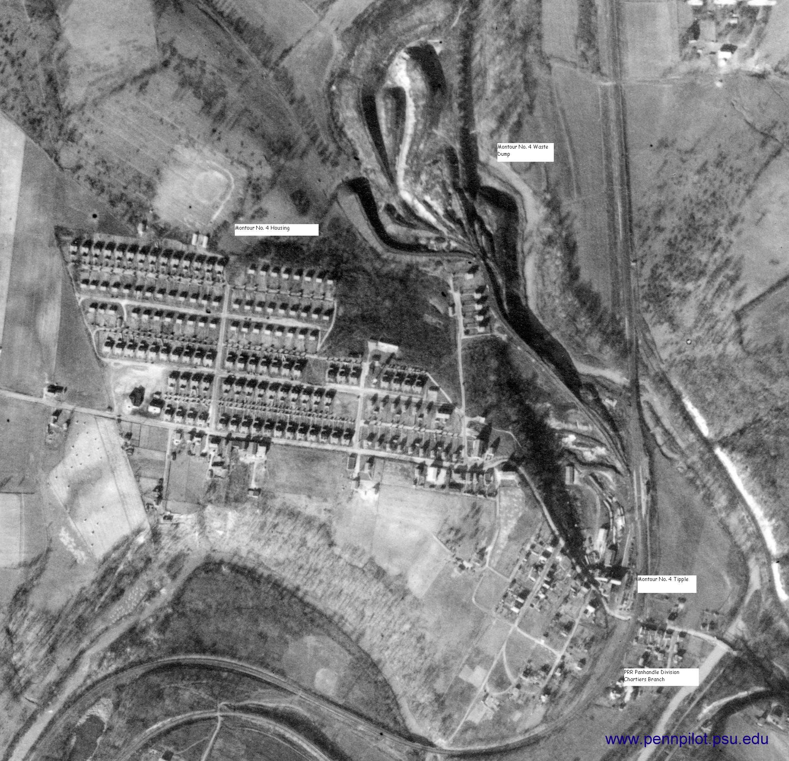
__._,_.___
Looking at the diagram for Hills Station, the trackage in and around Montour #4 and the connection to the PRR looks pretty simple on paper.
However to those not familiar with Montour #4 and the interchange to the PRR, the physical characteristics in and around this area are quite interesting.
From the PRR overpass at Greers Tunnel, the Montour turns left, then starts turning right while crossing over a dirt road while dropping downgrade to #4. Another left turn is made as the railroad nears Camps Cut then a tough right curve brings the railroad out overtop of the highway, the creek and the loaded yard main track (west) switch.
There were 2 railroad red/green signals mounted up on telephone poles 500 and 1,000 feet west of the loaded yard switch inside Camps Cut so as to identify to train crews the position of the loaded yard main track switch... "west end #4 Mine Hills"... which was located in the tough right curve.
Practically the entire complex at Montour #4 was built in a "S" curve along with this area being the bottom of a vertical curve.
The transfer to the PRR...known as "Pennsylvania Company - Transfer Hills" had two tracks known as the Creek & Hill Tracks.
On the paper diagram this interchange looks like a long curve which is actually incorrect. This transfer had a small tangent on both its east and west ends, then a long "S" curve in its mid-section.
All during the 1970s, the transfer track was in poor condition and derailments were frequent. These transfer tracks were carved into the hill and rocks were continuously falling onto the right of way.
On occasion PC/Conrail crews ventured up the transfer towards the Montour main track looking for their pickup.
Also kind of hidden to many was the fact there was a water tank located on the hill just above the transfer where it left the main track of the Montour.
When Montour crews departed westward from Montour #4, I always enjoyed lingering long after their departure.
With usually 4 EMD SW-9's in the locomotive consist, you could listen in for 15 or more minutes the cadence of those SW-9's climbing back out of the Chartiers Creek Valley as they made their way west.
That was a real treat listening to the SW-9's working their train back up the hill through Henderson. And sometimes, late at night living as far away as 10 miles from Montour #4, I could sometimes hear those SW-9's taking another train of coal up out of that valley.
I find it hard to believe those SW-9's...and the Montour itself have been gone for over 20 years...
Gene P Schaeffer

While it's been awhile since I've visited the Montour, I imagine things are pretty much the same. The nice thing about the Montour is that much (most) of the right of way is still there and accessible. The Montour Trail is
steadily growing and now covers much of the Montour right of way.
The last time I visited, the trail (west to east) went as far as the bridge over the creek at Greer Tunnel. I understand they have plans to eventually continue the trail over the creek (bridge steel still there) and through the tunnel, as they have with the other two tunnels.
On the other side of the tunnel, you can walk in along the old PRR (OC now?), across their bridge over the creek, and through their tunnel.
Do realize this is railroad property - ask and obtain permission if at all possible. And in summer beware of venomous serpents!
On the other side of the tunnel, the Montour through truss bridge over the old PRR is still there. You can climb up the bank and walk back to that end of Greer Tunnel.
Back on the road, it's a short drive to the location of Montour Number 4.
There is still activity in the old mine office building there. The site is fenced off. The building was being used to store a small but nice collection of old ('30's & '40's) cars and trucks the owner was working on.
Inside is in excellent shape, but renovated, not restored. I seem to remember he was planning to open a
small museum on weekends. If you catch him there (probably weekend afternoons), if he's not too busy and you explain what you're doing, he may give you a tour as he did us. There are several old pictures of Montour No.
4 back when it was operational.
There are also remnants of some old machinery outside. The trail picks up a mile or so east of there and is
paved through Library Jcn. There was a side trail down the Library Branch to Library.
There is a website with a lot of pictures of Montour No. 4 back when it was operational. It was referred to and discussed on this list a year or so ago. Really interesting. There were also pictures of the Champion Cleaning
Plant inside and out. Bob posted a few of each on the website.
If you check the old posts (I believe it was November '03 or so - Bob or Gene help me here) you should find the web sites and quite a bit of discussion.
The web address is http://memory.loc.gov/ammem/fsaquery.html I entered Montour No. 4 coal mine and found 100 photos. Click on "gallery view" for thumbnails and open and download them as you want.
I entered Champion coal cleaning plant for those pictures.
Entering Montour No. 10 coal mine just brought up the pictures of No. 4.
There was another site of historic Pittsburgh pictures that had a few of Montour No. 10. Again, I think Bob
posted some on the site, and the link will be in the files of old posts.
This site has track charts of the entire Montour RR: http://homepage.mac.com/sraque/TrackCharts/Track_Charts.html
I forget the date of the charts. Takes a bit of playing to display them at a helpful resolution and download them so you can work with them, but it can be done.
I checked, by the way, and all these sites are still active. I have a list of others including photos of 6 or 8 Montour steam locomotives I'll dig out as time permits. Remind me if I don't post them soon - I get forgetful!
The Montour Trail sites also have some interesting information on the Montour.
Doing a Google search for Montour Railroad and maps of the Montour Railroad have also yielded some helpful information.
Hope all this helps.
Bill Bigler

The supply yard originally had a vertical double elevator tipple for suppling the mine needs. That is the large (tall) building in the 1939 photo.
This was located at the base of the pedestrian stairs coming from the settlement of Lawrence on the hill.
Hills Station was the name of the settlement along the PRR.

The supply yard was the only maintenance facility for #4.
As I mentioned what was there a few posts again, it also had a first aid "hospital", offices, woodshop for timber construction, electric shop for general repairs and for the mine motors (locos).

In latter years the vertical shafts were replaced by slope shafts at both the supply yard and at the rail loading tipple along the MRR.
I trust this was a cost saving decision when you weigh the cost of maintain the lifting system versus rails down the slope.

I saw the supply yard many times and it still was impressive with the timbers and blocks stacked high.
The mine cars and motors were still being repaired by the well equipped machine shop and electric shop.
The offices had some wonderful photos of the complex hanging on the walls of the management and engineering personnel.

The "hospital" was merely a bandage station now, similar to the one that was in the MRR Jct, shops.
The stable was converted to a storage building.
The steps from Lawrence were long gone, just some remnants.

The showerhouse was original, and the locker room still used the hanging personal effects baskets instead of lockers. The communication room was next to the locker room, there was always an employee on duty at the radio & phone system when someone was in the mine.
Watchmen were constantly walking the underground, monitoring the pumps, methane, electrical ect.
They would report in at the callboxes located at given points. Even when the mines were down for holidays and weekends, they walked the interior.

All the buildings were of traditional brick construction and point work.
The storage yard area was strewn with mining artifacts, if you can name it, it was there.
The slope shaft had a concrete portal and a date cast in the top cement section over the track.
I have some slides of both the supply & rail load out portals and pretty sure they’re dated 1944.

I spent alot of time in Hills Station in the 70's and knew a great deal of the miners and their families, they were a good bunch of people that were a small part of the MRR story that are overlooked at times.

Tim Sposato

Changing thoughts, what we think of #4 is only the load-out. The shaft where everyone went to work was right there in town. Reflecting on Tim's post this was the hub of the mine.

#4 went to belts ( conveyers ) #10 loaded mine cars until the end and had a full machine shop. I think it was #10 that had a hole into Mathies. I'm sure my friends will correct me if I'm wrong.

Donald McCarty
O K, I'm sort of confused. The photo says mayview. But, it all seems to match exactly what Tim's description above is describing.
The area labeled tipple, on the PRR, should probably say portal. At any rate, this area was #4's support area, with shop buildings.
Coming down the steep hill from apropriately Hill Station, you could see mine cars sitting amongst the buildings, being repaired.
The photo labeled Mayview, shows the Montour main coming in the bottom right corner. This track is sort of pointing towards #4 tipple.
Main crossed road and creek on high span angled across valley. I used to stop on the road and watch the SW's run across.
Once across the valley track followed creek to tipple, correctly identified in another photo. The interchange of MTR and PRR is cutting southeast across photo away from PRR.
I can't imagine the PRR calling it Mayview. Mayview is several miles north, towards PGH. In between is Boyce station, barely visible as a crossing on PRR north of mine site.
Mislabeled photo?
And, last, was there a real, separate Mayview tipple on PRR at Mayview proper?
Area in mayview labeled photo is Lawrence and /or Hill Station.
Folks residing in either place would take offense at the suggestion they live in Mayview. ;).
Brian Budeit

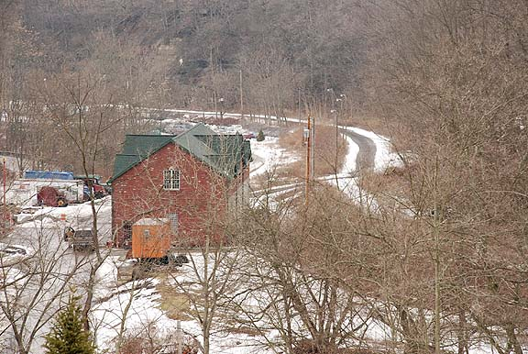

Looking down on former tipple location for Montour #4. This view is looking west.
To the right would have been the location of main track, and where the tree line stops and the path through
the snow begins, would have been the main track switch to Pennsylvania Company - Transfer Hills.
The loaded yard for Montour #4 would have been behind the building and the empty yard for #4 would have been to the lower right.
Gene P Schaeffer
This area has always intrigued me, there being a coal mine way over the hill from where we live.. It would have been interesting to see the various train movements there. There was one earlier posting from a year ago or so showing the mine in ‘73, and the empty yard loaded with cars, and a couple of cars on the transfer..(I think the old boilerhouse is further lower left of your picture)

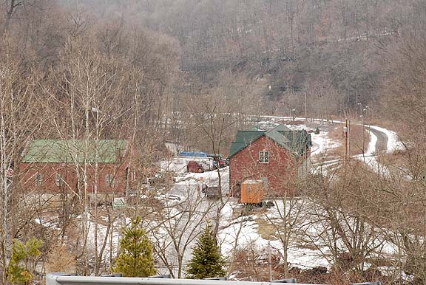

Bill;
Correct, here is another view of #4.
GPS
The portal to #4 for the tipple loadout was located to the extreme right of the photo on the hillside.
If you look at a photo of the tipple that was dismantled in the early 80's, you will notice the corrugated section extending over the MRR main track into the hill.
This was the conveyor belt and walkway that brought coal from the mine to the tipple’s bins for railcar loading.

This belt would enter the cement portal opening and angle at an approximate 35 degrees descent into the mine. At the base of the belt was a small version of the rotary dumper to empty the mine cars into a bin and feed the belt for a uniform flow to the exterior tipple. This belt shaft also had steps allowing access to the mine and maintenance to the belt system.

I was fortunate enough to know the tipple operators well enough to be able to get a helmet and light from the lamphouse and visit this arrangement quite often.
The last scene of the #4 operation that stays with me, was the walk I made the last time down the belt shaft. The mine was officially shutdown, the final loads and empties were moved out a few days earlier.
The power was still on, powerhouse still humming.

This visit to the rotary dumper in the shaft showed a partial bin of coal, and sitting ready for unloading was a "trip" of coal, about 15 car loads with the motor still attached. I always wonder if this was unloaded and moved by truck or did it get left behind as did many other pieces of equipment to be covered with water as the pumps were soon shutdown?

The portal was filled with loads of limestone as a plug and cement was then pumped into it.
The portal opening was destroyed and the exterior surface was graded over.
Last time I looked you can seen the cleared area where it once entered the hillside.

Tim Sposato

Library Junction

The Montour Railroad split east of McMurray, at Library Junction, with the main line continuing toward Bethel Park, and the Library Branch going downhill into the town of Library and the Montour #10 mine.
Library Junction was a wye, so trains could travel in either direction to or from Montour #10.

The west leg of the wye at Library Junction had a siding that scales to about exactly a half mile long on the track chart. The end of the siding was at the exact point where the 2.44% grade down to Library and #10 began. The trip from #10 up to the siding at Library Junction was about 2 miles, this again from the track chart. Trains went up at a walking pace of around 3 mph (no speedometers). So it would have taken about 40 minutes to make a trip back up to the Junction.

As I remember, the locomotive would run around the train and back down with the cars on the uphill end. In steam days this was to keep the sanders in front of the drivers for the trip back up, among other things.

None of you guys have (yet) corrected any of this information I'm tossing out - does that mean I'm basically correct, or that you've given up on me and just rolling your eyeballs? I'm working from info like track charts and what I can remember from age 10 to 14!

Bill Bigler

The empty trains to #10 at one time did operate engine pulling down grade to the mine. That all ended when the cross-over from the empty yard to the main at the tipple was torn up in a derailment. Since it never got fixed, the move became a shove from Library Junction.

The steam locomotives were operated backwards on the Library Branch because of the grade. This allowed the safety factor of water covering the crownsheet at all times without carrying excess water in the boiler if the engine was facing downhill. This also allowed the engine to work hard up grade without carrying high water into the cylinders.

I understood that the Steam locos would shove the cars up the hill, just as the diesels did. This allowed them to shove thru the West leg of the wye, onto the main track. The engine would run thru the east leg and tie back on to the train before heading for Mifflin Junction. Now the consist is in the correct order! This allowed the engine to face east as they liked it.

Standard practice was the Mifflin Crews to service #10 and the B&O, they would operate the engines facing east when making the round trip, thus saving any wyeing of engines.

So far Bill I haven't seen any defects in your memory!!

Tim Sposato

Operations on the Library Branch were operational headaches after Montour #10 reopened in the early 1970's. Derailments happened almost daily. When you have heavy car loadings such as raw coal, worn 90 pound rail and cinder ballast, and steep gradients with severe curvature, the stresses on the rail and roadbed are unimaginable. In the early 1970's, crews going to Montour #10 often had a four unit consist of SW-9's. The name of the game on the Montour was always moving every car load of coal possible with each movement.

During these last years of operations on the Library Branch, coal from #10 was shoved up the branch to Library Junction. Shoving trains is usually a sensitive issue, and even more sensitive on the Library Branch. If the locomotives didn't jacknife, then the cars themselves were shoved off the rail from that tiny 90 pound rail turning over. When you think about it, having a rail literally "turn-over" under the weight of a coal train, requires some genuine force to attain such activity. And yes, rail turn-over happened frequently on the Montour.

As derailments on the Library Branch racked up statistics in the Offices at Montour Junction, then in the mid 1970's, some new ideas were implemented for the Library Branch.

Restricting couple blocks were obtained for the SW-9's that limited coupler movement which prevented the locomotives from shoving "off-center". Then a 3 unit restriction for crews going down the Library Branch was ordered, and if for some reason a crew had 4 SW-9's, the trailing SW-9 had to be isolated. Furthermore, moving coal out of #10 was restricted to 11 loads per movement. Often, road crews made 3 trips (cuts) from Montour #10 to Library Junction. All these ideas helped prevent derailments.

When working Montour #10, crews would fill the siding at Library Junction with their first or second cuts of coal. The third cut of coal was shoved out on the main east of the East Leg of the Wye at Library Junction with the caboose still on its east end. That last cut would get shoved out far enough on the main east of Library Junction so as to hold the previous 22 loads from the first and second trips...and the locomotives.

In the early 1970's, prior to the operational restrictions mentioned above, often westbound trains of coal off the Library Branch from Montour #10 would build their train up inside Library Junction, run around it using the siding inside Library Junction, then use the West Leg of the Wye to get back out onto the main and head west.

I have a couple distant photos showing 3 SW-9's on a winters day in 1974 easing their train around the West Leg of the Wye at Library Junction and proceeding westward out onto the main for Champion. The racket those loaded coal hoppers made squealing around that West Leg of the Wye...was awesome.

Gene Schaeffer

Train lengths up the hill from #10 to Library Jcn. were short due simply to the 2.44% grade most of the way up. It was 1.6% right out of the tipple, so you couldn't get a running start. You slogged your way up at a walking pace. Based on the tractive effort of the Montour's Mikado's and diesels (close to the same), a year or so ago we got into this discussion. With the help of a guy from a Pennsy list, we went into a website called steamlocomotive.com or something like that, then to the section on "design your own steam locomotive," and plugged in the specs for the Montour locomotives and various grades. Our conclusion? A single Montour locomotive could only pull about 5 loaded hoppers from #10 up to Library Junction!

In the steam days, I remember a helper stationed at #10, but multiple trips up the hill were required to get all the loads up. MU'd diesels could take more per trip, but 4 MU'd diesels could only handle about 20 loads. This is why #10 was my favorite. Riding the locomotives on mine runs led to a lot of fun getting the coal loads up from #10, assembling the train at the wye at Library Junction, and getting ready to head back to Montour Junction. Once you had made it up that hill, you had no real trouble with a much longer train back to Montour Junction.

Note that trains from #10 rarely had to stop at Champion. #10 produced metallurgical grade coal used to make coke for the steel making process, so it was cleaned and processed at #10 which had its own cleaning plant.

Thanks for awaking some neat memories from the past with your question. If I remembered wrong guys, do jump in and correct things! The older I get, the lesser I remembers and the more I disremembers!

Bill Bigler

And let me recite a tale from that particular location from many winters ago...
See, back in 1976 and 1977 I worked on Montour’s Section Gang #1. Section #1 back then was under the supervision of Bob Maga.
We worked out of Champion, but on this winter’s night, and living in nearby Finleyville at the time, seems some locomotives got themselves off the rail just above Library Viaduct in an area known as the "apartments". Nothing new on the Library Branch, a derailment...
It was late at night when the telephone rang seeking gandy dancers to come out and gauge the rail so the crew could get back up the branch, and shove that train of coal back out onto the main and then head west.
If I remember correctly Pete Williams was the foreman who came out that night. Pete was not a tall fellow, but a big mass of flesh, muscle and bones. Soft spoken and easy to get along with, Pete was a little too easy going sometimes...but anyhow, we gauged the rail and the 3 unit consist of SW-9's came back up the branch, coupled into the coal and started shoving on that small train of #10 coal.
Well, those SW-9's, especially in multiple, could generate some lovely sounds as those 12 cylinder 567s worked a heavy train on the ascending grade of the Library Branch.
Couplers slammed hard on the uneven roadbed...and those SW-9's, no matter how much sand was used, still slipped and slipped and slipped.
The harmony was exciting. Standing a bit of a distance away, no musical could beat the sounds of the Montour shoving coal up out of #10...Anyhow, it was after daybreak when the crew got the train back together.
After a short amount of time releasing hand brakes on the train, walking the train and making an air test, the crew departed.
In typical fashion, the top of rail was powder white after the passage of the locomotives. Sand was heavily used and with no trailing cars, it just sat on top of rail until either the next movement or rain or wind removed it.
As the SW-9's shoved back up the branch, and after the locomotives were now out of sight, I remarked to Pete Williams something isn't right with that train. It left some time ago and listening to the locomotives, they’re throttling up when they should be throttling down. The caboose should be nearing the inside of Library Junction and the top of the hill.
Seemingly seconds later, the train went into emergency. I again remarked to Pete Williams, I knew something was wrong.
A short time later, after the crew inspected the train, they were on the radio calling the Montour Train Dispatcher reporting they were on the ground (derailed) again.
Seems, as the train turned itself around that tight curve at Greenhills, several loads of #10 coal derailed and were gently shoved into the ditch. These loads were all upright, but leaning badly...the reason why the locomotives began working harder.
Boy, I really miss those days...

Gene Schaeffer

Montour #10

The Montour #10 mine was in the town of Library, along with the Champion #3 cleaning plant.
Regarding the distinction between Montour #10 and Champion #3, I can offer that #10 was a separate operation from that of Champion #3 and because of that, there was 2 separate identities. Montour #10 mined coal and Champion #3 prepared the coal for market...

Montour #10 in the 1970's?
Two empty yard tracks above the tipple that converged into one track under the tipple for loading.
Two tracks below the tipple for loads.
The tipple stretched from hillside to hillside, crossing over the highway, where the mine "motors" had room to run around their train.
There wasn't much to the tipple in those times, a rotary car dumper for the mine cars was located on top of the tipple.
When the P&LE decided to discontinue serving #10 in 1978, trucks could NOT keep up with production and for a time there were two gigantic storage piles of coal, one above and one below the tipple.
I believe #10 coal was being trucked to Mathies?

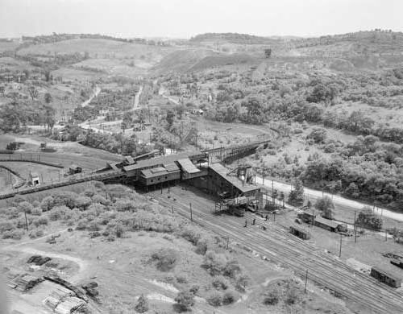

On the empty yard side of the tipple was a crossover, which was one car length long.
During the early 1970's when I was just a young'n and riding the coal runs from Salida to #10, the empty hoppers were shoved down the Library Branch to #10.
The caboose usually went right into the empty yard, and spotted inside the crossover.
When the SW-9's were done spotting empties, the engines got around the caboose at the crossover.
The loads were shoved back up the branch from #10 to Library Junction.
About 1974 the crossover was retired due to being torn up in a derailment.
A Montour crew returning from the B&O at Snowden derailed some empty hoppers under the tipple in 1974 which tore up the crossover switch on the main. The switch was never repaired and thus retired.

Crews then used the spur near the empty yard switch that led up into the research facility to run around the caboose. The caboose was shoved up to the gate and the hand brake applied. The engines would drop back down the spur out onto the main, then east on the branch below the spur. The flagman would release the caboose hand brake and using gravity, the caboose had enough momentum to drift out onto the main far enough to clear the switch, then down against the engines...

On several occasions I was afforded the opportunity to drop the caboose out of the research spur and down against the locomotives...

Gene Schaeffer

Montour #10 was a fascinating place to visit in the early 1970's. As a young boy of 14 or 15, I had the lovely experience of riding down to #10 inside many ex:Union Pacific cabooses now carrying MTR reporting marks.
Usually those rides were in the wee hours of a new morning when Montour crews came back west out of Mifflin Yard carrying empty hoppers for Montour #10.
Riding the caboose by the "West Wye Switch-Library Junction" then being shoved down the Library Branch was exciting for this teenager. Brakes would squeal as a gentle application of air was set on the train as we twisted and turned dropping down the branch.
Back then, the caboose was shoved right into the empty yard and down towards the tipple, as there was a crossover track near the tipple, where the caboose would be spotted so the engines could get around the caboose, so as to shove the loads back up the branch.
Usually we would ride one cut of coal back up the branch to Library Junction.
Then on the return trip back down with just engines and caboose, we would get off the train at Library Viaduct then drop down the hill to the streetcar tracks and wait for the first car of the day to take us back to the stop before Hillcrest where we would walk the path back to the Montour right of way there at Hillcrest shopping center and get back on the Montour right of way so as to walk back home, exiting the right of way at Salida.
Most mornings I accomplished this before 6:00 AM, before my Dad woke up.
If he discovered I was gone, I would get grounded for 2 weeks.
Being grounded was a common occurrence cause "Dad" didn't want me around the railroad - so this was my punishment.
Since I haven't seen my Dad in over 30 years, I have done just fine hanging around the railroad.
Gene Schaeffer

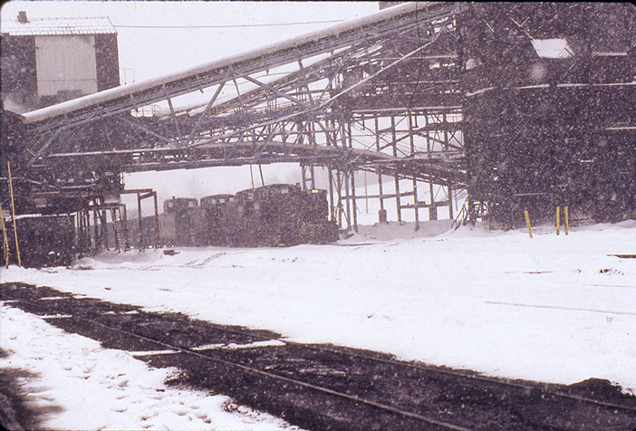

The mine railroad lasted right up to the end at Montour #10.
You could drive your car across the crossing down below the loaded yard, then make a left and drive out onto the spoil pile created by #10 that was used as a ball field. As you entered the spoil pile area, to your immediate right was 2 portals where the mine railroad
made daylight. From there was a short distance out and over the tipple. Montour #10 had a mine train rotary dump up on top of the tipple. Kind of a neat operation. Seeing that aerial photo sure brought back memories.
If you get down to Library these days, Port Authority has revamped their Library Loop quite a bit with the influx of new cars and the elimination of the PCC cars. I think the "loop" is now gone. The coal company buildings are also gone, however I think the Montour freight house survived.
You guys sure missed a good show watching the Montour move coal out of #10. Those SW-9's, in multiple, shoving coal up the branch with all of those back to back curves...not only the sounds of the SW-9's under load, but the compression of couplers as they were
shoved against on that hill created some good sound effects.

Gene Schaeffer

Many of my trips were out the line on mine runs. My favorite was to No. 10 in Library. We'd back the train into the siding on the east leg of the wye, run around to the back, and run backwards down the hill at the head of the string of empties. The trip back up was what made it worthwhile! That grade starts at over 1.5% right out of the tipple and goes to 2% and over 2.5% on the way back up to the Junction. We had to make multiple trips to get all the loads back up the hill.
I've long since forgotten how many loads one of those old Mikados could drag up the hill! At the top we put the train of loads together, backed out onto the mainline once the dispatcher gave us clearance, and we were off for Coraopolis.
A couple points here. We backed out onto the main, as to back up out of the wye toward Library would have put the trainload of loads on the 2% grade - impossible to get it started. The reason the locomotive backed down the hill with the empties was for visibility and safety, of course, but mainly so the sanders would be in front of all drivers for the trip back up.
Trains of loads went straight through to Coraopolis without stopping at Champion, as No. 10 had its own cleaning plant. They produced metallurgical coal - a more pure grade used
for coking, and it had to be kept separate from the regular coal.
Bill Bigler

The Montour had a siding below #10 tipple. Coal from Montour #10 was pulled out on the main and the crew ran around it here then pulled it back up the Library Branch.
There was a road crossing just below Montour #10 loaded yard switch. And for some time, the Montour had a crossing watchman assigned here protecting movements both on rail and highway.

As for Montour #10, you probably don't know this, but during summer months the Montour Railroad slowed down tremendously, I guess back in the '60's. Since the Montour hauled mostly coal, orders for coal coming out of the mines slowed and I have been told by many trainmen that had seniority, during summer months they were laid off. Some of these trainmen worked on other railroads such as the P&WV

When Montour #10 was idled for many years back then, I guess the need for an added expense in a preparation plant was no longer necessary and the whole operation...mining coal and the preparation plant...was downgraded. When the coal industry started picking back up in the early 1970's, Montour #10 and its met coal was a money maker for the coal company, so Montour #10 was reopened and its coal was shipped to a central location...Champion where it was processed.

Gene Schaeffer

Despite some past attempts to explain it, I still get confused about which side of the tracks #10 mine was located on (at least the mine entrance). I know, I know, straight down!

Now, to keep me from getting confused again, let's assume I'm standing under the tipple (wouldn't that be nice?) facing toward the trestle, hill, and Library Junction. Is the mine on my right or left??

Bill Bigler

Yes! (ha ha ha)
Or should I say No, It's under you... LOL
Sorry, I couldn't help myself. The real answer is yes. All mines have more than one porthole or shaft. This is for safety and ventilation, good air in, bad air out. As a mine grows more are added. #4 had a shaft at the tipple and a porthole across the tracks. The coal came out on a conveyer belt, over the line and into the tipple. There was also another shaft in town at the supply yard.
Our beloved #10 had 3 portholes near the tipple. Two to the North as Gene stated, near today’s ball field, the other was across Brownsville Rd. and was reached by a small double track bridge.
The slag dump was reached by a bucket line, buckets on steel cables overhead, much the same way #4 did. Most of the mines where built in the same manner. Sisters so to say, owned and built buy the same people.
Let's take a walk though the old town of Library. On the corner of Rt. 88 and Brownsville Rd. there is the gas station, Still looks like a gas station. Head down Brownsville to the first road on the left, That's Pleasant St. On your right was the old movie house, Later Ruby's dance classes, Firehall parking today. To the left is the company store, walk around back and in the brick work, you can find the words 'Champion Stores.'

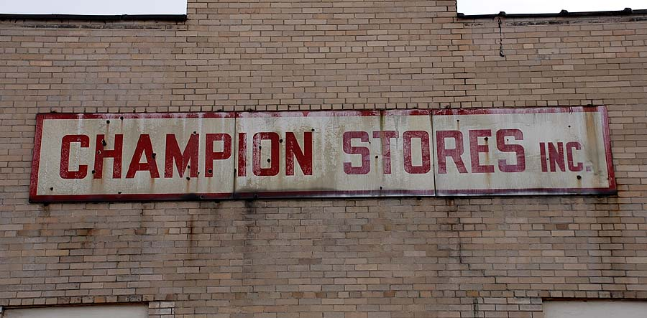

Gene Schaeffer photo
As of last Thanksgiving weekend, it still read "Champion Stores, Inc." on the rear wall. Sometime later, it became a laundromat, but has been abandoned as long as I can remember. Oscar's used car lot is right next door to this building.
--Chris Osterhus

Cross over the trolley line and on the right was Repair shop for #10 with a rail spur into the rear. It's a parking lot now. Next to it is the Montour freight house. On the left side of the street are garages for company trucks or horses.
Walk up under the railroad overpass and on the right, on top of the hill are a group of houses known as 'The Bungalows'. This is where all of the bosses lived.
Back out on Brownsville Rd. head east past the trolley loop and the bars. The road does a funny little S-curve. Stop here and look! This is a great place! The S is because this is where the Pittsburgh and Charleroi streetcar line crossed the road and headed up the hill between the houses on Cardox Rd. and the slate dump. Directly overhead are the mine cars hauling coal out of #10. To the left across the creek is the tipple and cleaning plant. It's a dry plant, cleaning the coal with blown air. The bag house isn't working so well today so coal dust is everywhere. Don't forget about the bucket line overhead hauling soils to the dump.
A Mike is working the loads yard making up a train. The smoke hangs heavy in the valley today.
Further down the road is the old school house. On to Edgewood St. on the left across the tracks we have 'The Patch.' This is where the workers lived.
Head east again on Brownsville Rd. and duck under the Montour one more time. On the left is a road into the new County Park.
A different place and time.

Don McCarty

Personal Stories

Thinking about our hole in history, here is a thumbnail sketch of my relationship with the Montour:

My grandfather, Charles J. Eggbeer, worked for the Montour in the Coraopolis office from the late '40's until his retirement in 1955. Starting in 1950, we had a car (we lived in Cleveland) and would visit the grandparents on Thanksgiving. Grandfather knew I had been interested in railroads from the start, growing up a block up the hill from a NYC branch line in Franklin PA - freight station, small yard, and a few industries in town.
So, each visit grandpa would take a day and take me down to the Montour and show me more and more each time, to teach me railroading from the ground up.
He (and everyone else) always stressed safety. We started in the office where he explained what went on and who did what and why. He worked in the accounting department and did payroll and handed out checks, so he knew everyone! He took me next door to the dispatcher's office and showed me how they controlled trains, issued orders, etc - all by telephone and those big books and pads on the dispatcher's desk.
Next, on to the engine house and yards. The hostler showed me what he did, let me up in the cab, and let me ride one engine (steam back then) out of the house to the ready track. Next was a tour of the yard from the cab of a steam engine, including a ride to P&LE Junction, with a load of coal to exchange for empties. Obviously, I was hooked!
I bugged my parents and grandparents constantly about how soon could I go back. So my folks made some calls, and arranged for me to take the train myself from Cleveland (Cleveland Union Terminal) to Coraopolis - Erie RR., with trackage rights on the P&LE for the last part of the trip. I spent a week each summer in Coraopolis, and you know where I spent my time!
Next were rides in cabooses and engines to Champion and a complete tour of the
facility, inside and out. I was fascinated - so big, so noisy, and so dirty! And the way that car dumper turned the cars over, emptied them, then the cable winched them out and they rolled down the hill.
Next trips were out the line on mine runs. My favorite was to No. 10 in Library. We'd back the train into the siding on the east leg of the wye, run around to the back, and run backwards down the hill at the head of the string of empties. The trip back up was what made it worthwhile! That grade starts at over 1.5% right out of the tipple and goes to 2% and over 2.5% on the way back up to the Jcn. We had to make multiple trips to get all the
loads back up the hill. I've long since forgotten how many loads one of those old Mikados could drag up the hill! At the top we put the train of loads together, backed out on the mainline once the dispatcher gave us clearance, and were off for Coraopolis.
The trip back to Coraopolis was fun with those loads. Especially the tunnels - they were either on slight upgrades, or in the case of National, the grade topped out in the tunnel, but since the train was still strung out on the grade, he couldn't shut off through the tunnel to minimize smoke and fumes. You sure found out how long you could hold your breath before you started breathing through the water soaked bandana!
The diesels never excited me like the steamers did. During the transition, I'd always ask for rides out the line in steam engines if any were going out. However, what I'd give to get those diesels back today!
Bill Bigler

I found your last email about your Grandfather interesting, as my Grandfather, J. M. Roth worked on the Montour at this time.

Carter Roth

My grandfather was Charles J. Eggbeer - they probably knew each other.

Bill Bigler

Bill, I have some news for you about your Grandfather.
When I started with the Montour as a messenger boy, I had a period of time to kill each day after lunch. For about an hour or more I had my own desk were I would sit and read, look out the window or make models.
My "office" was in the old house on what is now Rt51.
In the other corner of this office, at a desk just like mine sat your Grandfather. As I remember, he didn't seem to have much to do and always felt that they kept him on out of respect to an old railroader.
At the time I had no idea who he was or what he did. Back then I was just a kid.
We didn't talk much, mostly due to his condition. I do remember that I was building a model car at my desk and the next day he came in with paints for my project, just like that.
After that, even though we didn't talk much, I felt that he was a special person. He always came to work dressed in a suit, a very neat gentleman. How I wished that we could have talked together.
You said that he retired in 1955. Bill this was 1957. After I moved to the shops, I never saw him again, but I never forgot him.
My memory is that he was he was a fine old gentleman and wish I knew him better. Can you add to this?

Carter Roth
Carter,
He may well have retired later than I remembered, so I'm not surprised you remember my grandfather from 1957.
Communicating with him took some getting used to, but I don't remember that we kids in the family had any problems - probably were used to it.
I think it's incredible that you knew him and remember him. I'm not surprised he brought you paints for your model - he was that kind of guy. And yes, he always wore a suit and tie. He said that if he ever got fired, it would never be for being sloppy or late for work or goofing off.

Bill Bigler

My grandfather didn't work directly for the Montour but may have been employed by the Pittsburgh Coal Co. He was a mining engineer and must have been in some of the Montour mines since his took pictures in 1950 of the Champion plant.
I know he also worked for Joy Manufacturing so perhaps his job was to sell mining equipment to the Montour mines. I also have a number of pictures of him in mining garb.
His name is the same as mine.
Ken Caine

The mines were one place my grandfather wasn't able to get me access to. However, my dad and his brother had a business in Cleveland that made replacement parts for mining machinery, from small nuts & bolts to clutches & transmissions and their parts.

Initially this was for equipment manufactured by Joy Manufacturing. Later Jefferies and Lee Norse got into the act (1960's). Joy liked having someone else take care of the spare parts as it saved them from a part of the business that was more nuisance than anything else. My dad's company basically set their prices about 5% below Joy's and provided superb customer service, including always having parts on hand or warehoused somewhere so they could deliver to a mine quickly in an emergency.

His company's biggest part of the spare parts business, however, was conveyor chain and chain flights. This is BIG chain - no bicycle size chain here! One to two inch pitch. I worked for my dad's company during summer vacations, and when big orders for conveyor chain and flights would come in, he'd wring his hands with glee as he exclaimed "water and coal dust make a great grinding compound!" The stuff literally devoured itself.

It was through my dad that I gained access to numerous coal mines. Coal mines are among the most hostile places you'll find!

Bill Bigler

Re: [montour_rr] COLD COAL

Reminds me of the time I dropped a co-worker off at the P&LE scrap plant in the winter one early, frigid morning back in 1975. We put 4 center plates in the trunk of my 1966 Pontiac Catalina. Each one probably weighed 125 lbs. That car did a wheelie leaving out of there but man-o-live what traction!
Kurt Anderson

I'm new to the list and thought I would introduce myself. My name is Paul Koren and I'm originally from Western PA, now living in Oregon.
My grandparents lived about a half mile or so West of the Hendersonville mine site, and that's my connection to the Montour. My grandfather had worked at the mine, and the Montour tracks ran right in back of the house. When I was young, we would visit my grandparents at least once a week, and my earliest (vague) railroad memories are of watching Montour steam.
No doubt it was the Montour that led to a lifelong fascination with railroads. While the steam memories are very vague, the SW-9 memories are vivid.
I remember sitting on the back porch of my grandparents' house on those humid, lazy Pennsylvania summer evenings with a cool breeze coming from the woods across the tracks, then hearing the crescendo of a coal drag building up from the direction of the National tunnel.
If I sprinted down to the tracks, I could watch the whole show unfold from beginning to end.
Funny how certain memories become icons for certain parts of your life, but I don't remember my
grandparents' house without thinking of the Montour.
Like many of you on the list, it was particularly sad news to me when (already living in Oregon) I learned that the Montour had been abandoned.

What really makes me feel good about the MRR website are the pictures of coal trains. They remind me of a somewhat simpler time.
In the morning, where I work, I see a coal train every day (right next to the Union RR ROW). This view is VERY similar to the pictures posted.
My daughter (who is 10) asked why I am so fascinated with trains..
1. I have seen/heard them since I was 3.
2. I remember seeing the Bicentennial Train going thru Edgewood in 76'. One time walking home from school, I remembered seeing a boxcar on a siding, near where I grew up, (there was a lumberyard/sawmill there)
I have not read all the postings, but I'll bet we all have great memories of trains from our youth.

Bill

Where does one start?
Remembering back to the 1970's when train crews were shuttled around via Coraopolis Taxi Service.
Seeing bib overalled trainmen climbing out of those unique checkered taxi cabs. Watching Montour car shop employees "hostle" locomotives out along the line of road with the car shop flatbed all dressed with Montour logos on the cab doors carrying
around 55 gallon drums of sand for the locomotives, then seeing the bucket brigade load sand into the SW-9's...and remembering back to a time at Thompsonville, during late summer, when a consist of SW-9's needed radiator cooling water, and Easton Lumber was a location where a garden hose was kept and the train crew gave a teenager the nod to "go ahead" and climb up on the hood of those SW-9's and unscrew the radiator water fill and put the hose inside and fill those radiators...
So many times riding the caboose platform down the Library Branch, as empty hoppers were shoved down the hill for Montour #10....then riding the SW-9's back up the Library Branch as 2 and sometimes 3 cuts of coal were shoved up to Library Junction...at a time when Superintendent J.E. Schomaker placed a 13 car limit on the shoves so as to prevent the SW-9's from derailing on the bad track.
Absorbing all of the sights and sounds of those SW-9's shoving a loaded coal train back up the Library Branch...
One winter’s Saturday night when 4 SW-9's and 45 cars of coal for the Union RR interchange at Mifflin Junction pulled into Salida with Conductor Mike Desko riding the head end and engineer Herb Wirth and 2 P&LE trainmen, and Mike giving me the O.K. to ride to Mifflin and return over the P&WV Mifflin Branch.
Then weighing those 45 loads of coal on Montour’s Mifflin Junction scale...wondering why the 3rd load over the scale wouldn't roll on its own, and discovering that 3rd car was off center...and hearing the crew talking about seeing sparks coming off that car several times on their way east.
Bleeding off the air both at Montour #4 and Brookside thinking the brakes weren't
releasing.
And remembering the night the Old Track at Champion got away from the coal company car droppers, and seeing those 16 loaded hoppers speed their way through the rotary dump and after coupling into the 4 empty hoppers on the Champion empty hill, worrying for a few moments where all of those run-away loads and empties were going to end up, into the run-away track or hitting the empty hill derail and destroying the Champion Yard Office which was in direct line of the empty hill derail.
Then the time I rode into Montour Junction from Champion and the caboose was “kicked" over to Boggs and driving the caboose all by its self down to the west end of Boggs using the hand brake to control the caboose’s speed as the crew took the engines through Boggs yard where their train was located.
And the time in 1973 following a Montour crew to Snowden, as the Montour train crew ate lunch at Snowden, along B&O's "Pike", along comes a B&O train out of Benwood running on #2 track and the fuzzy 126 instamatic photo I was able to get of the meet.
The 2 times I was able to photograph Montour detours over the P&WV so as to get around main track derailments.
Or the time in 1981 when I had the opportunity to reroute a Montour train crew over the P&LE, PC&Y and Conrail due to the derailment at Jeffrey Town Tunnel while working as a train dispatcher...and begging fellow train dispatcher Russ Wright to work the 12-8 shift so I could ride with the crew.
But alas, Russ chose to ride with the crew that I lined up, taking 7 engines, 70 empty hoppers and 3 cabooses, which turned out to be the last time a Montour train detoured over a foreign railroad.
Unfortunately at that time the engines were P&LE as were the hoppers, but the cabooses were Montour.
And the "unofficial" Hi-Rail trips Tim Sposato and I took on Saturdays over the main track. Then, that one night with Tim driving, we were taking a side trip to North Star "Y" and as Tim rolled that yellow Chevy van through Ackelson Curve at speed, and remembering me saying to Tim, about half way through Ackleson Curve, "ahh Tim, there’s a kink down here. We need to slow down"... but it was to late, the damn thing derailed on that kink and we bounced along 2 rail lengths of ties before stopping, then rerailing that van in darkness on frosty ties and rail.
One summer’s night I hi-railed alone from Champion to Brightwood Spur, and having the Bethel Park Police pull up and check me out, as I drove down the main, past their Public Works building in weeds that were as high as the van’s windshield.
All the memories, I could go on and on...
Gene Schaeffer
“If Mom Ever Knew…..”

OK, my turn. My memories of the Montour go back to the forties. My uncle was a coal miner (I don't know which mine) and they lived in one of those company houses on the hill overlooking the Montour in Hendersonville.
Visiting my cousins was one of the highlights of my youth because they did all sorts of "country" things like hunting copperheads and skinny dipping in a mud hole. We had to cross the tracks to get to the swimmin’ hole and traffic was frequent enough that it probably was more dangerous than we knew. My mother would have killed me if she only knew.
The only railroading I knew about was the PENNSY branch through Canonsburg so discovery of the Montour was a whole new experience for me. Strangely enough, my memories are not of coal trains but of relatively fast moving manifest freights powered by steam engines WITH THE HEADLIGHT IN THE CENTER OF THE SMOKEBOX pulling box cars and orange, white and yellow wooden sheathed reefers trailed by those wooden cabooses.
I took special notice of the multicolored freight cars because that was something I had never seen on "my" railroad.
Another high point was the money handling in the company store. The clerk would put the customer's money in a little car that ran on a cable to a central office that was out of sight somewhere. In a few minutes the car would come back with change and a receipt. Tennessee Ernie would have been right at home.
Joe Andrews

Derailed hoppers had been set to the side of the wye. They were great fun to play on sitting upside down. Mom used to turn me loose early in the morning and as long as I made it home for dinner, or at least before the street lights came on it was cool.
Donald McCarty

I'll bet your Mom would have tanned your hide, if she knew you were playing around those hopper cars. Just like mine would have if she'd known we were jumping on the Cheswick & Harmar RR coal trains that ran between Harwick Mine and Duquesene Light's Colfax power plant on the west bank of the Allegheny between Springdale and Cheswick!

Bob Ciminel

No, Mom would tell you how dangerous it was and turn Dad loose when he got home.
I only hopped the Montour once. Most of the trains were short little hops out to Brookside to swap out a car or two of lumber.
One day a string of hoppers came in from Longview and I couldn't resist the chance to take a ride.
I grabbed a handrail at the curve near Lions' Park. By the time I got to Jewel I figured out I'd have to walk back, and that was about far enough!
Those where the days of great adventures.
Once I decided to ride my bike to the W.V. State line along Route 50. That's the day I found Morris Mine, (not knowing it was part of the MTR then) about the same time my front tire went flat. That was a long walk home.
#4 was always a favorite destination. On the interchange track one could see where the crews had cleaned out the hoppers and resecured the doors. Little piles of coal, stone and best of all, iron ore pellets. I always filled my pockets with them. They were great in a slingshot.
As for those hoppers laying belly up along the Library wye, I can't really say what road they where from. You see they were upside-down and I couldn't read them. LOL ☺
The cars where laid in a line parallel to the track. Like they where going to come back later to pick them up. If I had to pick a color I'd say they were black.

Donald McCarthy
My family moved from Philadelphia to a home near Rocky Ridge in 1957.
At the time I thought it couldn't get any better for a 12 year old kid to live so close to a railroad.
I met a kid my age, who loved trains as much as I, and he became my best friend. We spent a good deal of our time exploring the Montour and walked the tracks to Mifflin, Southview, and Library.
Anytime we heard a train we would run up to the tracks to get a closer look. As time went by we started "camping out" in the summer on Friday nights around Rocky Ridge or Library Junction and we would hear the SW-9's straining with a string of loaded hoppers as they slowly worked the grade at McMurray, I think it was about 9:00 or 10:00 pm. The fact that we heard that from so far away and it would grow louder, only heightened our anticipation.
Eventually, we started to hop on and ride to Mifflin where we would get off, use the bathroom at Eat n Park to clean up and get back up to the tracks in time for the ride back with the empties.
We had a spot near a cut at Library Junction where we would jump off. We had “groomed" this area of anything harmful to us, as they would be going at a pretty good speed and our exit off the train was more of an awkward stumble, followed by a long roll.
Between mileposts 33 and 34(just east of the McMurray road bridge) there was a Montour work shed along with a hand pump car.
One moonlit summer night after the train of empties had passed, we got it on to the tracks and pumped all the way up to Jewell. We commented that we now knew why we never saw it being used because it was hard work getting up that grade. We started coasting back down and by the time we crossed over Sugar Camp Road, I believed it was the fastest I had gone at that point in my life. There was a mine ventilation blower west of Library Junction, where there was a wheel flange lubricator, and it was a blur as we sped by. Convinced that we would not make the curve ahead, I put my Keds on the brake pedal and pressed with all I had.
My heart was still pounding as we returned the car and walked the tracks back home. That was a one-time only adventure that we never tried again.
After high school, I went into the service and subsequently moved to New Jersey. Later on, business would take me to Pittsburgh and I would always make time to take a drive from Hill Station and #4 to McMurray and #10 at Library.
There is a point on McMurray road near the county line where you would be perpendicular with the track and you could see the Brush Run bridge.
I always looked whenever I drove by, hoping to see some activity on the track. Even after the tracks were removed, I would still look; go figure!
A few years ago, I was in the area and drove up Brush Run Road to a parking area they have on the Montour Trail. I walked down the trail to Library Junction and was shocked to see all the homes in areas where I used to camp near the tracks.
I walked around the wye, remembering where sidings and tool sheds had been. The next time I'm in the area, I will go by #4 to see what it looks like now, although I prefer to remember it as it was.
I will always remember the nightly drone of a Montour eastbound, looking out my bedroom window and seeing the headlight, with the background of a reddish sky caused by the hearths at the mills.
Carl Timm

Way back in the summer of 1973, I followed 3 Montour SW-9's and red caboose #33 down to Snowden. I had a Honda CB-200 motorcycle back then. Even though the CB-200 was a street bike, often it wandered off-road and onto Montour’s right of way.
On this long lost date, the Montour crew took lunch at Snowden, and as they sat there, down #2 main at Snowden, came a B&O crew heading for Glenwood. My instamatic camera captured that moment although it was a blurry moment.
I was also down there one Saturday about a year before. It was a rainy day and 2 or 3 blue B&O units arrived at Snowden to pick up off the Montour. There was no Montour crew there on that visit.
Back during that period, I was 17 or 18 years of age. I kick myself for being there with a junky camera, but can't change it now...
And of course the last Montour crew to Snowden had a terrible trip. The engines derailed 2 times shoving down the Library Branch. And finally, as the caboose arrived at Snowden, with the train of coal loaded in P&LE equipment, the 7 loads next to the caboose derailed. The Montour hailed the services of Chessie to provide locomotives to do the rerailing. Seeing 3 GP-40s rerail the cars was interesting.
And after that 1975 date, that was the end to Snowden other than perhaps an "un-official" hi-rail trip here and there...

Gene Schaeffer

I was riding in steam locomotive cabs back as early as age 3 or 4!!! I lived in Franklin, PA, a river town about halfway between Pittsburgh and Erie. A NYC branch line came to town and the daily local stopped at the freight station, which was a block down the hill from our house. It then switched the town for a couple hours, filled the tender from the steel water tank, and headed for Oil City.

I wasn't supposed to cross the street, but hey, there was almost no traffic, and the train was over there. Didn't take me long to figure that one out.
I sat on the steps of the freight station watching the engineer "oil around" while the fireman tended the fire and the conductor went into the freight station to get a list of work to be done and where cars were currently spotted and where the station master wanted them to be spotted.
After a week or so of watching this, I knew all the spots that needed to be oiled on that Mikado. One day the engineer missed one and I pointed it out to him. He almost dropped his teeth!
He asked how I knew that, etc, one thing led to another, and he asked me whether I'd like to come up in the cab. I quickly learned that you always answer "would you like to" questions with "sure!' So he picked me up and set me up on the deck and showed me the cab. The fireman opened the butterfly doors, and I said something like "Wow! That sure is hot!"

One thing led to another: "Does your mom know you're here?" "Sure!" And eventually: “Would you like a ride down to Brown's Boiler Works a block away, while we drop a car inside and pick one up!”
I thought he'd never ask. I spend many an hour with my buddy playing down there and we had often looked in the big door of Brown's Boiler Works and were dying to see inside - what went on. This was my chance!

After that, cab rides around the yard and around town were a regular thing for many years until we moved to NE Ohio where I did the same thing with the Nickel Plate. Never got a ride in a Berkshire, but did get a ride in a Mikado the 10 miles to Painesville and took the bus back, and once got a ride in the cab of The Nickel Plate Limited in one of those Alco PA Bluebirds.

When my grandfather went to work for the Montour and set up cab rides on mine runs, it was business as usual for me. Guess that kind of thing just came naturally. Hang around until they think you belong.

My friend and I also went for many an evening hand car ride on the NYC just off its main line in NE Ohio. They left the hand car outside, and we were always careful to put it back just as we found it. We used long poles for propulsion down the branch and really got that thing rolling.

Mom: "Where did you go?"
Me: “Out.”
Mom: “What all did you do?”
Me: “Nothing!”

And the beat goes on!

Bill Bigler

I grew up in Enlow and watched the activity on the Montour daily.
We used to play baseball at the Enlow field. The ground rules stated that any game had to be stopped to let a train go by. (The tracks were the out of play line on the 3rd base side. As the train would go by, we would throw baseballs off the sides of the hoppers. If you hit a flat spot, the ball would come right back to you. If you hit a rib, the ball would follow the train down the track....
For 2 summers (late 70's), we used to ride maintenance carts from the Jeffreytown tunnel down to the Cliff Mine crossing.
My dream was to always get a cab ride in a Montour SW9. Unfortunately, that never happened.
However, in the late 90's, I was living in Baltimore, and I would take my 2 year old boy down to the Sparrows Point Bethlehem Steel plant almost every Saturday and Sunday morning. The plant is serviced by the Patabsco and Back Rivers Railroad (PBR).
The majority of their engines at that time were SW9's. Conrail and CSX trains also make daily drop offs and pick ups. Anyway, the guys got used to seeing us and started picking us up.
They let my boy and myself drive every morning. We got to pick up cars, drop them off, ride through the mill and service the industries along the right of way.
They gave my boy all kind of goodies - a lantern, work gloves, hats and a railroad sign. These guys really went out of their way to make my boy’s day (and mine!!!). Well then 9-11 came along and of course all of that changed.
I still have lots of pictures, and even some video, and of course, I finally got an SW9 ride.

Jack Chamberlain

I guess you know, my official "first" day of employment on the Montour RR, Friday June 25, 1976 began at Montour Junction, where I was placed...Section #1 - Champion under R. Maga.
I was very fortunate in being hired.
The P&LE was hiring many maintenance of way employees to begin overhaul of the Montour RR.
After recieving word I was hired, passing the physical was next. We were warned a day before, watch what you eat and drink for your urine test.
20 of us were hired in my group, only 3 passed the physical !
After receiving safety gear, the 3 new hires, followed Supervisor of Track, P. Muto to our respectful gangs. R. Maga was working at the ball field at Enlow, and that is where my career began, as I worked out of all places, Champion !

Speaking of Baltimore and Sparrows Point, the fellow who introduced me to photography was a Western Maryland man. He knew the WM well.
On weekends when the Montour was idle, we used to travel to Bowest, Cumberland, Elkins and shoot anything Western Maryland.
One such Saturday we had caught up to a coal train climbing Sand Patch. The lead locomotive was a red & white WM SD-40. The entire train was 100 ton P&LE hoppers. So we followed and photographed the train as best we could into Cumberland. The unique thing about that coal train, it was a P.H. Gladfelter train that just 2 days earlier, was loaded entirely on the Montour RR at Champion. I probably "wheeled" half of that train at Champion for its trip into Montour Jct.

Anyhow, back to Enlow. I made a photo of that ball field, 3 SW-9's, 1 PRR(?) hopper that was pulled out of the car shop and a green caboose, eastbound. Little did I know when I made the photograph, that exact location 1 year later would be where my short career on the Montour RR began.
And near the end, I visited the ballfield one last time during removal of rail & ties. That was a sad time in the life of the Montour RR. Only a few years earlier, so much time and money was being invested in the roadbed, and now it was all gone.

Reading Tim’s message awhile back concerning the miners, I often kick myself for not seeing the mines as a factor in recording the railroad. I was too busy to see that 2nd page of that story. When this photography hobby began, I was 18 years old. My parents had no interest in my interest and if it wasn't for D. Dudjak, photography would of never entered my life. I learned by seeing Dave's work, and work of some of his friends.
Attending slide shows during those early years, I often was shocked at what others were doing with a camera and film. During those moments I knew I had to follow suit.

Back to stories...
On page 106 in the Montour book, bottom photo shows a hi-railer on the Bridge at Brightwood in Bethel Park. On occasion, I would join Tim in hi-railing the Montour RR, mostly on Saturdays when the railroad was idle. Tim, was this particular trip the time we returned the rail at Alleco that was removed from the main track near Broughton Road overpass. One rail was removed from the main track on order from Superintendent J.E.S as application was made for the first phase of abandonment. We also replaced the rail at the West Switch Salida. The frog was removed for use elsewhere on the Montour, so Tim cut a new piece and we spiked the main track back together at both locations so we could complete our hi-rail trip.

On that trip I believe Tim & I went down the Library Branch. I wanted to try for Snowden, but Tim was cautious, so we turned at Wood Street crossing and came back up the Branch.

One Saturday evening, I hi-railed alone in this same PC truck.
Leaving Champion using the shove-up track as my set-on point, I would back through the West End Champion crossover and out onto the main track, then head east. Speed was somewhere around 30 MPH on the 115 pound rail to Gilmore Jct.
East of Gilmore Junction I was more cautious and remembered Tim warning me about a couple of joints inside Kamps Cut that looked normal, but for some reason would derail the pony wheels.

East of Montour #4 the trip was sweet. Loose rail joints and that ever loving sound of wheels slapping those loose joints made the trip rewarding. On one particular trip, as I eased over the bridge at Brightwood pictured in the book, alone, it was dusk and the weeds were about 2 feet high between the rail. I had just passed over Slaters switch, eastbound and a Bethel Police car paced me with his spotlight on me. It was almost dark and I stopped to see if the Police man wanted to question me. I went as far as Horning Road on that trip, then backed all the way to Library Junction where I turned on the wye and headed back to Champion. I had planned on setting off at Horning Road, but there was so much traffic there, that I decided simply open the back doors to the van, and back west.

Passing through Kiefers you had to be careful. There was a mountain of sand that came up onto the right of way and I shoveled some of it off, and eased over some of it.

I remember as I went through Thompsonville hearing the train dispatcher’s radio key on and off. So I keyed the radio in the hi-railer and few times. Who ever was in train dispatcher’s office again keyed the base station. I thought it was the night dispatcher who also, like me, started out on the track gang. The night guy on weekends when the railroad was idle would come in early and do his paper work. The night train dispatcher was viewed by many as being the best train dispatcher the Montour RR had, even though he was quite young versus the old heads.

Some of the crews would call him "_ _ _ _ - _ _ _" so I took a chance and transmitted, "_ _ _ _ - _ _ _ " is that you? His familiar voice echoed back. He wanted to know who I was, but before responding I asked, are you alone? He hesitated, but acknowledged he wasn't. I figured he had his wife with him as he often did, so I asked is your wife with you? Again, he hesitated, but acknowledged and probably by then knew who he was talking to.

I was quite certain this train dispatcher would not turn me in to the Superintendent, so I told him it was me and what I was doing.
He chuckled in his reply. He said he wouldn't be long and was leaving.
Slapping rail joints returned to the hi-railer as I slowed cautiously passing Thompsonville towards Montour #4. The roadbed through here, that worn 90 pound rail over the bridges down past the empty yard was rough. It was dark out and I didn't want to derail here. Passing the loaded yard, the train dispatcher told me he was leaving and as I echoed a reply, I was passing through Kamps Cut...followed by a couple loud bangs from the pony hi-rail wheels as I felt sure they tried picking one of those bad joints...

Once west of Kamps Cut, speed was brought back up and I sailed up through Greers Tunnel...Henderson, around the curve at National on the welded rail, down through Muse Junction and around another sharp curve.
Half of this trip was on brand new 115 pound rail with the other on older 115 pound rail. An hour later I arrived Champion.
I hi-railed down over Boggs and set off. Backing through the facing switch points at Champion made me nervous, so it would be easier going to Boggs and setting off.

My next trip a week or two later was another Saturday afternoon trip to Westland. That adventure was a nightmare. Heading in at Gilmore Junction, that freaking Dodge hi-rail van derailed on the Gilmore Junction frog. I think the switch was 115 pound rail, and it took me sometime...alone, to rerail that truck. Lots of sweat, a track jack, some old pieces of crossties and lots of cussing.

Once back on the rail, hi-railing the Westland Branch was wonderful.
All brand new 115 pound rail was smooth as silk. But in the back of my mind, I couldn't help remembering the derailment. Listening to the flanges on the hi-rail pony wheels as I traveled the Westland Branch was a constant cause of concern. The Westland Branch was one curve after another and I was worried this old Dodge van might again leave the rail. Arriving at Westland, I pulled down near the tipple.
Lifting the pony wheels, I turned the Dodge and set back on. Westland was silent this Saturday afternoon, and in moments, I was again hi-railing West...Trackage at the empty yard switch was terrible and again I eased through here slowly. The switch to the empty yard was typically reversed as crews often pulled their train out of the loaded yard, then after taking lunch, pulled past the empty yard switch with the entire train, and backed in, coupling to the caboose.

The empty yard switch was usually left reversed, but on this Saturday, I left it lined down the main.
When I returned to the scene of the derailment, slowly, with the door opened, and me hanging out as far as I could, I watched myself as best I could back over the Gilmore Junction frog.
I made it over the frog without incident and headed back west to Champion.
Those indeed were Great times along the Montour Railroad...

Gene Schaeffer

Gene, I do not have your talent for telling a story, and I do not have exact dates as I was in my mid teens at the time….
I do remember you saying that you started working at Enlow. That is part of the reason I kept quiet for so long. I was afraid that I might have stolen my first cart from you !!!
But, after looking at your date of 1976, I think that I am OK. I am probably talking around ‘78 or ‘79.
One afternoon, one of my buddies and I were at the ball field, walking towards the Jeffreytown tunnel, were I spent half of my childhood growing up. Well, lying on the side of the tracks out by the outfield fence was a maintenance cart (It was red with wood floor boards - with a hole through the bottom of it).
We decided to place it on the tracks, push it and go for a short ride. At the time, I never really paid attention to the fact that the track elevation dropped significantly from the ball field and down past the tunnel.
All I can say was we were terrified by the time we came shooting out the far side of the tunnel. We thought for sure that a train would come along and were going to get creamed.
We started frantically dragging our feet off the back of the cart and finally got it stopped down at the end of the straight-away after the tunnel. From there we started again and dragged our feet every so often to regulate our speed until we got down near the first at-grade crossing at Cliff Mine Road and the tracks evened out.
We then pushed the cart back up near the tunnel and hid it behind a dirt hill. We took it out nearly every afternoon for the rest of the summer and went for a ride. We would push it back into the tunnel and ride all the way down to the crossing at full speed.
On a good day we would just clear the crossing. A few times we came to rest in the middle of the intersection. I always held my breath and hoped that my parents would not be sitting there one day in the family car....
Yes, I know that this sounds extremely stupid. But, once we were ready to go and sitting in the tunnel, we would get perfectly quite and listen for a whistle. We figured that we would hear any train coming through Enlow or at Cliff Mine. And of course you know that the train speed was very slow at that time, due to track conditions. Also, we were always prepared to jump off in case we rounded a bend and came face to face with a train. I have to say that this never did happen.
Anyway, one day some of our buddies borrowed the cart and did not hide it when they were done riding. The next day we went back for it and it was gone. I can only assume that an Engineer spotted it and that the railroad reclaimed it.
So the next summer (maybe ‘79 or ‘80), I spotted one on the siding at Wicks furniture. It was attached to a maintenance set up with a motorized cab and several different style carts. Every car in the set was yellow.
We disconnected the cart during a driving rainstorm and took it back to a new hiding spot at a dirt crossing after the tunnel, as it was much heavier than our first one, and we could not get it back to our original hiding spot. We went back the very next day for a ride and it was gone. There was a house back there in our line of sight. I always assumed that the guy living there had seen us hide it and called someone about it. That was the last cart that we ever had.
Both of them were just plain carts, no hand pumps or anything else on them.

Jack Chamberlain

GREAT story Jack...
PLEASE, keep them coming.
I, like you borrowed our cart from the Montour.
Shucks, if I only took some photos back then... And recorded dates of trips and details.
And not to worry, Jack, one such trip of ours, found us departing Salida just after dark.
Hours earlier, a Mifflin crew departed Champion with Train Orders into Salida.
But we set on anyway, and headed west ...
I think it was 6 hours from Champion to Salida then, so we had 2 or 3 hours in our favor before expecting a headlight meet.

Gene Schaeffer

Speaking of "if mom ever knew" stories and getting cab rides by hanging around, it's still possible. However, you need a prop - a kid. Preferably between 5 and 10. If you can, find a stretch of road where you can pace a train, and have said kid keep waving to the engine crew, then follow them to a crew change/fueling point.

Here in the Corning area, at the former Erie, now NS yards, at the south end, through freights often stop to make set-outs & pick-ups. I've waited there with one of the grand kids, started talking to the engine crew, and had them invite us up into the engine. Then they asked if we wanted to stay up there while they made their set-out & pick-up.
This was after 9/11. Takes persistence, though - just keep showing up. And don't ask - wait for them to invite you. But it can still be done.

Bill Bigler

You’re right Bill, we have a few "riders" here on the OCRR.
I know a teenage boy and a girl that will show up from time to time wishing for a cab visit or ride. Actually I used to give a teenage boy rides in the steam engine a lot in the early 90's. He has since become a conductor here and is now an engineer . So it can benefit the RR too.

I now think back, how I would look up at the cab window or caboose with those pleading eyes at that age and the thrill I felt when the friendly crew would invite us aboard.
I figured now its my turn to please a youngster, as those fine gentlemen had done for us.

Trouble is now a days the liability, Homeland Security, owner and our RR police department all frown on this. You have to be discreet, similar to what the MRR men had to do.
At least back then, it was just the superintendent and the bulls that may cause trouble.
But, a few of us still do it, just don't tell anyone!

Somewhere in my paper collection, I have the bulletin from Montour Superintendent FC Rauschart, warning the crews that he is aware of crews giving young boys rides in the
Brookside and Salida area. He stated that it must cease, or actions will be taken to those who break the rule.

Tim Sposato

I remember those days of wondering. “Will they or won't they let us up for a ride into Mifflin?”
What an incredible rush to hear from the engineer one early misty morning, " Come on up before somebody sees you."
As a conductor on NS in today’s world, I feel a little guilty. Like you said, Tim, with bulls, trainmasters, and road foreman hiding in the weeds just to catch you doing something wrong, the thought of inviting kids aboard is pretty much out of the question. What a wonderful gift those MTR men of the 70's gave us. I will never forget!

Kurt Anderson

A Tip of the Cap

Today I learned of the passing of Conductor Mike Desko.
Mike was one of many Montour Railroad employees who understood the interest and fascination that this small southwestern Pennsylvania coal road held for that young man who grew up near Longview.
Mike was one of those guys who never minded my endless questions about the railroad. Mike seldom turned down my request to ride his caboose (#34) or the locomotives.
I first got to know Mike sometime in the early 1970's. It was around 6:00 P.M. on a Saturday evening. The sounds of approaching SW-9 locomotives under load intensified as four SW-9's hauling 45 loads of coal made their way through Bethel Park, Pennsylvania enroute to the Union Railroad at Mifflin Junction all within earshot of our Bethel Park home.
That Saturday evening run into Mifflin Junction was a bit unusual for a Saturday night.
After stopping at Salida to call the N&W (ex: P&WV Rook Train Dispatcher) to obtain permission to enter the N&W Mifflin Branch for the 3 mile run into Mifflin Yard, Mike gave me the o.k. to ride with them.
Mike had 2 P&LE trainmen who were unfamiliar with this part of the railroad, so he was riding the locomotives. Mike gave me and another friend the o.k. to ride "round-trip" from Salida to Mifflin Junction and return.
Upon arrival in Mifflin Yard, the 45 cars of coal needed weighed prior to delivery to the Union Railroad.
Watching trainmen bleeding the air off 45 loaded Montour coal hoppers, then gently shoving them over Montour’s Mifflin Junction scale one by one was "the" experience of a lifetime.
Mike allowed me to ride the Library Branch many times as they bailed coal out of Montour #10. Mike allowed me to walk with his trainmen as they assembled their coal trains in the loaded yards at Montour #4 & #10.
Mike always made extra copies of his train orders so I could add them to my memorabilia collection.
Mike also had a unique characteristic in his voice.
Mike was always proper in appearance and meticulous in his work.
One of my most favorite characteristics about Mike was the way he radioed the Montour Train Dispatcher with that unique voice.
A simple "Montour Dispatcher" graced each conversation.
I was fortunate to obtain a tape recording of that voice.
Today, it graces this computer each time it is started.
Mike, Thank You for allowing me your time in my constant fascination in the Montour Railroad Company.

Gene Schaeffer

Thanks Gene for the Mike memory. Thank goodness we had the opportunity to know so many of the Montour personalities that made up the "Mighty M".
I recall one of the first meetings with Mike in 1970. Kurt A. and I bicycled to #4 Mine and waited until the #4 Coal Run turn showed up. We left the bikes at the car cleaner shanty for safe keeping with Warren and ate some of the lunchbox goodies he offered us. The short empty train arrived behind 4 units, with Roy Winters as engineer and Sam Lynn firing. Roy spotted us and told us to get in the trailing engine #74 as they had to go out to Boyce for more empties.
Mike soon joined us in the cab as we moved thru the transfer and down the Hill Track. When we stopped at the PC phonebox he allowed us to jump off to listen to the PC dispatcher give him the ok to move onto the Boyce siding and down past the golf course for more "yellow ball" hoppers.
The entire time Mike explained all the finer details of his daily procedure that he took so seriously. So much was remembered by us on just that one day, how could we thank him then or now?
Fortunately I had many more good times with this fine gentleman in the years to come. My last time to see Mike was at an unhappy time, the funeral of Fred Rauschart’s wife. Mike was just like old times, a short breathe of fresh air from the past.
Thank you Mike for being a true railroader, thank you for having the patience for Gene, myself and others you crossed paths with.
Your Reward has now begun.......God Speed.....

Tim Sposato

More Stories

The year was 1982.
The date, December 17.
My last day of employment with the Montour Railroad Company.
I worked 1st Trick Train Dispatcher.
No crews out at the end of that day.
No relief at the end of that day.
Westland Mine and Champion Preparation Plant were idled.
At 4:00 P.M. I said farewell to Chief Clerk Jane Guzik.
At that point, the Montour Railroad Officially shut down for the balance of that year.
What a sad time for the Montour Railroad Company.
The end was not far behind...

Gene Schaeffer

Since we are on tales of taking the long way around...
This account is from June of 1981 when a Montour main track derailment occurred at the east portal of Jeffrey Town Tunnel.
The Champion job left Champion with a train of coal for the P&LE. The locomotives this day were two P&LE SW-1500's, Conductor Bill Blumling, Flagman Fred DeGolier, Head Brakeman C.L. (Barney) Barnhart and Charley Ross
who was Engineer due to lack of Engineers on the Montour. (No engineers wanted to work that day)!
Anyhow, the details are as follows...
The westbound had just come down of the stiff part of the grade leaving Champion and down at the ballpark below Imperial, most engineers released the air and recharged the trainline as the grade leveled out here.
As this westbound entered the curve approaching the east portal Jeffrey Town, 7 loads derailed and went sideways.
Of course they were all P&LE 70 ton hoppers and most likely a few of them were scrapped due to their center
sills being twisted.
There were no other crews out this date so later that evening, Montour Management decided to detour a crew over the P&LE to McKees Rocks, the PC&Y to Scully and a Conrail crew to McDonald.
I was working the 12 to 8 shift Train Dispatcher that night and when I walked in the train dispatchers office that night, I was relieving Russ Wright who gave me the turnover about the derailment and a crew going on duty shortly to detour.
He told me take 7 engines...unfortunately they were all P&LE SW-1500's and three cabooses...all Montour...and whatever amount of hoppers you can put in McDonald Siding so the crew can bring all of the engines and cabooses back
to Champion without being fouled by too many hoppers clearing McDonald Siding...
After the turnover I begged Russ Wright to work for me that night so I could ride the detour.
Russ denied the request stating he was riding the detour.
So I instructed the crew to take no more than 70 empty hoppers. Russ had already ordered pilots for the P&LE...PC&Y and Conrail.
This crew took the better part of 4 or 5 hours to make the detour from Montour Junction to McDonald. The Montour crew built up their train at the east end of Montour Junction Yard and shoved down under the Neville Island
bridge to wait for the P&LE pilots. Then they shoved out on to the P&LE for their trip east to McKees Rocks where the PC&Y would take over. PC&Y crews handled the train to Scully I believe where the Conrail pilots took over.
I vaguely remember for some reason, the Montour detour was delayed at Wagner Tower. Radio transmissions between the crew and myself were full of static.
The crew was calling about the delay, but I can't remember all of the details. The detour arrived McDonald around dawn and pulled in on the Industrial Lead and up towards Primrose...shoving back down onto the Montour.
Once on top of the hill at McDonald and back on Montour rails, the empties were pulled back through McDonald Siding and tied down there. The seven P&LE SW-1500's and three cabooses ran light back to Champion so the Champion crew
had two locomotives to work with and a extra SW-1500 for the second Champion crew when they arrived there several hours later.
A second road crew was called and taxied out to Champion (4 hour arbitrary deadhead for a road crew taxing) to get the remaining four SW-1500's and one caboose and headed back to McDonald for the 70 empties for Westland...

I also wanted to mention another interesting note regarding Snowden.
Not only did you have the double track B&O and Montour’s Library Branch, but just a short distance away was the main line of the N&W..."P&WV".

In many places there at Snowden, you could stand in one spot and wait out the B&O, the Montour, all the while being entertained by the N&W trains meeting there at their Gastonville Siding. The former P&WV main line was not more than 50 yards away from Snowden. Being out in the middle of nowhere often had its rewards!
And if you really wound the clock backwards prior to the 1960's, you might be able to add in some P.R.R. action on their Peters Creek Branch.
There you have it...the B&O - "Pike"...The Montour - Library Branch...N&W's - "P&WV"...The PRR - Peters Creek Branch...

From my perspective, the trail council saved most of the right of way from total destruction.
Years ago when I peddled the trail between Montour Junction and Boggs, I got a kick out of thinking back to a time when the roadbed was still intact and coal runs made their way over that roadbed.

All to myself, I recounted the times when I was riding Montour locomotives...and the times I was actually operating those multiple unit consists of SW-9's with and without trains...then noting locations where there was a switch...passing siding...a pile of coal from a derailment...where a engineman once remarked to me (who was running engine 80...west)
you better slow down a bit, there rocking pretty bad back there...

Then the time with 4 P&LE SW-1500's in multiple, caboose light, eastbound, coming out of Montour Junction and stepping up on the brand spanking new 115 pound jointed rail at Snyders scrap yard switch, all dressed nicely with new ties and ballast...and rounding the curve at the water treatment plant...whistling furiously for the crossing as I brought the throttle out to #8, and P&LE Extra 15 _ _ (something or another) East, was doing perhaps 30 mile per hour at the crossing...and hitting that long tangent out past Mile Post 3...acting as if we were Amtrak making up time...as those four SW-1500's loaded themselves up as we inched our speed up to 40 or even 50 miles per hour...

That lonely winters night back in late 1981...as a light blanket of fog engulfed the right of way that drifted in off Montour Creek...
And enjoying seeing that twin sealed beam headlight piercing each of those light blankets of fog...from that night long ago...then remembering the comments 40 minutes later from trainman Dave Sherwood at Champion Yard Office where we stopped to pick up empty hoppers for Westland Mine...You hit that crossing back at the "shit" works kinda fast
didn't you...you know the caboose was rocking so bad that the wheels were leaving the rails as you throttled up through that curve...
And remembering that gigantic smile on my face as I then made a little history of my own...once upon a time on the Montour Railroad Company...

May the heavens be with that Montour Trail Council if the time ever comes and I hit big on the lottery...yes, rail will be laid on that abandoned roadbed...

Gene Schaeffer

To most people, train derailments are ugly marks on a railroads reputation. In 1975 there was a 19 year old who found passion in the Montour Railroad and its battered reputation.
Wind the clock backwards to 1971-1972. This teenager, whose parent’s home on Marilynn Drive in the southwestern Pennsylvania community of Bethel Park first discovered railroading via Norfolk & Westerns famed Connellsville District. The Connellsville District sliced through a small 2 to 3 mile corner of Bethel Park. Located high on a fill behind our new home, the Connellsville District separated two new housing plans nearly dead center between Longview - Mile Post 46 and the West End of Horning - Mile Post 45.
The Connellsville District was an impressive title that was used to erase the heritage of the 111 main track miles of Pittsburgh & West Virginia. My first introductions to the Pittsburgh & West Virginia right of way were that of a young boy of perhaps 10 or 11 years of age when the family moved from the Beechview section of Pittsburgh, to a new home in the Meadow Craft Plan of Hardt Homes during the mid 1960's.
After moving, Mom often joked about our realtor and how he had his information mixed up regarding the railroad and public transportation serving Bethel Park. Realtor Joe Renzie, according to mom, stated the railroad ran trains every few hours and the bus line ran every hour. In reality, the buses ran every few hours and the railroad ran trains continuously.
As the 1960's turned into the 1970's, fascination with the railroad was demanding more attention. Exploration of the Connellsville District became fascinating.
West of our Marilynn Drive home was a red roof station still housing a Agency-Agent, CTC signals, a small yard, a branch line leaving the main track at the station, a Fairmont motor car kept inside a steel shanty for the signal maintainer, a unidentified railroad overpass at the east end of the yard...and railroad police that highlighted both the pro's and con's of railroading.
Not only did the Connellsville District have a neatly maintained physical plant, but boy could they run trains. Morning, Noon and Night, there were trains. Windows and dishes rattled as westbounds climbed the hill to Longview while eastbounds gathered slack in a thunderous roar right behind our home dropping down the hill into Horning and Bruceton.
There was no doubt the Norfolk & Western could put on a show. The teenage railroad buff was fascinated with those mile long freight trains with locomotives from both the Norfolk & Western as well as locomotives from the Western Maryland. Add in grain trains with their helpers, locals, motor cars, and hardly an hour went by each day something of some nature was moving over N&W rails. Mysteriously, near Longview, a second rail line sliced through the heart of Bethel Park crossing over the Connellsville District at the east end of Longview Yard. The physical plant of this railroad was no where as impressive as that of the Connellsville District. The roadbed was ragged looking with cinder ballast and 90 pound rail. Unusual looking locomotives, often in 3 and 4 unit consists with 2 digit numbering and silver exhaust stacks passed this way perhaps twice weekly, seemingly only after dark and carrying a single name on the locomotives...MONTOUR.
Cabooses from the Montour Railroad were mostly green and followed an endless parade of Bessemer & Lake Erie and Montour hoppers, both loaded and empty. There was something magical about the Montour Railroad. As time progressed in the 1970's, a driver’s license allowed exploration of both railroads. Emphasis was usually placed on the Montour.
In 1974, High School friend David Dudjak impressed this teenager with impressive photographs of Western Maryland locomotives knee deep in snow in Bayard, West Virginia. For Christmas in 1974, Santa Claus brought a 35mm Mamiya/Sekor camera enabling this teenager the ability to document the railroads of his youth...the Montour and the Connellsville District of the Norfolk & Western.
During 1975, derailments on the Montour Railroad had turned into daily happenings. Deferred maintenance had finally caught up to the Montour. Locomotives and coal cars were destroying the roadbed with each derailment. Through it all, management had to keep 3 coal producing mines and one preparation plant serviced each and everyday. Service was of utmost importance.
Management...the Superintendent and Train Dispatchers acted like magicians during derailments. Keeping the mines and preparation plant properly serviced was difficult during times when the roadbed crumbled under each passing train. Often...after a derailment, the objective was getting locomotives behind a derailment quickly so as to pull the rear of the train back away from the derailed cars allowing Penn Erection unrestricted access to the derailment for rerailing.
In addition, locomotives behind the derailed cars afforded the railroad the opportunity to keep railroad service to a particular mine. And thus on that first day of December 1975, as Montour Extra 83 west enters the horseshoe curve west of Muse Junction nearing Mile Post 26, five loaded coal hoppers derail due to a broken rail. Starting with the 3rd car behind the locomotives, one load of coal turns over on its side, then 2 loads jackknife accordion style and two loads derail staying upright and in line with the roadbed.
Montour's Superintendent informs the Montour Train Dispatcher that the next #4 crew that was called on duty for 1:00 P.M. needs to detour over the N&W. Montour's Superintendent further instructs the train dispatcher to telephone the N&W immediately and get N&W pilots called to meet the Montour #4 crew at Southview (George Transfer - N&W Mile Post 69) and detour them east to Salida, (N&W Mile Post 46 via the Mifflin Branch at Longview). Norfolk & Westerns - Rook Train Dispatcher notifies his Superintendent of Montour's request. The Rook crew caller puts out a 2:30 P.M. call for N&W Conductor Waters and Engineer Aston Keller who will taxi by N&W company van to George Transfer, board the Montour engines and detour them over the N&W the 23 miles to Longview. Just after 3:00 P.M. Montour Extra 80 east arrives at Southview, pauses, lining itself in on the transfer leading up to the N&W Connellsville District, just east of N&W Mile Post 69. Montour Conductor Bill Ceyrolles and P&LE Engineer Ron Garvan are in charge of the Montour crew.
At 3:20 P.M. the Montour engines...Extra 80-78-77-75 with red caboose 33 depart George Transfer on the N&W in a hail of heavy exhaust and roar of those 12 cylinder 567's as transition is manually made as the SW-9's get up to track speed on N&W's immaculate right of way. Following the SW-9's as they detour over the N&W is no picnic. The new 4 lane Route 50 is still under construction from Cecil to Bridgeville and the windy, old Route 50 takes its toll on staying ahead of the Montour crew. At N&W's - West End of Gladden, a distant photograph of the detouring SW-9's is taken. Rolling along at 40 or so Miles Per Hour towards Rook, this is the last photograph of the detouring Montour engines before Longview.
According to the train sheet from the Rook Train Dispatchers Office, the Montour SW-9's rolled through Rook at 3:55 P.M.. Twenty five minutes later, at 4:20 P.M. the SW-9's arrived Longview where they were photographed off the Baptist Road overpass as they neared Longview Station. The eastbound cantilever signal at Longview displayed a diverging "clear" signal for movement up onto the Mifflin Branch. The power switch for the Mifflin Branch was lined for the branch and also was controlled by the Rook Train Dispatcher.
Luckily, those early photographs of this detour came out o.k...Luckily, 15 years after the detour, the N&W leaves the Connellsville District behind and the new regional Wheeling & Lake Erie takes over saving the Connellsville District from possible abandonment...Luckily, the new regional Wheeling & Lake Erie wants to lease out the former office building at Rook and contacts a local P&WV Historian inquiring if he is interested in preserving a basement full of old railroad records...and luckily, in those records are the train sheets from the Rook Train Dispatchers Office and in particular a specific train sheet from December 1, 1975 is found which neatly illustrates the events involved in the detour movement of the Montour Railroad Company over Norfolk & Westerns' - Connellsville District.
And neatly on the "Eastward" side of that December 1, 1975 train sheet...18 columns over on the top half of train sheet representing the 55 miles of Connellsville District between Rook and Pittsburgh Junction is a specific entry dedicated to the Montour Railroad Company and detouring engines, 80-78-77-75. Then on the bottom half of the same sheet, 11 columns over representing the "Eastward" side and the 56 miles of Connellsville District between Rook and Connellsville is yet a second entry for the Montour Railroad and Extra 80 East and the movement between Rook and Longview.
And the unique part of this now historic December 1, 1975 N&W train sheet, is the illustration of N&W's famed "hotshot" trains...DJ-12...CJ-12...PJ-01...along with Locals and Yard Crews...then a unusual entry of "Passenger Extra" behind N&W's very own Bicentennial painted 1776 coming west out of Connellsville with 10 passenger coaches all entered on the same train sheet as that of the Montour Railroad detour.
And on that Monday December 1st, 1975 Norfolk & Western's - Connellsville District and the Montour Railroad Company became the "Best of Both Worlds" for a teenage railroad buff if only for 60 minutes and 23 miles...
Gene Schaeffer

Gene,
If you don't mind answering, in the book there are three of your photos of the "spectacular" wreck at Black Rock Cut, near Monessen (this wreck involved a fatality).

How did you come to be in that area on May 18th, 1964?

Was it something you heard about on your radio?

Anything else you might care to add?

Thank you, Sincerely,
Troy

Troy;
The P&WV named their interchange with the Montour at Southview as George Transfer.

The P&WV photos of the Black Rock cut mess were given to me by a retired P&WV man and were lent to Howard Worley for his book.
Of course I didn't photograph the accident as I was 8 years old at that time.
I have the ICC Accident report for Black Rock Cut.
If I remember correctly, and if you’re familiar with that area, the railroad had CTC signals in place.
That ore train met a westbound P&WV train at Maple minutes before the accident.
After the meet, coming into the accident area, there is a "Approach Signal" for the West End of Monessen.
This approach signal was also tied into the Black Rock Cut slide detector fence.
Coming off the gigantic Speers River Bridge over the Monongahela River, the right of way makes a small right and crosses St. Mary’s Road...
On the East Side of that crossing were 2 automatic block signals.
The East bound signal for the ore train had a restricting signal...
The engineer apparently ignored the restricting signal, thinking the Train Dispatcher had the ore train set up to go in the West End of Monessen Siding to deliver the train.
So at track speed...40 MPH(???) (some parts of the P&WV east of Rook were 40 MPH back then)
The ore train passed signal 22.6 approaching Black Rock Cut at speed.
And found the hillside down on the track.
It is believed the P&WV westbound that passed a few minutes earlier created the vibration that lead to the landslide.
The P&WV built a Shoofly around Black Rock Cut while the derailment was cleared.
The main track through Black Rock Cut was permanently relocated to the shoofly.

Gene P Schaeffer

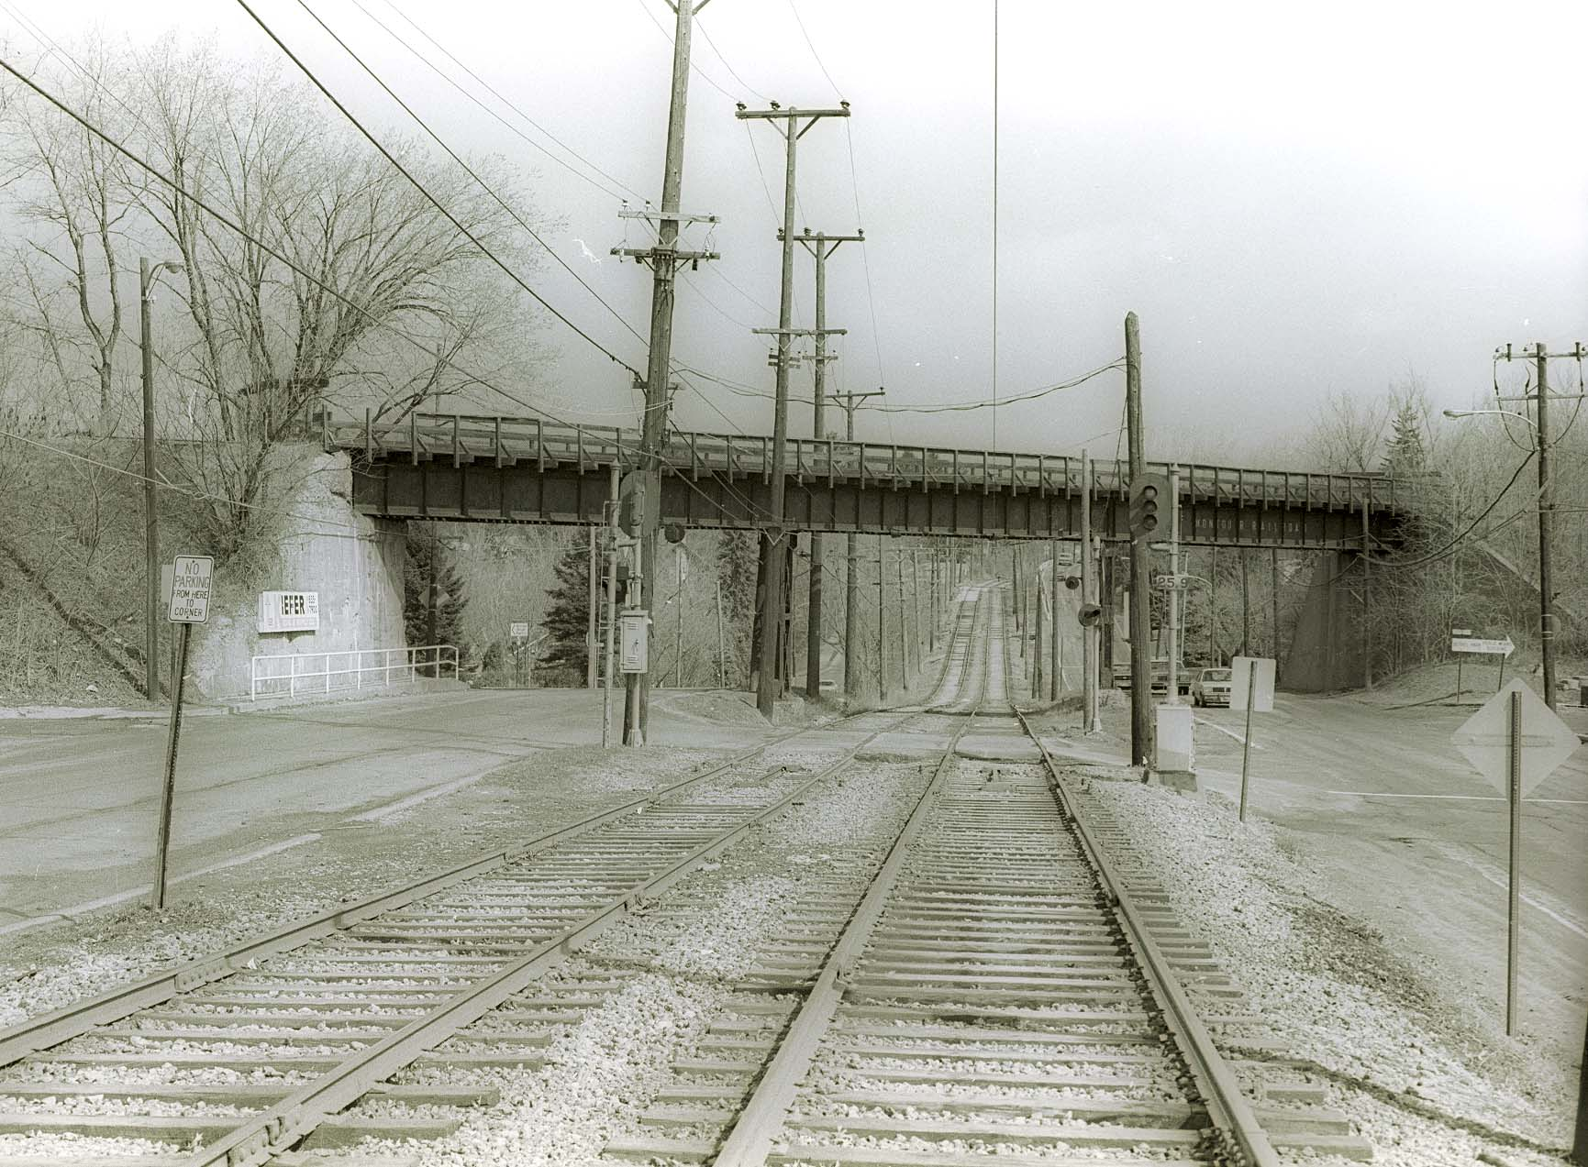

This photo illustrates Montour's crossing in downtown Bethel Park.
This scene at Brightwood was one of many interesting scenes along the Montour RR that could capture one's heart with or
without an actual train inside the scene.
In the center of the scene is the double track streetcar line that once ran to Charleroi, but now terminates in Library.
On the right, Brightwood Road and just out of site, is Slaters Supply.
Slaters Spur-Brightwood, was where Engine 78 upset in the 1960's during a switching move. Engineman Jim Lane rode the 78
down the small embankment.
Montour Mile Post 41 is also to the right in the scene as well as Brightwood Section for the maintenance of way department.
The road on the left, is West Library Road.
Also to the left, the Bethel Park Police and Bethel Park Library.
Kiefers Supply is also on the left and their bill board is attached to the left wing wall for the bridge.
This overhead bridge, is single track, has 2 small wood walkways on each side of the track.
This bridge carried Montour RR lettering on its east side only.

If class would now open your books to page 106, we can see in the bottom photo what the bridge looks like from track level.
Interestingly, early in the life of the Montour RR Company, probably while this area was un-developed, this location was
identified as Summit Park.
If you turn to page 16, the Passenger Ticket lists Summit Park as Station #155.

In the early 1990's, I spent perhaps 15 hours here over a 2 rainy day weekend and thoroughly documented the dismantling
of this unique structure.
Streetcar traffic was halted during those 2 weekend days.
The Bethel Park Fire Department positioned a truck here as removal of the steel decks proceeded.

Today in 2007, Port Authority has erected an interesting station here on top of the exact location of the bridge piers.
Slaters Supply was also demolished a few years for a park n ride lot.

For many years, at Christmas time, I purchased a Christmas Tree at Slaters Supply. On many of those occasions, I walked through
the rows of Christmas Trees with my companion Shelby.
As the years passed, I often thought how neat it would have been to preserve this bridge, along with placing 2 or 3 SW-9's on
the bridge with a caboose in tribute to the Montour RR.
And during the late 1970's, on occasion I would stop here, and photograph the evening rush hour of PCC trolley cars as they passed under the Montour Bridge while many of the PCC cars were still in their flamboyant colors.

Luckily, during the end of Montour railroad operations through Brightwood, I was able to photograph 2 Montour Railroad
crews on this bridge.

How neat it would of been just to photograph a train of B&LE or Montour hoppers crossing this span...

Gene P Schaeffer

After receiving an email from a group member responding off list about the Brightwood photo, I neglected to state...

Not only did the Montour RR operate trains over the bridge at Brightwood, coal trains of the P&WV operated over that same bridge into and out of Coverdale Mine.
Coverdale Mine would be to the left in the photo, perhaps a half to three-quarters mile distant...

So any modelers interested in recreating that Brightwood scene, feel free to include P&WV coal runs in your modeling interests.
Thanks Dave for stimulating my sleepy P&WV brain cells.

GPS

