Sept 3, 2008
Today’s step was to get some ballast onto the X-1 track.
Gene & Bryan were at #4 to spread it out – after TAR gave us a couple of buckets full of rock. Rocks – dirt – cinders - It is probably genuine Montour ballast.
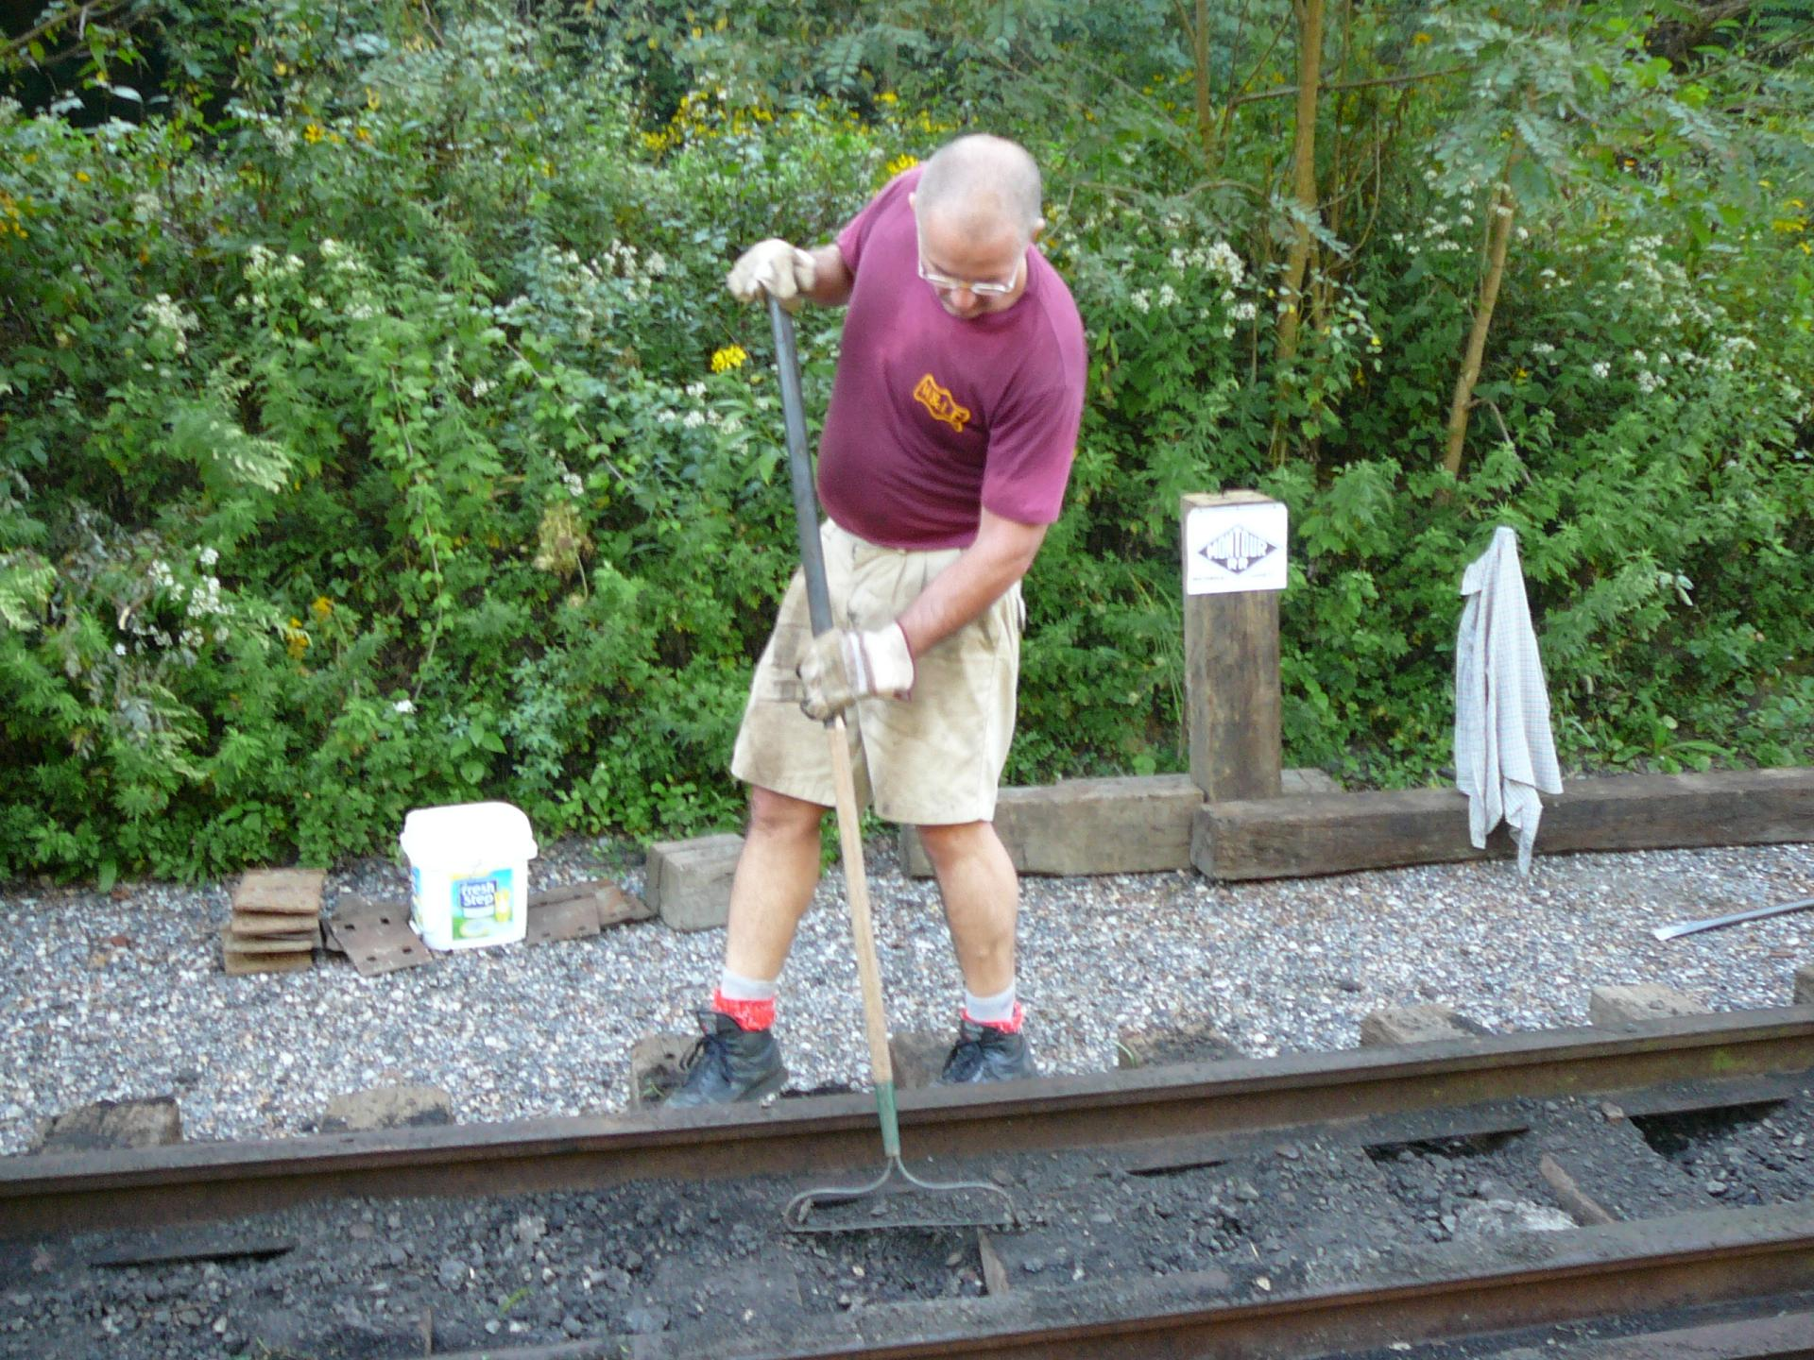

After some shovel work & clean-up – we have a track section just waiting for a tenant.
Friday morning the wheels should hit the rails.
