September 5, 2008

The X-1 is finally home!!
What a sight – as Century Steel Erectors’ truck rolls down the hill on McMurray Road & under the Montour Trail Bridge. The X-1 is ready to make the last turn towards home.
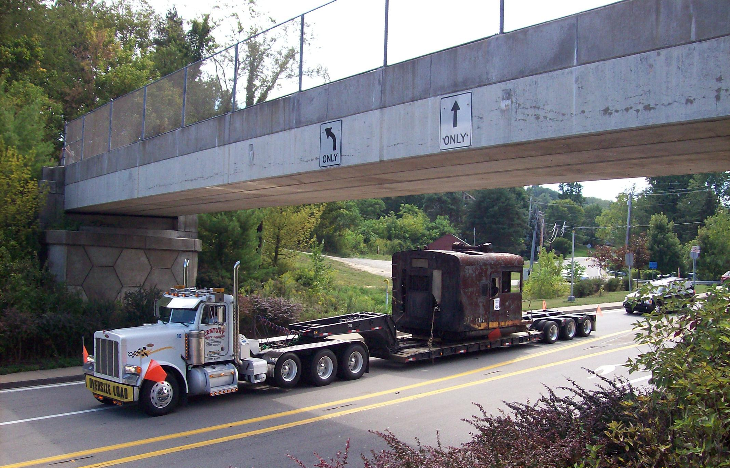
Meanwhile – Matt – Don – Eddie – Eric & Stan set the first truck on the rails at Montour #4 – the new (or should we say old) home of the X-1.
Gene’s rail gang had made sure everything was set and in gauge.
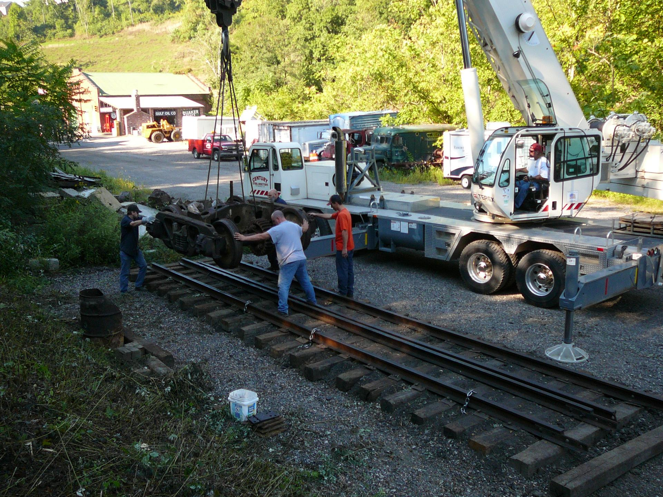

The frame arrives and is placed back on the trucks.
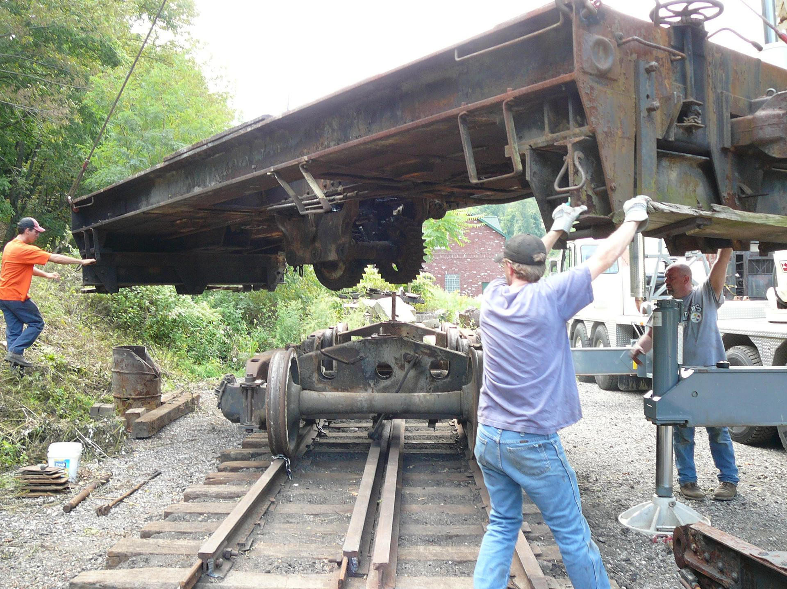
Then the big one – as the cab house is swung into position on the frame.
It goes much easier than yesterday – no trouble as the X-1 behaves itself and goes right into place with only a little friendly persuasion needed.
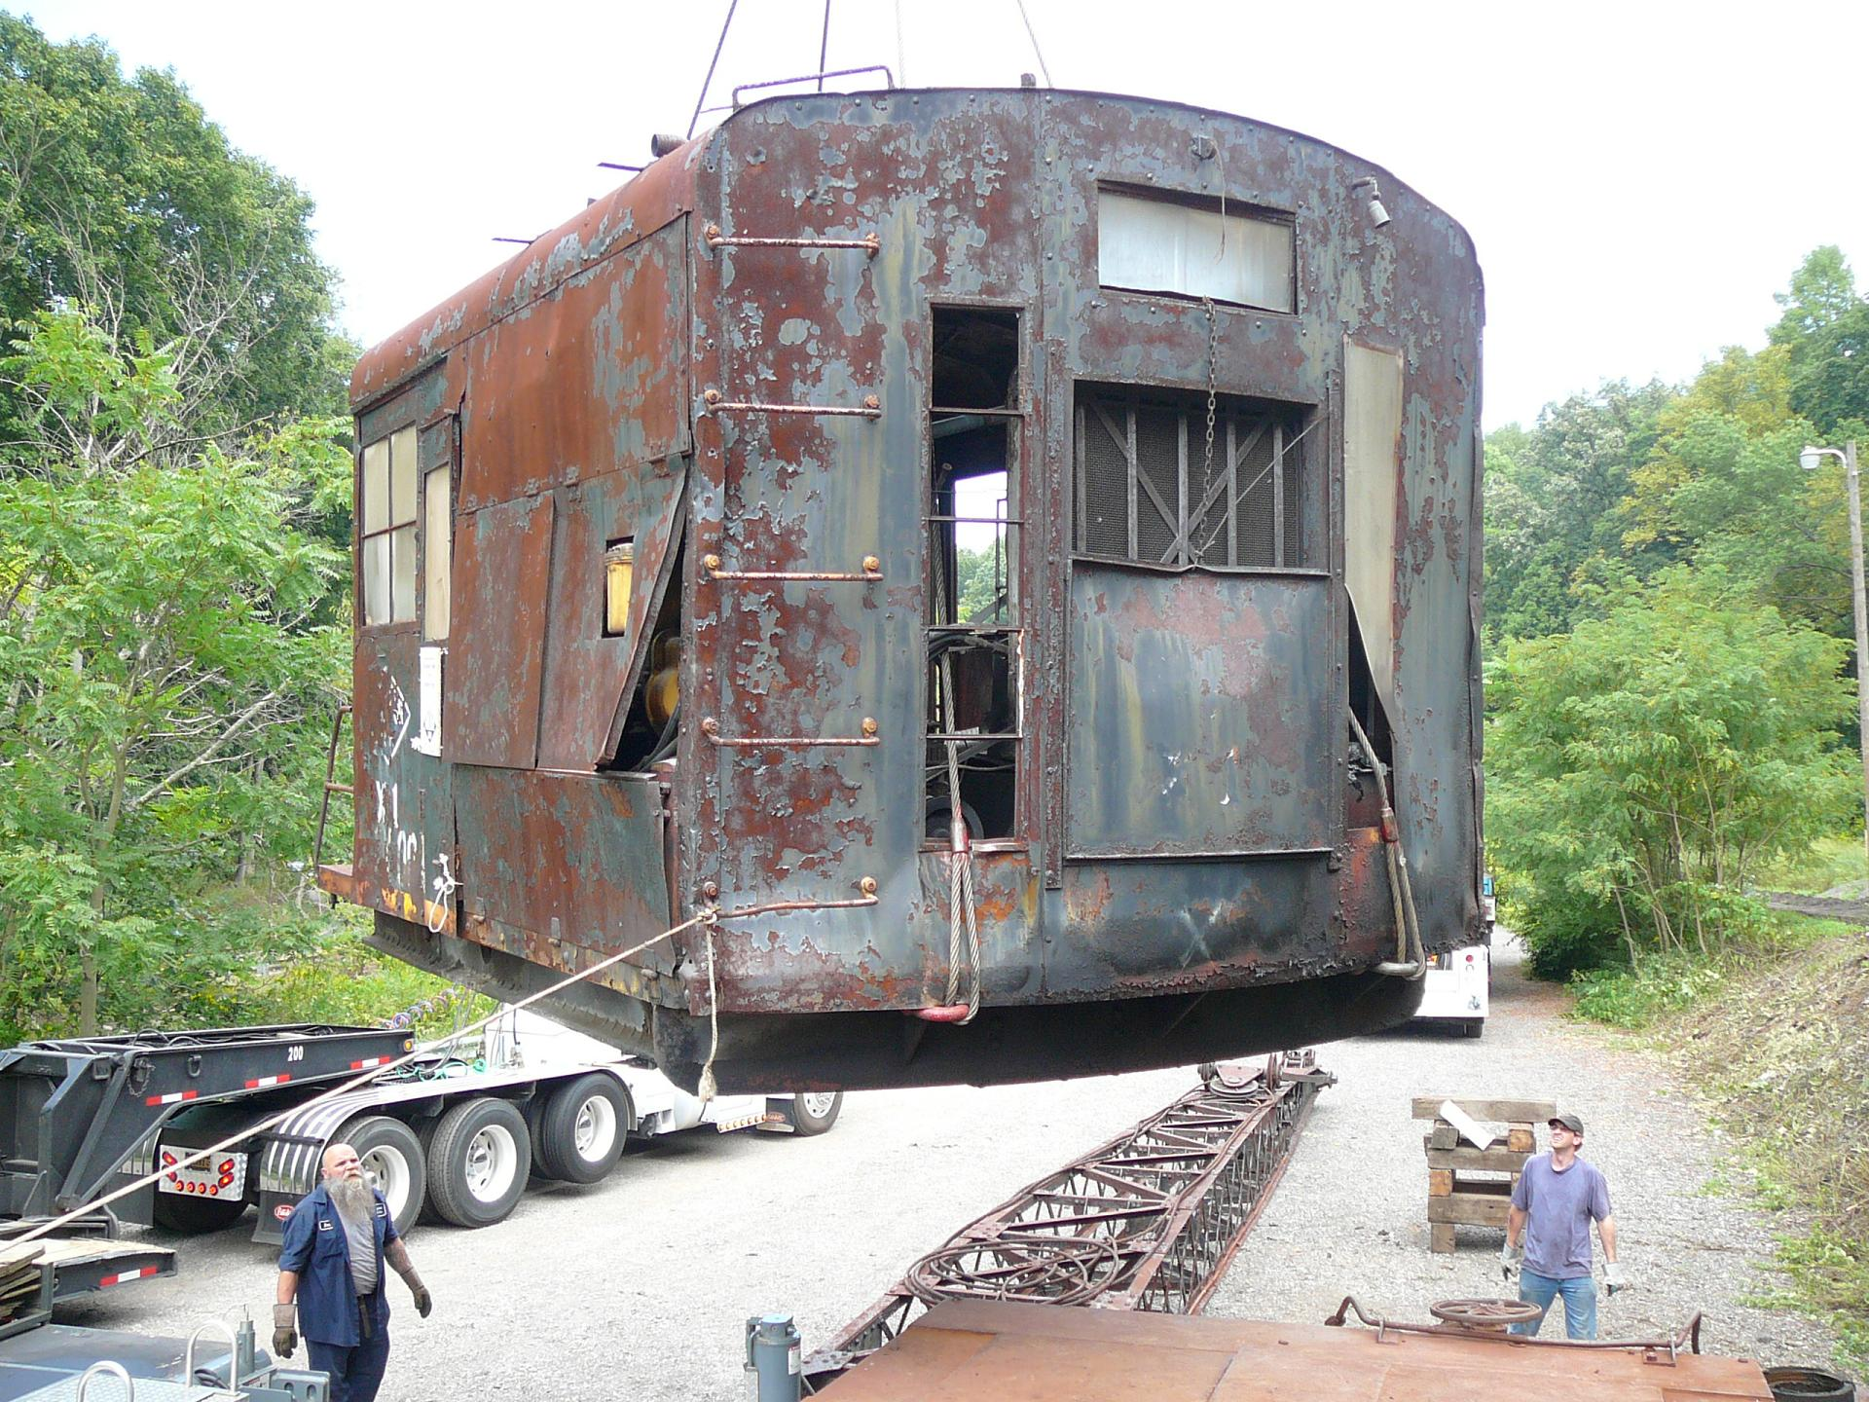
The final step – the boom is reseated.
All the King’s horses and all the King’s men – but the Century guys got the X-1 together again.
“The Hammer” and his crew wrap up the final lift – and the X-1 is once again on Montour rails - Home to stay!!
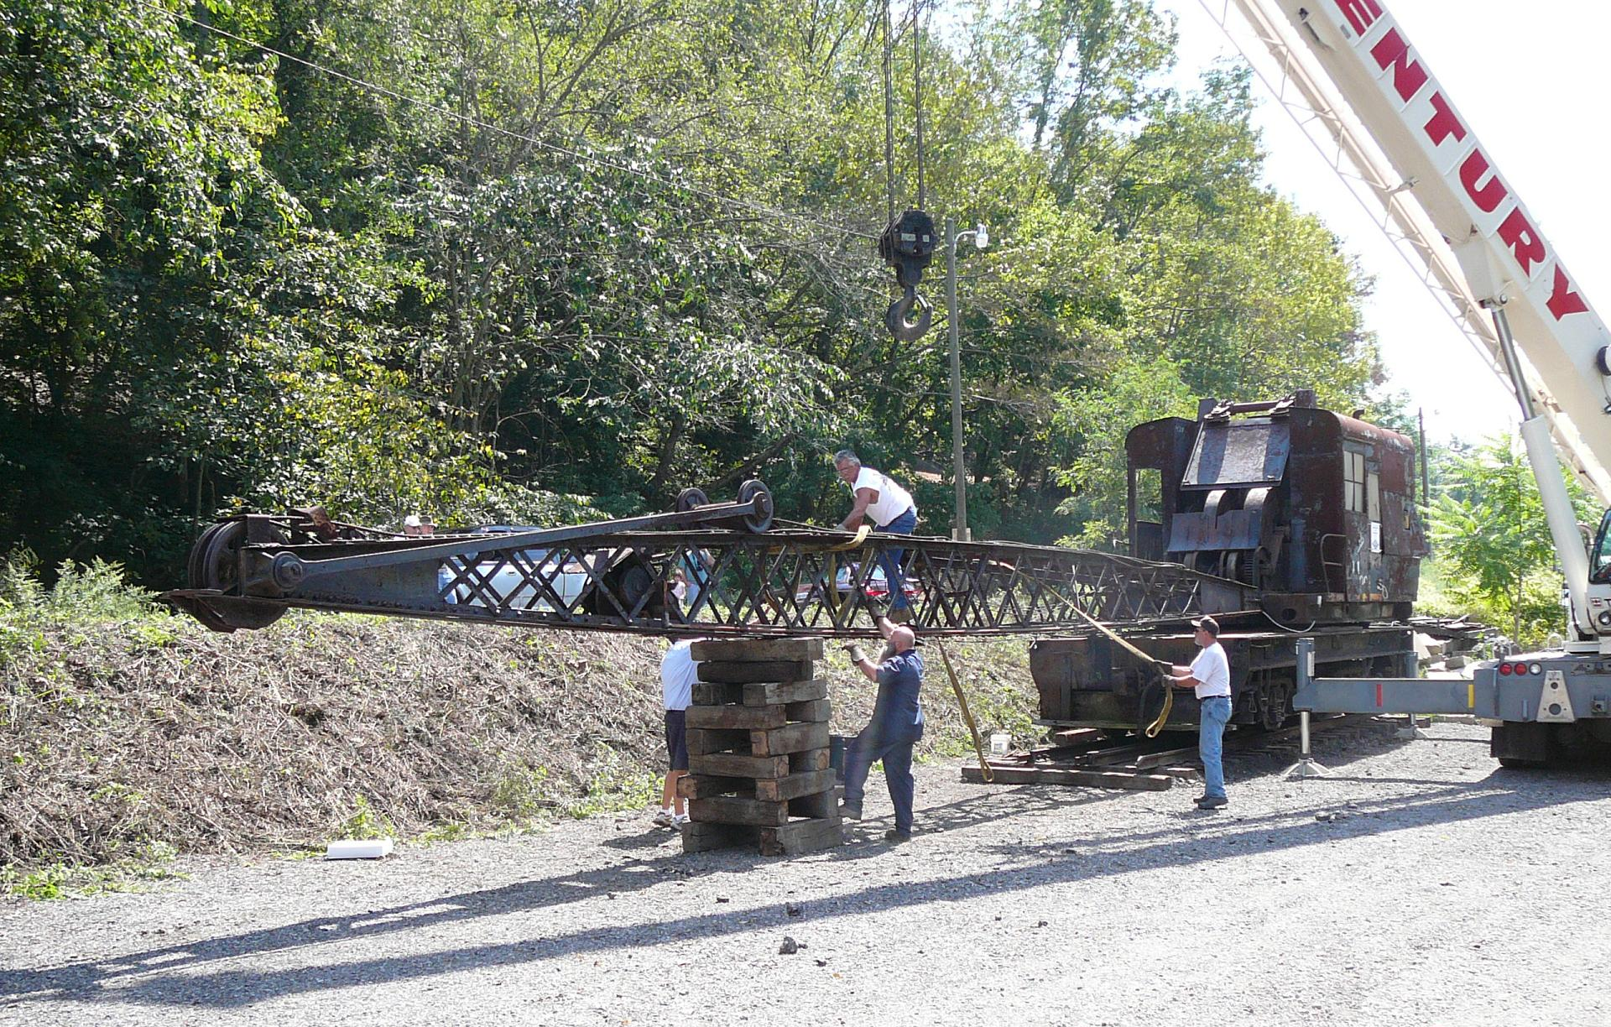
Century Steel Erectors crew for this day - the final step of the journey - strike a pose.
Jake Simcic – Eddie George – John Cecchine – Stan Indyk – Matt Green & Don Shuttleworth got the move done. Somehow Eric Graziano escaped the picture taking chore.
Thanks fellas – for a job well done!!
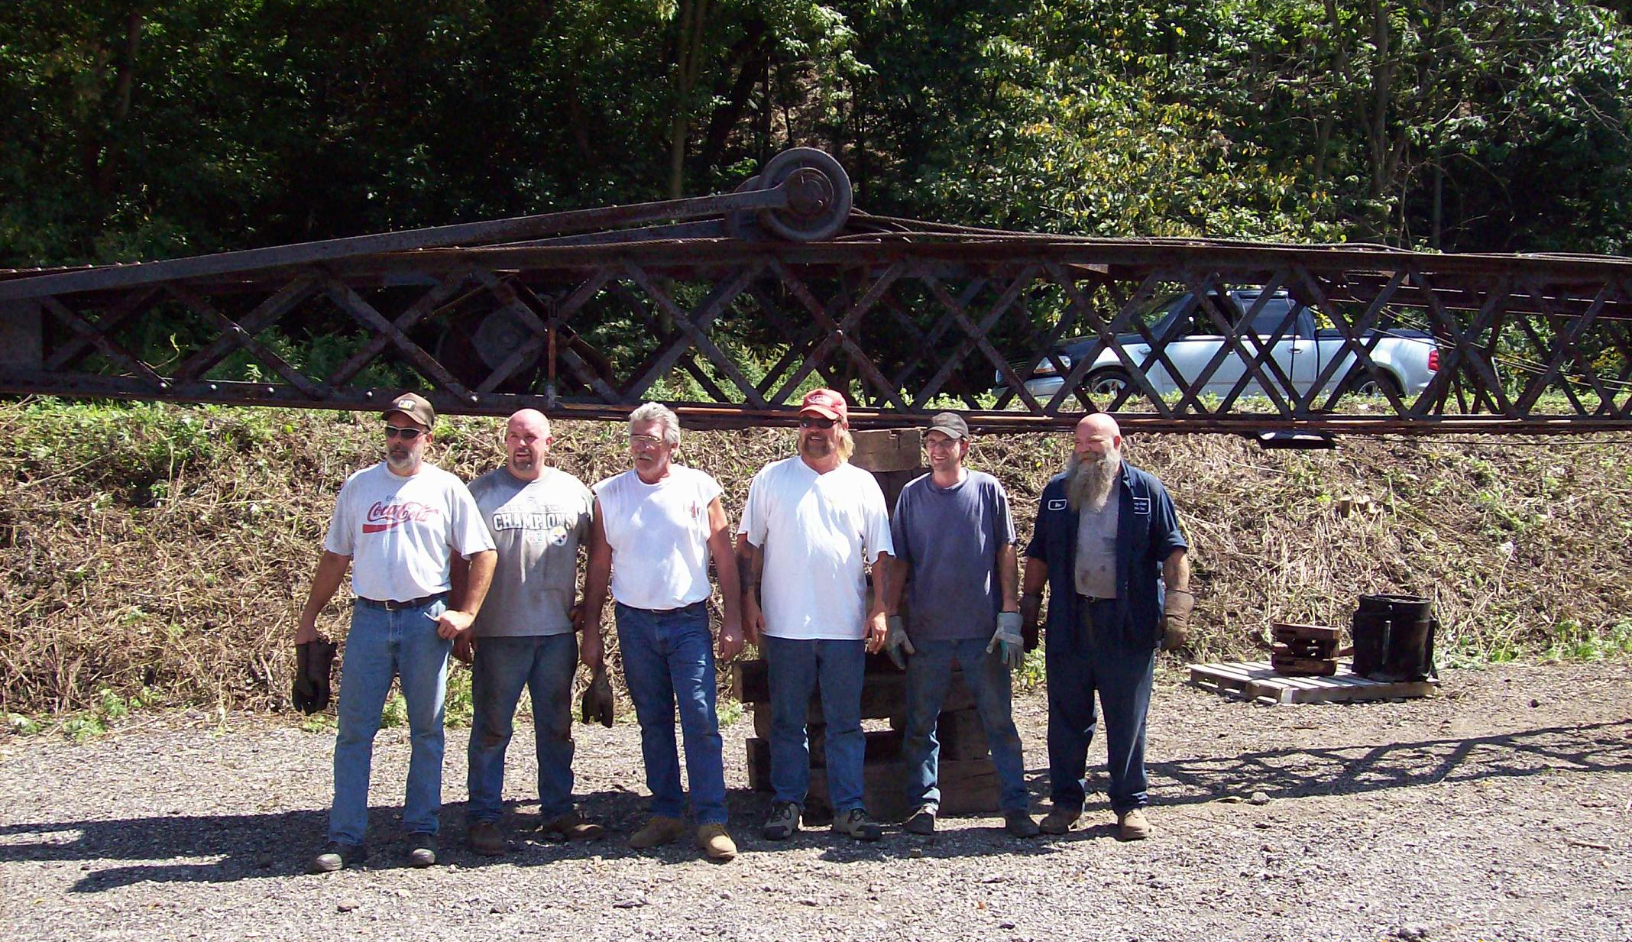

Perhaps the biggest smiles were on the faces of the MRHS members who joined us today.
The X-1 Project will continue – as we clean – scrape – fix – paint & renovate the crane for permanent display.
Still a lot of work to do – but the biggest step is now done.
The X-1 is Home!!

Our sincere thanks go to those who helped make the X-1 Project come together.
- Jerry Joe Jacobson & the Ohio Central Railroad System
- Donn Taylor & the Taylor Family of Century Steel Erectors
- Tom Robinson of TAR Storage
- Bill Errera Truck Fabricating & Joe Lane
- Tim Sposato – the guardian angel who saved the X-1 years ago –
- and our ex-Montour guys, Gene, RJ & Carter for putting in their time with the X-1 – both in years past and now.
- And – to all who helped with the “grunt work” – lifting – cutting – digging – dragging - spiking and all the other chores that were necessary to bring the X-1 home!
Thanks to one and all.

The Montour Railroad Historical Society

