September 2, 2008
Today the X-1 took its first step in the journey back to home territory.
At Dennison, Ohio the X-1 was moved for the first time in 7+ years as it was relocated onto a siding where Century Steel Erectors can disassemble it for the move to its destination at Montour #4.
Ohio Central engine 2912 and crew coupled up to the X-1 with a flat car and tank car to move it from the spur where it has been sitting for years.
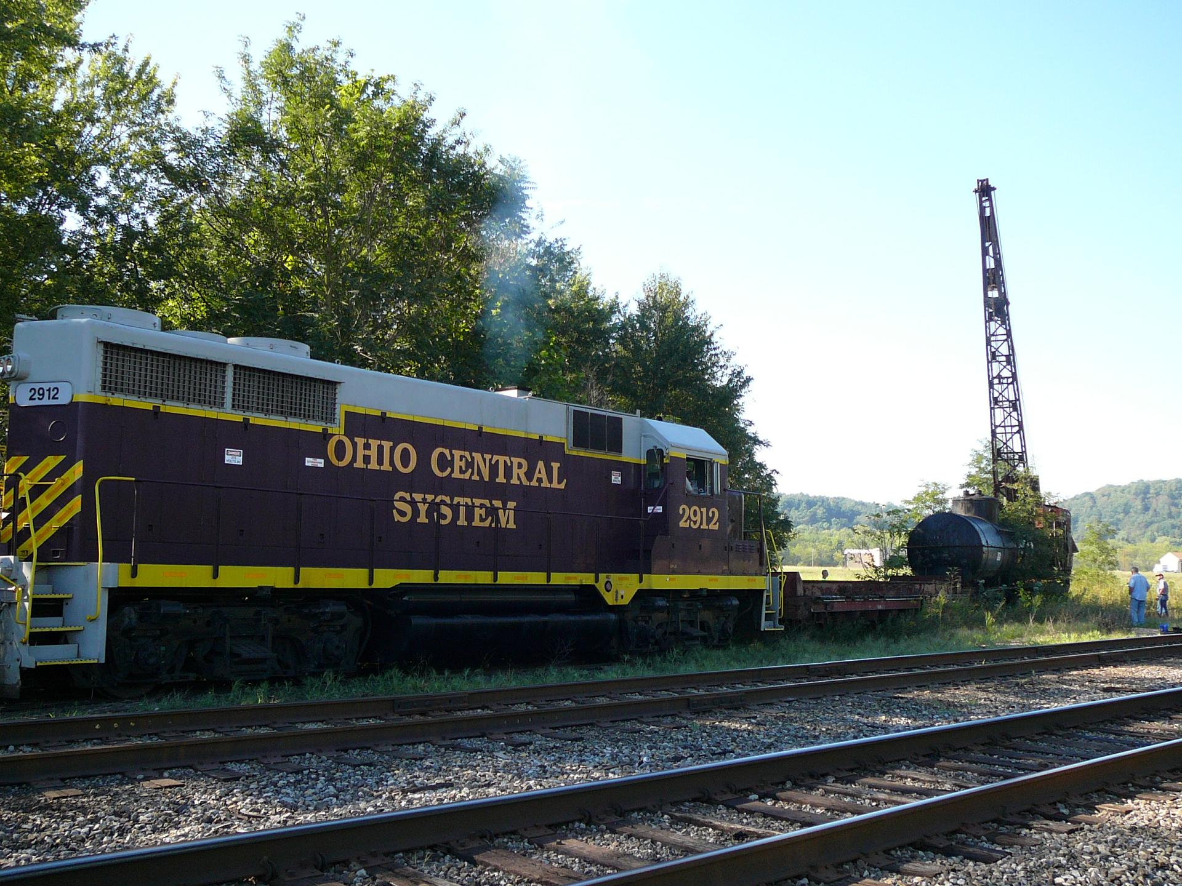

Nice and easy – over some old switches and broken rail that had to be wedged into position – keep checking to make sure everything stays on the track – it is rolling easily.
It was really neat to watch it move and walk along with it down the track.
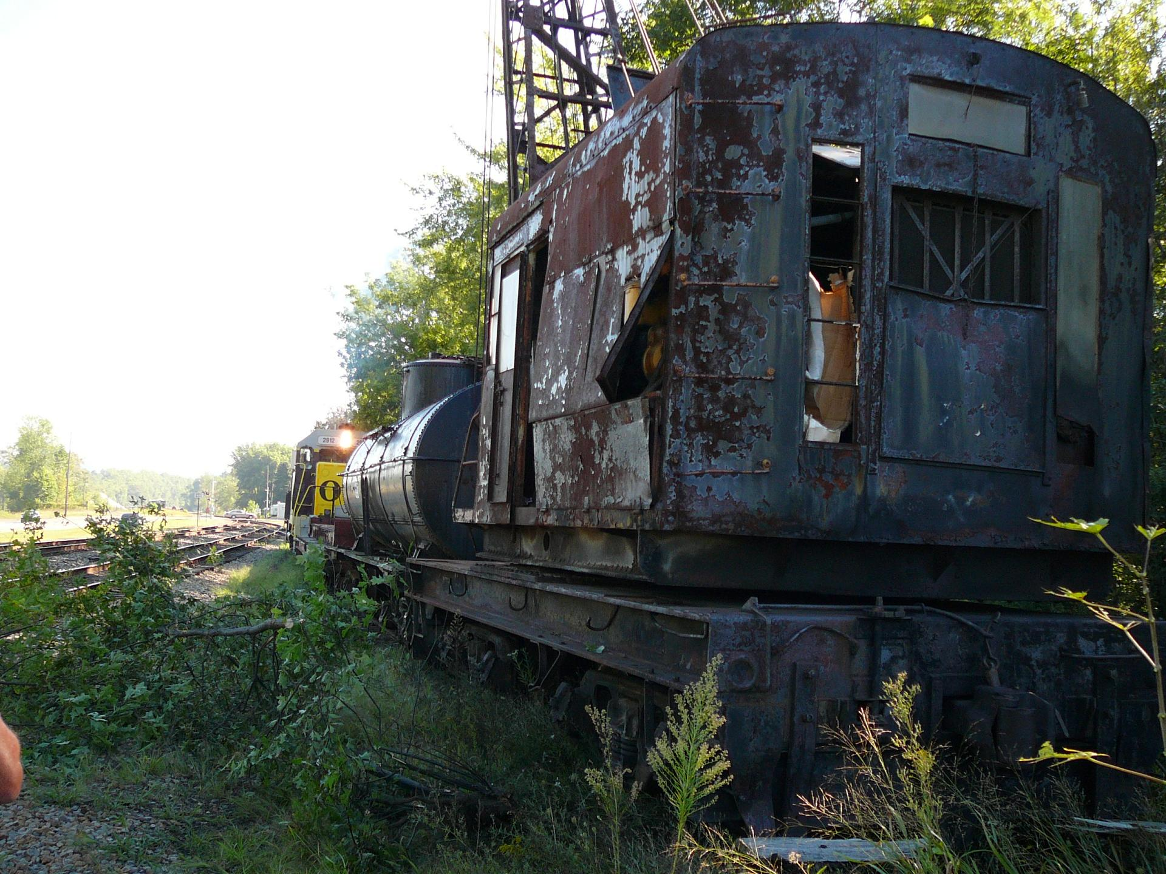

X-1 clears the switch – now the shove back can begin to push it down the siding.
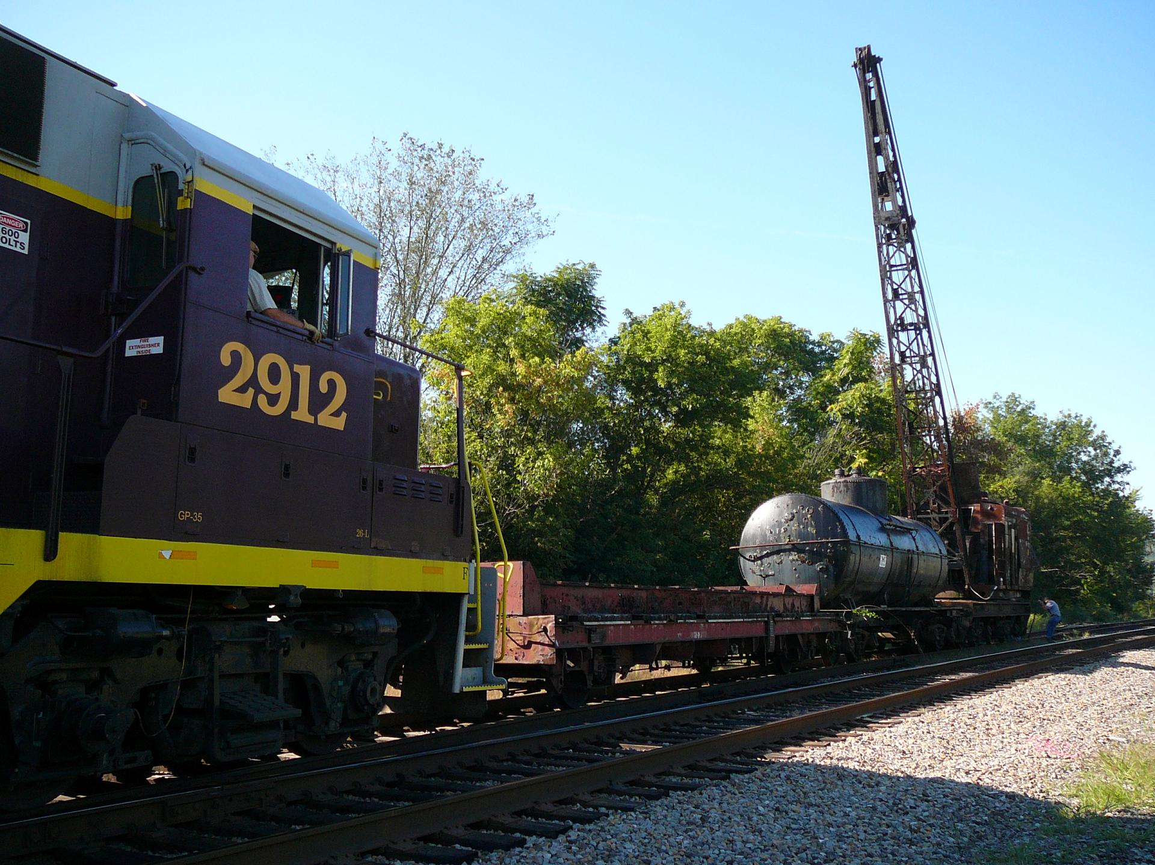

Shoving back along the siding to be spotted.
Tim keeps an eye on the proceedings.
Almost there – only a couple of car lengths to go.
It seems only fitting that it is shoved next to a string of coal hoppers waiting to be loaded at a coal mine nearby.
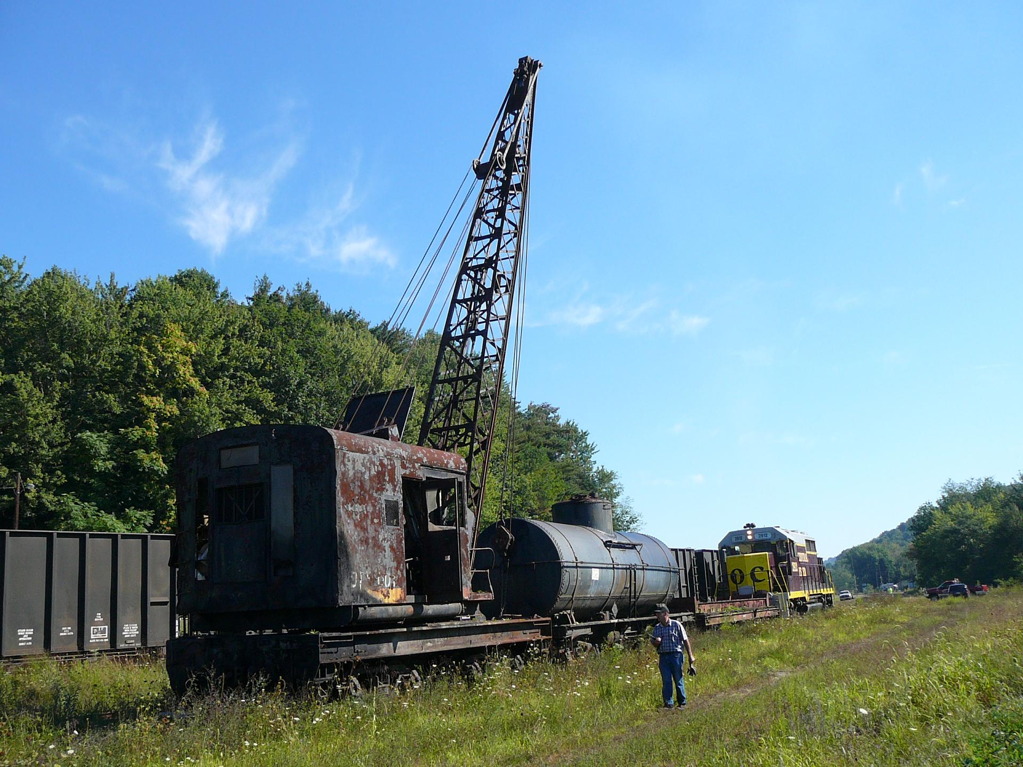

Then Conductor William Dick gives the call, “2912 – that’ll do.”
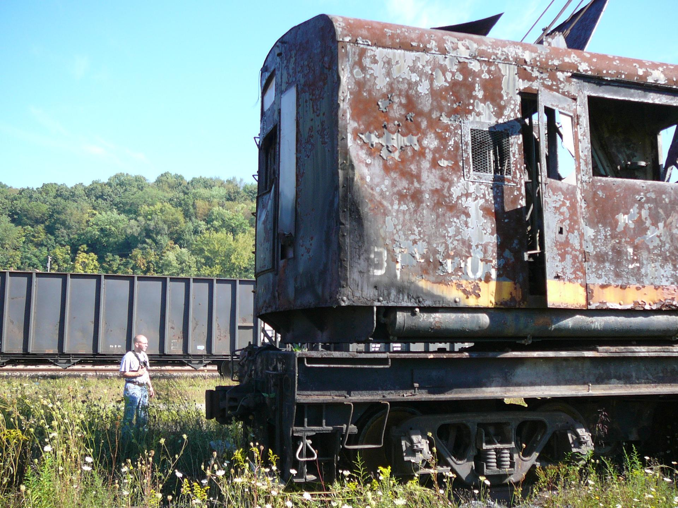

Tim takes care of uncoupling.
This is the last move X-1 will ever make on a working railroad.
The next step will be a move by trucks over a 90 mile journey.
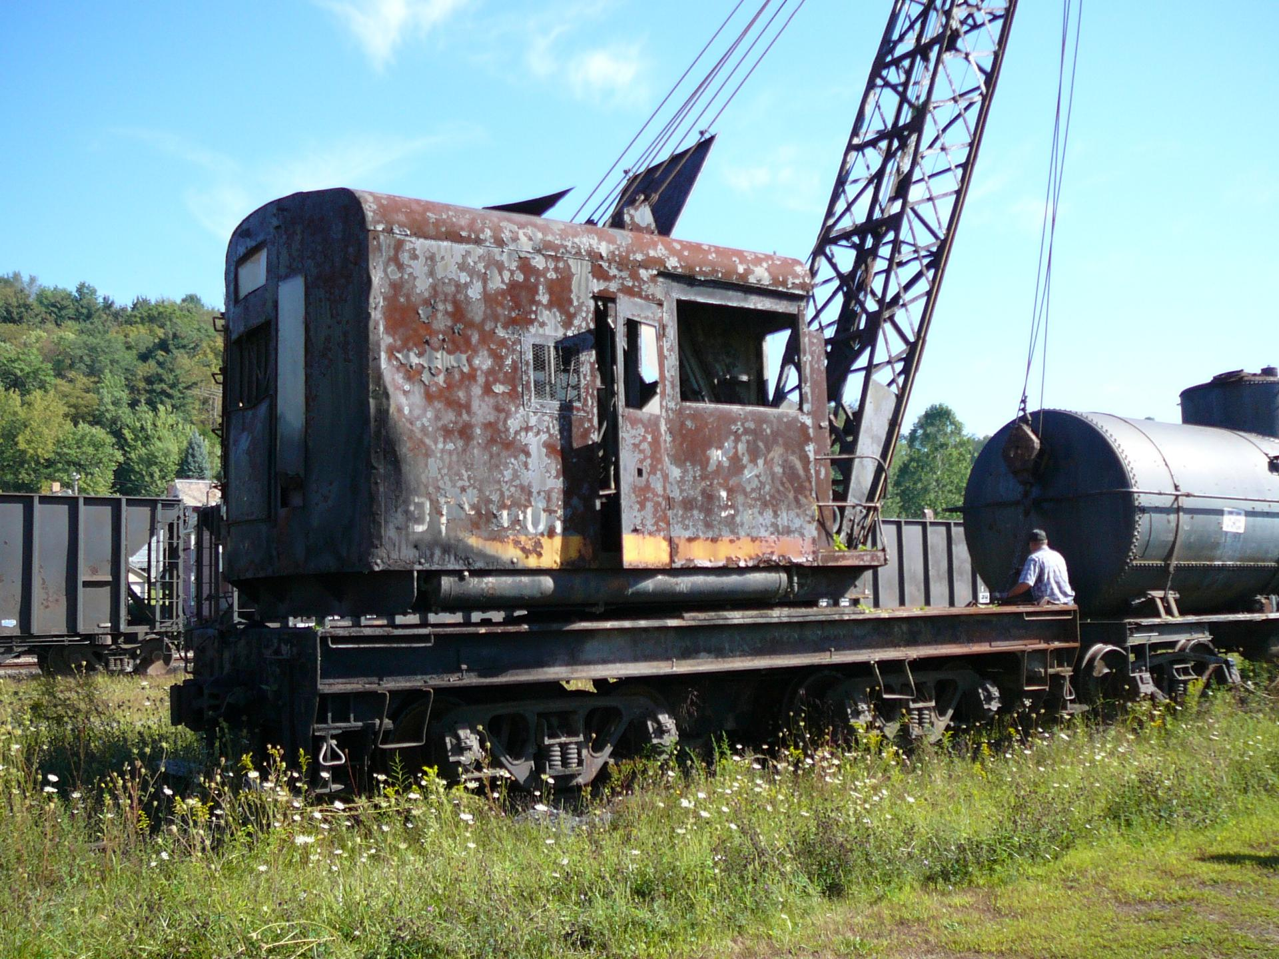

This is the Ohio Central Crew that gave the X-1 a nice ride.
They have it spotted and tied down.
Conductor William Dick– Engineer Clarence Miller – Track Dept. Gary Gerber – Supervisor Tim Sposato

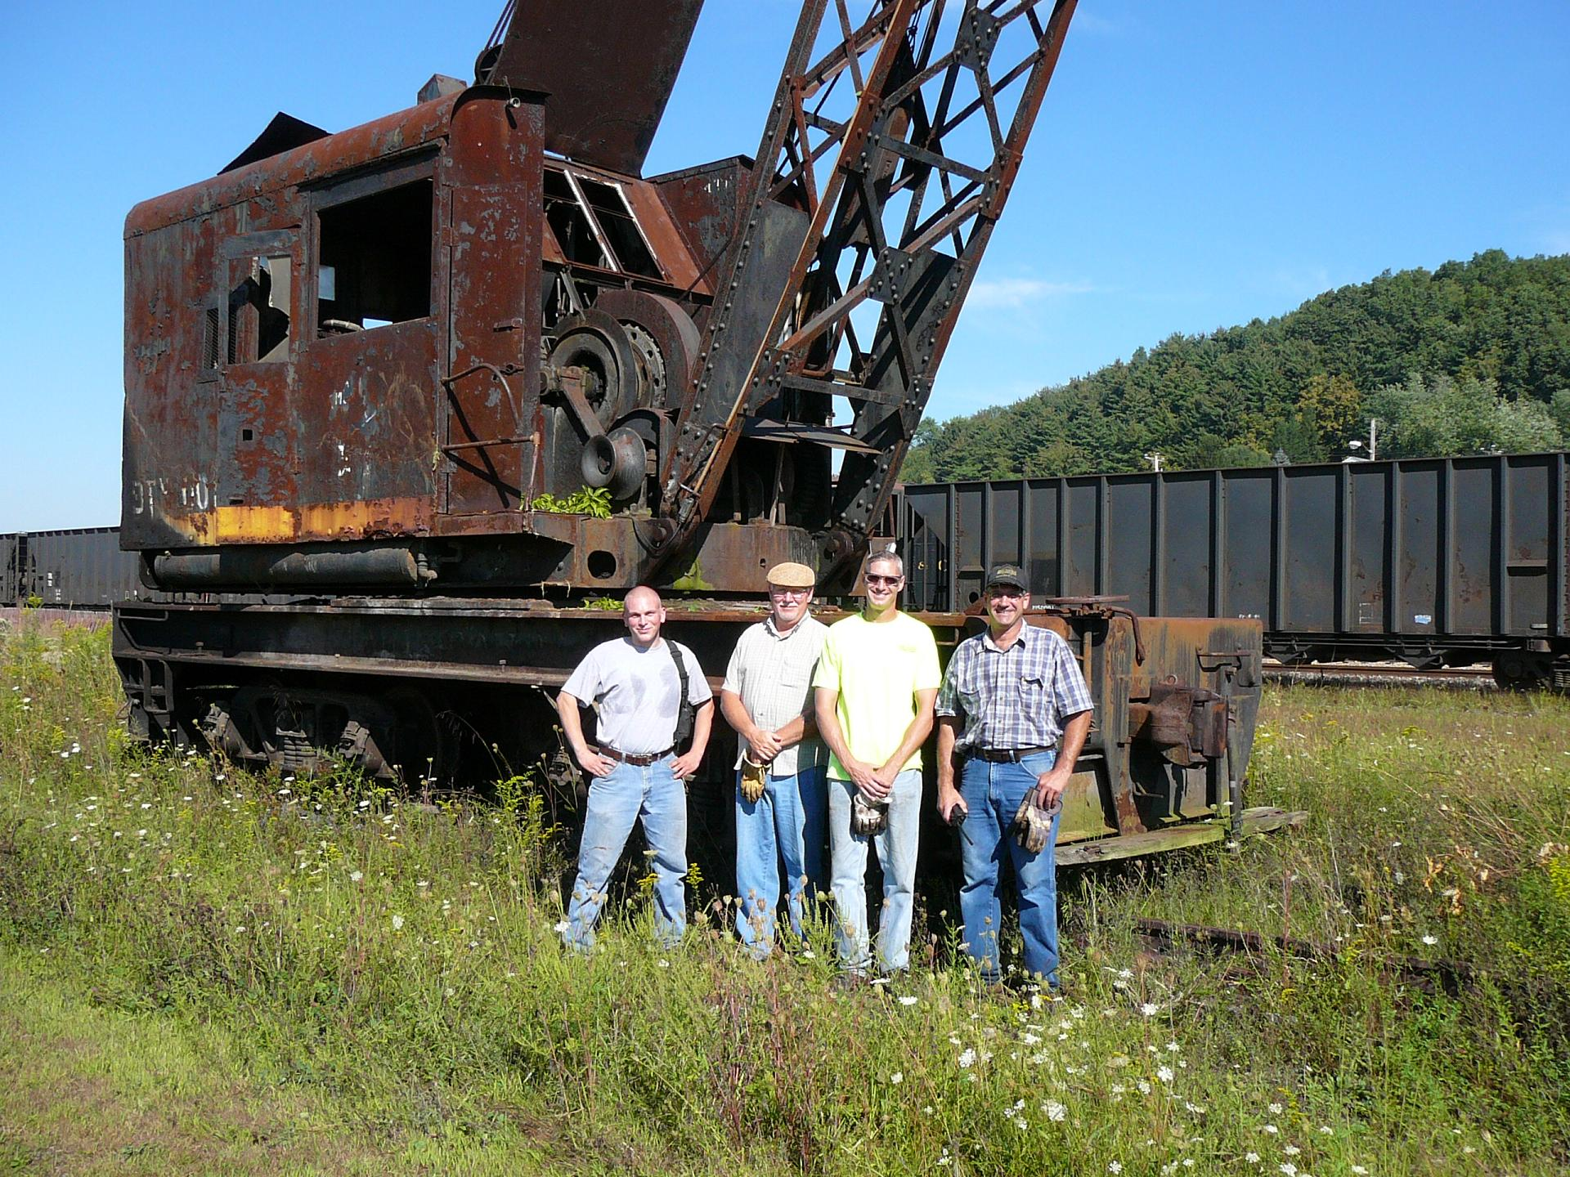
Thursday morning – Century Steel Erectors will take over and X-1 will be loaded onto 4 semi-trailers to continue its journey. A ride east on Rt 22 – the Parkway West – and South on I-79.
Hopefully all loads will be in or near McMurray by Thursday evening.
Then Friday morning the X-1 will be placed on its new home track – back in Montour Country to stay.

