September 1, 2008

Today the MRHS laid rail for the X-1 at Montour #4
Thanks to Joe Lane and to Bill Errera Truck Fabricators for supplying the truck and the expertise to recover the rails and transport them to the X-1 site.

The track gang was busy - as RJ - Carter - Gene - Dennis & Ken made sure the rails were in gauge.
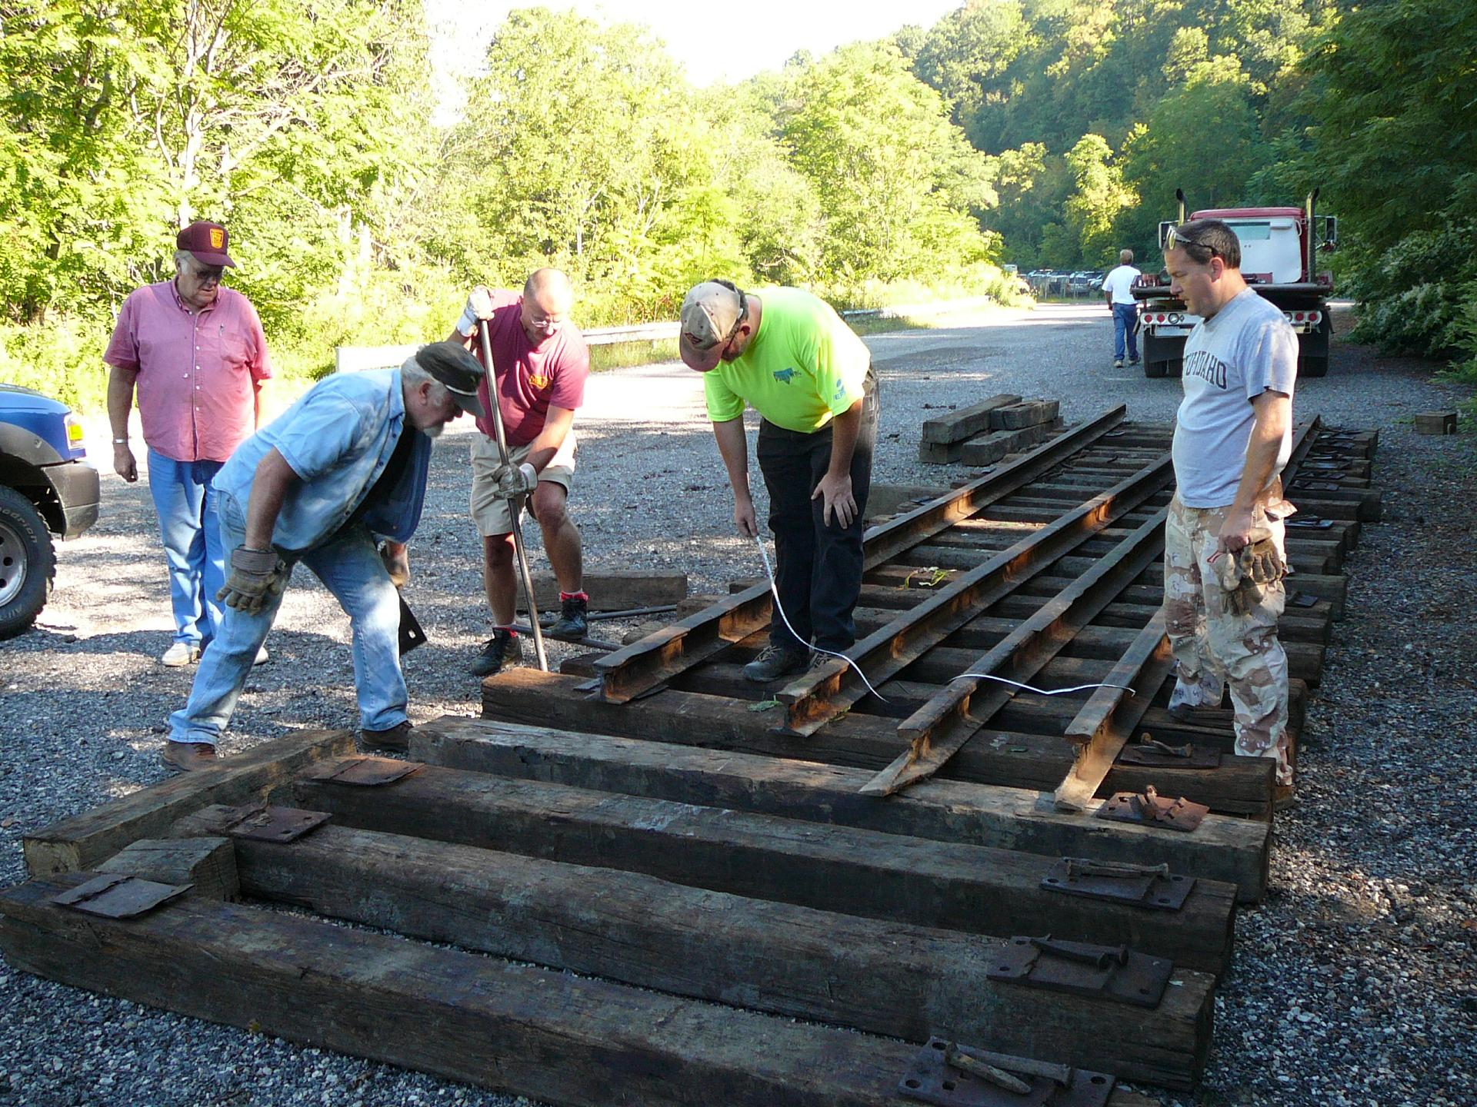

Then the track gang went to work spiking down the rails. Gene still has the knack after 30+ years.
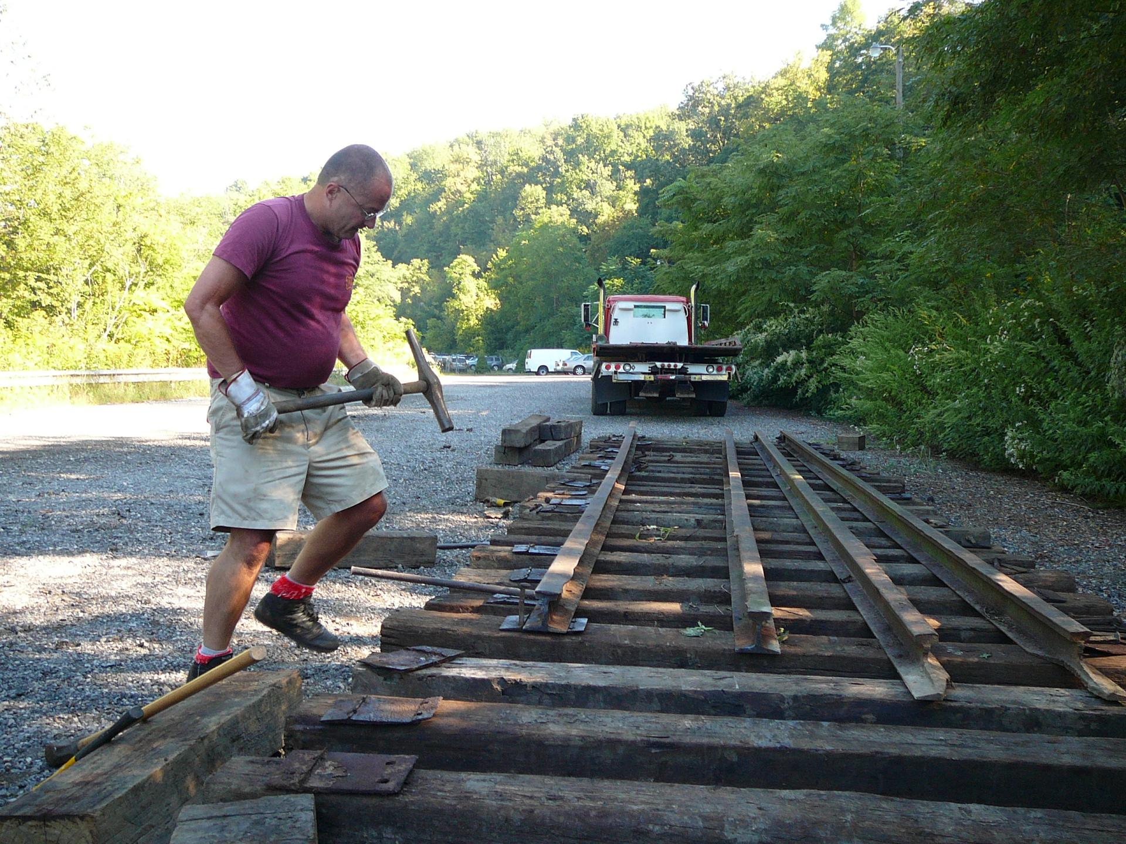

Bill gave it a whack.
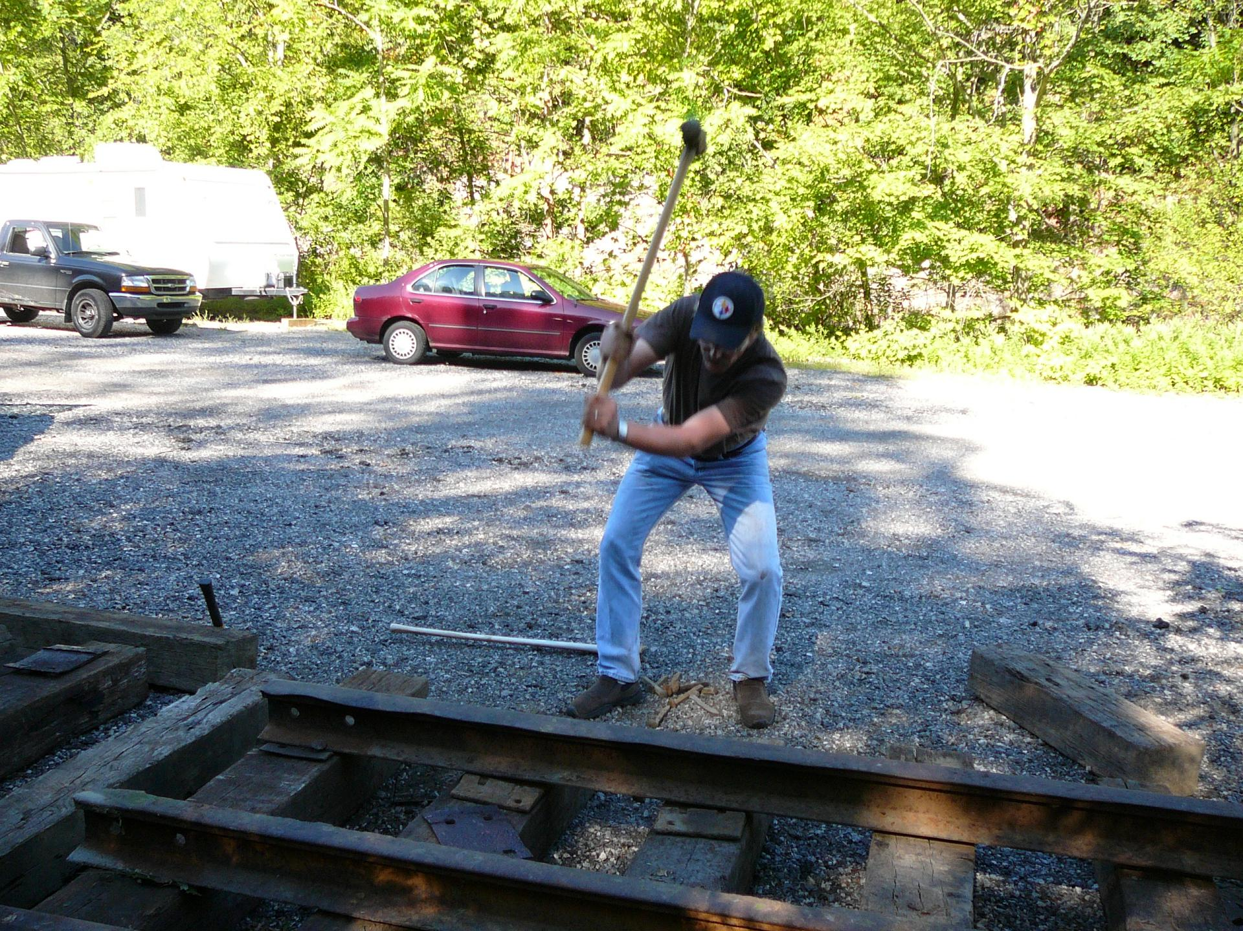

And Ken tried his hand at it, too - with RJ holding things steady.
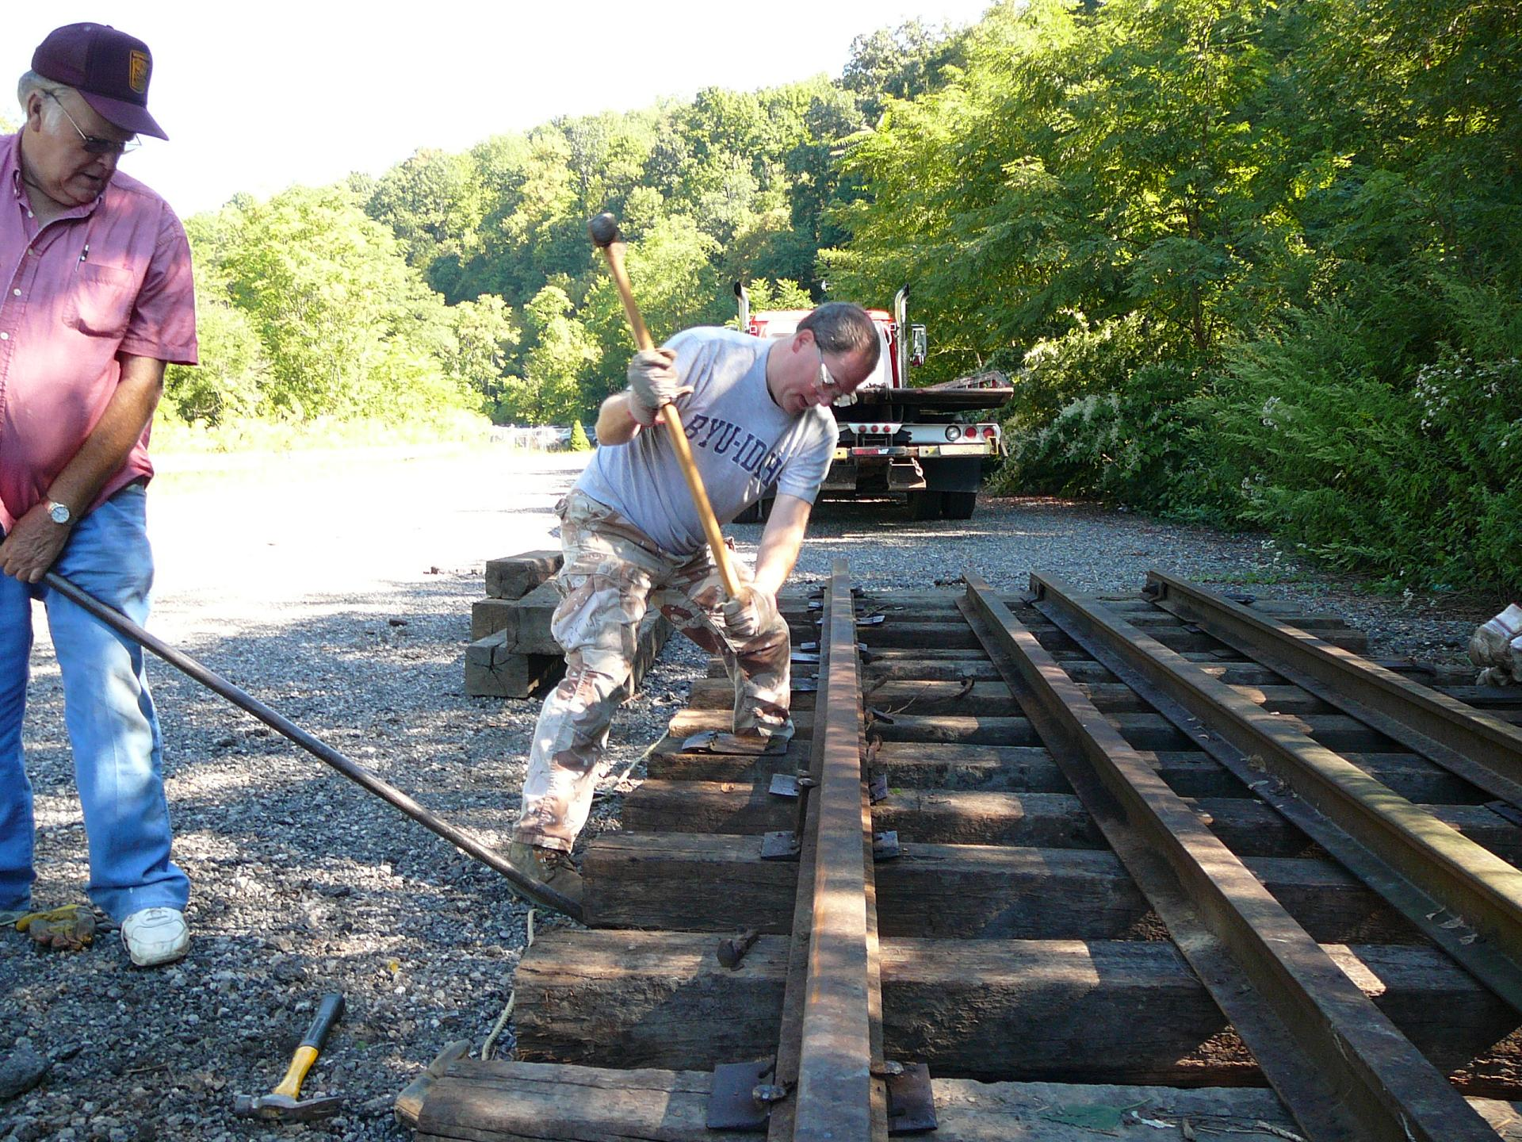

So, with a few achy muscles - we now have a section of track at #4 for the X-1 to live on.
A few more spikes have to be driven & some ballast put down - that should happen in the next couple of days.

Tuesday - Carter & I will go to Dennison and meet with the guys from Century Steel Erectors and with Tim to check out how the X-1 needs to be disassembled for the ride home.
X-1 will also get moved for the first time in about 10 years - as it must be re-positioned for Century to be able to work on it and load it on their trucks..

3 more days until X-1 comes home.

Bryan

