September 4, 2008
Moving Day!!
Things started early in Dennison. A bright sunny day ahead of us.
It seemed appropriate that the X-1 lay snuggled up to a string of coal hoppers.

Eddie climbs the boom to set the first piece of rigging and get the day started.

The boom comes down with no problems.
The cables are cut and the block & hook removed.
The first step is done by 8am. The boom is loaded onto a trailer and moved aside for its trip home later in the day.
Things are really looking good.
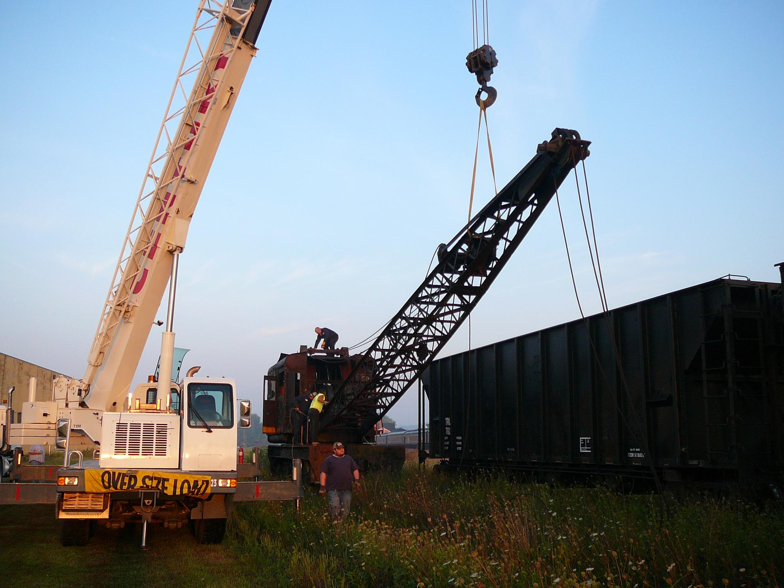

As we take a quick coffee break, the Century Steel Erectors crew is anticipating a good, fast move.
“The Hammer” John Cecchine heads up the move – along with Eddie George – Bill “Buck” Desko – Virgil Carver – Ryan Shipley – Jake Simcic – and Stan Indyk, who manned the crane.
Look carefully – as this was probably the last time of the day that Buck had a smile on his face.
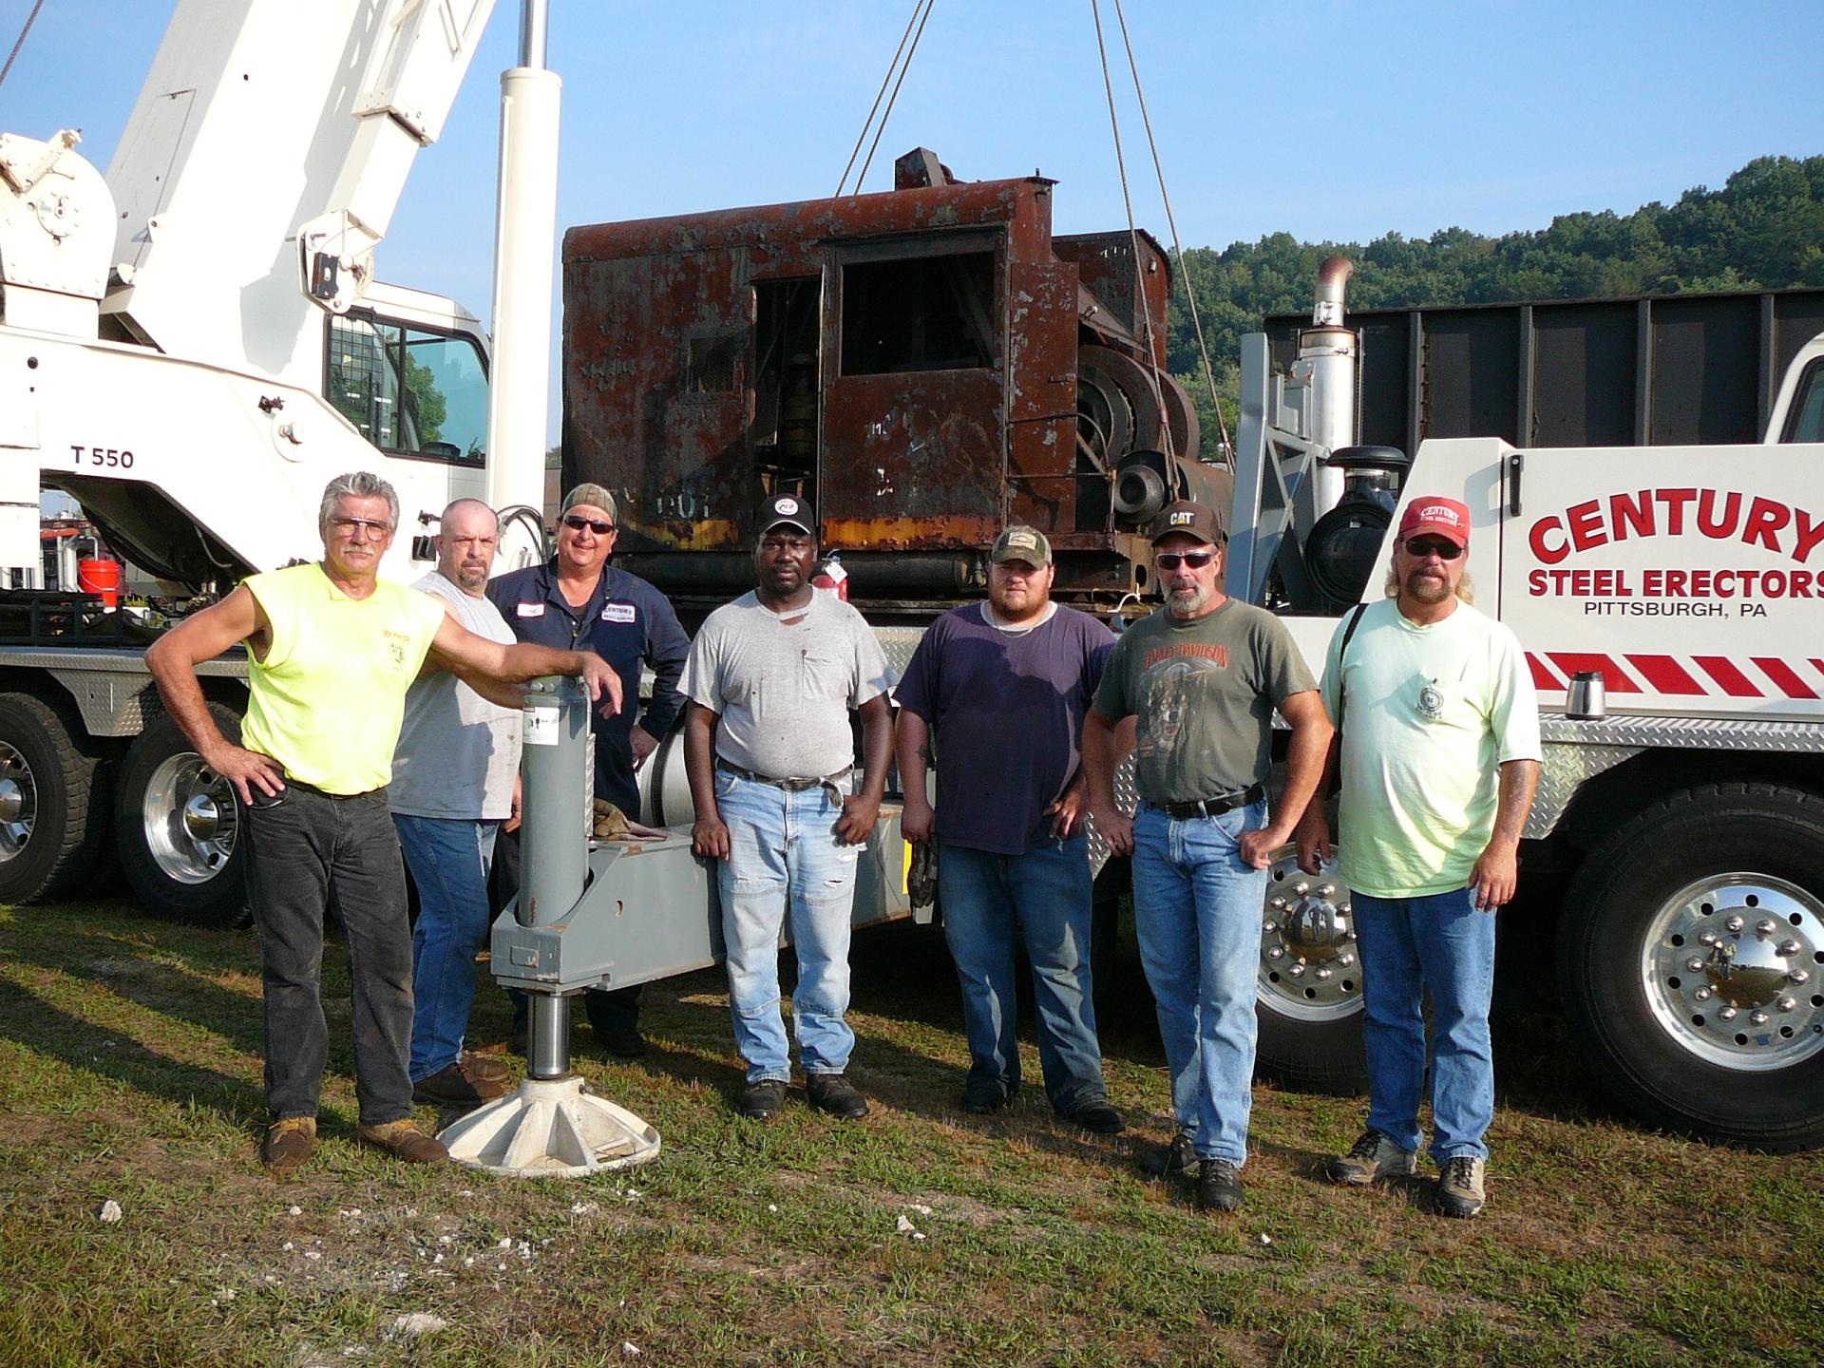

The ol’ X-1 wasn’t about to go quietly.
I guess it just didn’t want to leave the rails – because at this point of the day, it started to give the crew a bad time.
What everyone thought would be a simple lift to pull the cab house off the frame turned into a 7 hour marathon of cutting – torching – lifting – and cursing as X-1 refused to let go.
Calls were made to the American Ohio Locomotive Crane Co. asking for any advice and a look in the manual – but they couldn’t come up with that “secret magic step”
Buck and Eddie took turns with the torch – up underneath the frame – cramped quarters – sparks in their face – fumes in their eyes – molten metal at their feet.
Still, the X-1 refused to budge.
Finally – at 4pm the cab came free & that lift was completed.
Buck had the last laugh anyway.
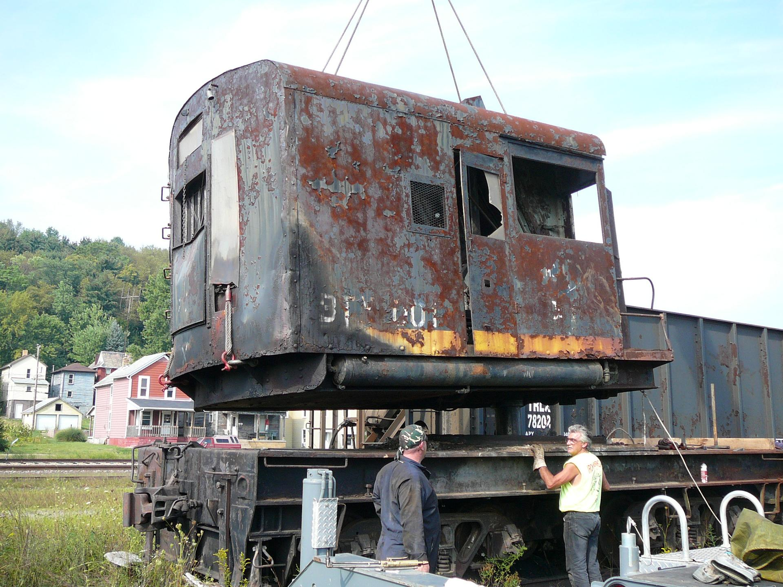
When Stan gave it a lift, we found out that the Cab weighed in at 68,000 lbs.
Next it was the frame – an easy lift. 63,300 lbs.
The X-1 had given up its fight for today and finally said “Take me home”
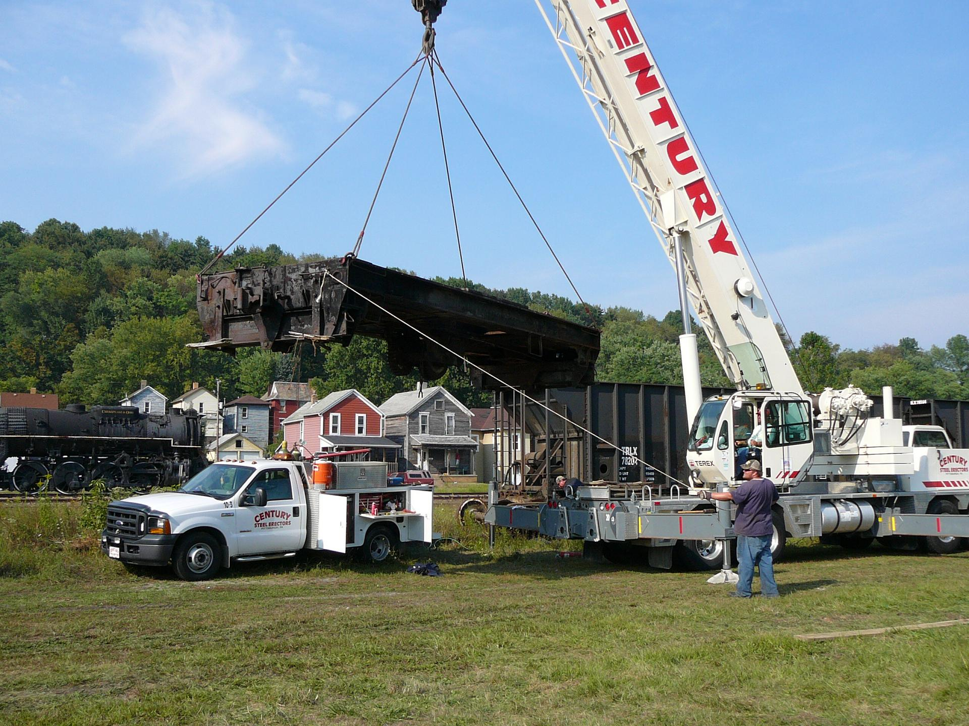
After that – the X-1’s trucks were loaded onto the last trailer.
The boom load and the trucks load were sent on their way – arriving at Montour #4 at 7:30pm
The Cab and Frame loads started their journey – but were stopped by the curfew put on the permit for those loads. They will finish their journey in the morning and the X-1 will finally be in Montour territory again.
Friday morning’s show – like Humpty Dumpty - put it all back together again.
Thanks to the Century crew for all their work in getting the X-1 back where it belongs.

